YOGA

**YOGA Introduction**: Yoga is essentially a spiritual discipline based on an extremely subtle science, which focuses on bringing harmony between mind and body. It is an art and science of healthy living. The word ‘Yoga’ is derived from the Sanskrit root ‘Yuj’, meaning ‘to join’ or ‘to yoke’ or ‘to unite’. As per Yogic scriptures the practice of Yoga leads to the union of individual consciousness with that of the Universal Consciousness, indicating a perfect harmony between the mind and body, Man & Nature. According to modern scientists, everything in the universe is just a manifestation of the same quantum firmament. One who experiences this oneness of existence is said to be in yoga, and is termed as a yogi, having attained to a state of freedom referred to as mukti, nirvana or moksha. Thus the aim of Yoga is Self-realization, to overcome all kinds of sufferings leading to 'the state of liberation' (Moksha) or ‘freedom’ (Kaivalya). Living with freedom in all walks of life, health and harmony shall be the main objectives of Yoga practice. “Yoga” also refers to an inner science comprising of a variety of methods through which human beings can realize this union and achieve mastery over their destiny. Yoga, being widely considered as an ‘immortal cultural outcome’ of Indus Saraswati Valley civilization – dating back to 2700 B.C., has proved itself catering to both materials.

**Definition of Yoga** : 1. Yoga is defined as a mind-body practice composed of physical postures, breathing techniques, and meditation.

2. Definition According to Bhagavad Gita – Lord Krishna defines yoga - Yoga is a balanced state of the body and mind. Yoga is a balanced state of emotions. Yoga is a balanced state of thoughts and intellect. Yoga is a balanced state of behaviour. We are excited in the situation of pleasure and we become sad when it is a negative situation.

3. According to Sri Aurobindo, all life is Yoga, while Yoga as a sadhana is a methodised effort towards self-perfection, which brings to expression the latent, hidden potentialities of being. Success in this effort unifies the human individual with the universal and transcendental Existence.

**AIMS OF YOGA :**

The six aims of yoga provide a comprehensive roadmap for individuals seeking holistic well-being and spiritual growth. Dharma, artha, kama, moksha, shanti, and prema encompass various dimensions of human existence, guiding practitioners towards self-realization, balance, and connection with the divine.

The aim of Yoga is Self-realization, to overcome all kinds of sufferings leading to 'the state of liberation' (Moksha) or 'freedom' (Kaivalya). Living with freedom in all walks of life, health and harmony shall be the main objectives of Yoga practice

OBJECTIVES OF YOGA :

* To attain a higher level of consciousness.
* To practice mental hygiene.
* To enable the students to have good health.
* To possess emotional stability.
* To integrate moral activities.
* To integrate spiritual ability.
* To increases concentration and self-control.
* To increase productivity in life.

MISCONCEPTIONS OF YOGA

**1 Yoga belongs to one religion**  
  
Body , mind and soul exist in all human beings irrespective of religion. Yoga helps one to bring these aspects together and does not concern itself with labels of any sort, be it religion or any such superficial difference in human beings. What Yoga requires is practice with true dedication and consistency and not one's membership to a particular belief system.  
  
**2 Yoga is only bodily postures**  
  
A person who performs a rope trick, a magician or one who performs physical exercises including only Asanas should not be considered as a Yogi. Yoga is comprehensive. In the great Patanjali Yoga Sutra only one Sutra talks about Asanas. Patanjali advocates the practice of eight unique branches called Ashtanga Yoga for development of one's true personality . It involves the practice of certain principles enumerated as Yama and Niyama, Asana ..  
**3 You can learn it through books**  
  
People think that learning Yoga is as simple as referring to innumerable books available in the book store. It is not that simple. Such practices may lead not only to bodily harm but also result in halfbaked knowledge about the practice of Yoga. It is a systematic process to be learnt from an able guide or guru. There should be a perfect understanding of what one should do and also about the benefits and ill-effects of certain practices ..  
**4 You should be flexible**  
  
As one ages, bodily movement becomes more rigid. It is not necessary that to start with the practice of Asanas one's body should be flexible. Every person has some extent of flexibility. One may begin practice at anytime. There are simple Asanas which will help the body become more flexible and adapt to the situation. The practice should be with a combination of strength, balance, flexibility and concentration.

**5 Yoga is only for young people**  
  
When people think of only Asanas, this misconception does arise. But Yoga is for everyone irrespective of age and gender. It just requires dedication and regular practice. Anybody can start practising at any age under the able guidance of a teacher. It has been seen that people aged more than 60 years are able to perform complex Asanas such as Shirshasana, Sarvangasana, etc with ease and perfection. It is practice that makes you perfect. ..  
**6 It is time-consuming**  
  
It is not necessary that one should spend a lot of time. Initially, 30 minutes in the morning and 30 minutes before going to bed will suffice. If you have more time, you can extend this. Let each session include 10 minutes of Asanas, 10 minutes of Pranayama and 10 minutes of meditation.If one has a busy schedule and feels paucity of time for anything other than work, it may be beneficial and even necessary to start practising Yoga as this helps

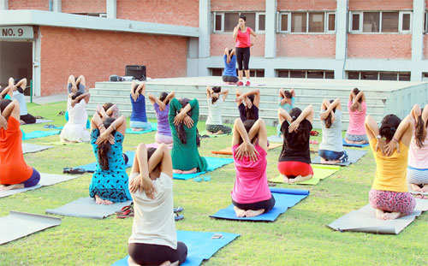

**7 Yoga means total lifestyle change**  
  
Yoga definitely demands a change in one's lifestyle. However, Yoga does require one to change one's lifestyle completely . There should be moderation in whatever one does. It does not mean that one should become completely vegan and sacrifice all material belongings. A predominantly vegetarian diet is advisable with

ORIGIN AND HISTORY AND DEVELOPMENT OF YOGA

HI Early yogis were ascetics, challenging nature under the snow covered Himalayas all year round. To live a long and healthy life, we must face the relationship between "disease", "death", "body", "soul" and the universe. They carefully observe animals to see how they adapt to the natural life, how to breathe, eat, excrete, rest and sleep. And imitate animals to do some postures, which is the origin of yoga asana.

At the same time, they think about ways to make the body, mind and nature harmonious, which is the origin of the idea of yoga meditation.

When yoga practitioners enter the deepest level in meditation, they will wake up the inner sleeping energy, which makes yoga have strong vitality and attraction, and gradually spread among ordinary people in India.

01

Primitive period

In 2500-3000 B.C., Indian practitioners realized yoga practice methods from animals in the primitive forest, mainly in the form of secret transmission, through the evolution of 1000 years, in the form of meditation, meditation and asceticism. At this time, yoga is Tantric Yoga.

In the Indus River civilization period, a group of native people roamed the land in the Indian subcontinent. They were inspired by everything. They held serious rituals and worshiped gods to inquire the truth of life, worship sexual power, special function and longevity are the characteristics of Tantric Yoga.

02

Vedic period: the initial concept of Yoga emerged

From the 15th century B.C. to the 8th century B.C., the invasion of the nomadic Aryans intensified the decline of the indian indigenous civilization and brought about the Brahman culture. The concept of yoga was first put forward in its religious classic Veda, which defined yoga as "restraint" or "commandment".

In its last classic, yoga was used as a method of self-discipline and some content of breath control, which was produced by priests who believed in God for better chanting.

The goal of Vedic yoga practice began to achieve self liberation based on physical practice, and then it was transferred to the religious philosophy of realizing the unity of Brahma and self.

03

Pre classical period: becoming a way of practice

From the 8th century B.C. to the 5th century B.C., in the religious scripture the Upanishads, there is a way to get rid of pain. There are two kinds of yoga schools prevailing here, namely: karma and wisdom yoga.

Yoga believes that behavior is the first manifestation of life, such as food and clothing, daily life, speech, behavior and so on. Yogi advocates focusing on the inner world and guiding more perfect behaviors through inner spiritual activities. Yogis usually take extreme restraint of asceticism, do good deeds, worship God and self-discipline, persevere in asceticism, pure heart and few desires. They think that man's best friend and worst enemy are himself, which is determined by his own behavior. Only with complete dedication and Sakai, can one's spirit, sentiment and behavior reach the ultimate state of oneness with Brahman.

Wisdom Yoga advocates the cultivation of knowledge concept, the liberation from ignorance, the attainment of divine knowledge, and the integration of expectation and Brahma. According to wisdom yoga, knowledge is different from low and high. What ordinary people call knowledge is limited to the external expression of life and matter. This kind of low knowledge can be obtained directly or indirectly. However, the knowledge that wisdom Yoga seeks requires yogis to experience and understand Brahma, the God of creation, through the essence of all external things. By reading the ancient and regarded as apocalyptic classics, we can understand the true meaning of the book and get the holy essence

04

Classic period: the emergence of important Yoga classics

From the 5th century B.C. to the 2nd century A.D., two classic works, Bhagavad Gita and Yoga Sutra.

The Bhagavad Gita originated from the upanishadi, which mainly talks about various ways of communication with divinity, including Wang yoga, love yoga, karma yoga and wisdom yoga.

The Yoga Sutra talks about the state of balance of body, mind and spirit through spiritual purification. It defines yoga as a kind of practice way of controlling mind and mind.

It refers to the eight branches of yoga practice, namely: making precepts, observing, asana, regulating breath, making sense, holding, meditation and Samadhi.

These eight contents are:

1. Discipline: it refers to the discipline that must be abided by, including non violence, no lying, no stealing, no lust and no greed.

(2) compliance: refers to the moral standards to be observed, including purity, contentment, asceticism, self-study and respect for God.

(3) body position: keep natural, slow and deep breathing in a stable, natural and safe posture, and at the same time, the consciousness is constantly aware of the combination of body and breathing, and jump out of their own ideological interference to observe and witness the emotional state at this time.

(4) regulating breath: regulating and controlling breath. The Yoga Sutra points out that the three functions of breath should be paid attention to first when regulating breath: the function of inhaling inward, the function of exhaling outward, and the function of not exhaling and not inhaling long to store the air in the chest and abdomen. In addition, four things should be noted:

(1) "place" refers to the area where the breath reaches in the chest and abdomen after inhalation; where the breath reaches in the universe after exhaling.

(2) "hour" refers to the time of breathing. In the process of exhaling, it is required to keep a proper speed, interval and rhythm.

(3) "number" refers to the number of breaths. It is required that the air flow out and in must be slow, light and long. It is forbidden to be short, rough and urgent.

(4) "focus on one situation" refers to the problem of adjusting one's mind. When breathing, one should focus one's mind on a certain point instead of dispersing it.

(5) sense making: it refers to controlling the desire of all kinds of senses to the outside world, keeping inward and introverted, so that the sensory activities are distinct under the awareness of the heart.

(6) dharana: it is to make the heart focus on a part of the body, such as the navel, nose tip, tongue tip, etc.; it can also focus on an object outside, such as the moon, gods, etc.

(7) meditation: also known as meditation, it is to unify the mind that focuses on one place with the object that focuses on, and integrate the subjective and objective. It means that consciousness can concentrate for a long time, and will not be disturbed by external things. At this time, the understanding and cognition of things will gradually deepen from the surface to the essence.

(8) samadhi: it means that the mind and its object of focus are really integrated into one. Samadhi can be divided into two categories: "samadhi with thoughts" and "samadhi without thoughts". The former refers to the state of thinking after reaching Samadhi. The latter refers to that all changes and functions of the heart have been eliminated and reached the state of integration with the object of concentration, that is, the highest state of yoga.

05

Post classical period: a period of vigorous development of modern yoga

From the 2nd century A.D. to the 19th century A.D., Tantra, who had a profound influence on modern yoga, believed that the ultimate freedom could only be obtained through strict asceticism and meditation. They believed that everything had relativity and Duality (good and evil, heat and cold, yin and Yang). The only way to get rid of the pain was to release what was in the body Some relativity and duality are connected and fused.

Although Patanjali stressed the need to exercise and purify the body, he also believed that the body was unclean. A truly enlightened yogi would try to get rid of the company of the crowd to avoid pollution.

But (tandoro) Yoga school appreciates human body, believes that Shiva exists in human body, and believes that the origin of all natural things is sexual force, which is located under the spine bone. The world is not an illusion, but the proof of divinity. People can get closer to divinity through the experience of the world. They prefer symbolic ways to combine the energy of men and women. They rely on hard yoga positions to awaken the female power in the body, extract it from the body, and then combine it with the male power at the top of the head. They respect women more than any yogi.

PRINCIPLES OF YOGA

The basis of Yoga are the Yoga Sutras of [Patanjali](https://en.wikipedia.org/wiki/Patanjali). In it, Patanjali recommends a two-step way. The first stage is the development of positive ethic qualities (the ten yoga principles). Without positive qualities in meditation inner peace will break through the chaos of the outside world again and again. The second stage of the yogic path is to practice meditation. One can say, that Yoga in the essence is based on positive thinking and meditation.

1. **Non-violence (ahimsa)**

No killing other beings. Be meek. Be peaceful.

1. **Truthfulness (satya)**

Live in the truth. Basically, be honest with yourself and others. Also no little lies of convenience. A lie is permissible only in well justified situations, for example, if you save with a lie the life of another human being. A Yogi is silent in doubt. Those who consistently lives in the truth radiate truth. Their fellow men trust them.

1. **Righteousness (asteya)**

Not stealing, not cheating. A Yogi is in professional life generally honest. He does not seek unwarranted advantage, but he is looking for fair trade.

1. **Wisdom (brahmacharia)**

Live in the spiritual focus (in the light/in God = Brahman). Do not serve the money (outer luck) but the inner happiness (God, Brahman, enlightenment). Be centered in your inner happiness and peace.

1. **Simplicity (aparigraha)**

Be moderate in external enjoyment and consumption. A spiritual person lives modestly outwardly and inwardly rich. A Yogi uses his energy not in outer actions, but lives so peaceful that it turns inward and cleanse his body from the inside. One day, he lives permanently in the light.

1. **Worship of the spiritual goal (ishvara-pranidhana)**

Thus we do not lose our spiritual path, it is necessary that we remind ourselves again and again to our spiritual goal. We can worship an image (Goddess, Shiva, Patanjali), we can bow before a statue (Buddha, Jesus, Shiva) or speak a mantra (prayer).

1. **Sacrifice the ego (shaucha)**

Purification / cleaning. The way into the light passes through the crucifixion of the ego. Without a crucifixion there is no enlightenment. True sacrifice is an art. He who sacrifices too much braced themselves internally. Who sacrifices too little, does not solves his tentions.

1. **Self-discipline (tapas)**

A clear goal, a clear life plan and a clear way of practicing. Tapas means to lead a disciplined life.

1. **Reading (svadhyaya)**

The daily reading (mantra, meditation) keeps us on the spiritual path, cleanses our spirit, connects us with the enlightened masters and makes us to spiritual victors.

1. **Contentment (santosha)**

Satisfied with what one has.

INTRODUCTION TO MAJOR SCHOOLS OF YOGA

Yoga is a diverse and ancient practice that has evolved over thousands of years, resulting in various schools or styles, each with its unique emphasis, techniques, and philosophies. Understanding these major schools of yoga provides insight into the rich tapestry of yoga practices. As someone interested in yoga and its teachings, this knowledge can enhance your understanding and practice. Here’s an introduction to some major schools of yoga:

Table of Contents



* [1. Hatha Yoga:](https://www.askyogaexpert.org/blog/introduction-to-major-schools-of-yoga/#1_Hatha_Yoga)
* [2. Ashtanga Yoga:](https://www.askyogaexpert.org/blog/introduction-to-major-schools-of-yoga/#2_Ashtanga_Yoga)
* [3. Vinyasa Yoga:](https://www.askyogaexpert.org/blog/introduction-to-major-schools-of-yoga/#3_Vinyasa_Yoga)
* [4. Kundalini Yoga:](https://www.askyogaexpert.org/blog/introduction-to-major-schools-of-yoga/#4_Kundalini_Yoga)
* [5. Iyengar Yoga:](https://www.askyogaexpert.org/blog/introduction-to-major-schools-of-yoga/#5_Iyengar_Yoga)
* [6. Bikram Yoga:](https://www.askyogaexpert.org/blog/introduction-to-major-schools-of-yoga/#6_Bikram_Yoga)
* [1. Jnana Yoga:](https://www.askyogaexpert.org/blog/introduction-to-major-schools-of-yoga/#1_Jnana_Yoga)
* [2. Bhakti Yoga:](https://www.askyogaexpert.org/blog/introduction-to-major-schools-of-yoga/#2_Bhakti_Yoga)
* [3. Karma Yoga:](https://www.askyogaexpert.org/blog/introduction-to-major-schools-of-yoga/#3_Karma_Yoga)
* [4. Patanjali’s Ashtanga Yoga:](https://www.askyogaexpert.org/blog/introduction-to-major-schools-of-yoga/#4_Patanjalis_Ashtanga_Yoga)

1. **Hatha Yoga:**

* **Overview**: Hatha Yoga is often considered the foundational school from which many other styles have emerged. It emphasizes physical postures (asanas), breathing techniques (pranayama), and relaxation to balance and align the body, mind, and spirit.
* **Focus**: Physical well-being, alignment, breath control, and energy flow within the body.
* **Asanas**: Various poses aimed at enhancing flexibility, strength, and balance.
* **Pranayama**: Techniques for breath regulation and control.
* **Example Poses**: Mountain Pose (Tadasana), Downward-Facing Dog (Adho Mukha Svanasana), and Child’s Pose (Balasana).

. **Ashtanga Yoga:**

* **Overview**: Ashtanga Yoga is a dynamic and physically demanding practice characterized by a specific sequence of poses and synchronized breathwork. It follows a set series of postures, promoting strength, flexibility, and focus.
* **Focus**: Breath synchronization, progressive series of postures, physical discipline, and mental concentration.
* **Eight Limbs**: Derived from Patanjali’s Yoga Sutras, emphasizing moral and ethical guidelines.
* **Example Poses**: Sun Salutations, Warrior Poses, and Lotus Pose.

3. **Vinyasa Yoga:**

* **Overview**: Vinyasa Yoga is a fluid, movement-based practice that synchronizes breath with movement. It is a dynamic and energetic style where postures flow seamlessly from one to another.
* **Focus**: Breath coordination, continuous movement, flexibility, and strength.
* **Breath**: Coordinated with each movement to create a smooth and continuous flow.
* **Example Poses**: Cat-Cow Pose (Marjaryasana-Bitilasana), Chaturanga Dandasana, and Upward-Facing Dog (Urdhva Mukha Svanasana).

4. **Kundalini Yoga:**

* **Overview**: Kundalini Yoga focuses on awakening the dormant spiritual energy (kundalini) within the body through a combination of physical postures, breathing, chanting, and meditation.
* **Focus**: Energy awakening, spiritual growth, and balancing the chakras.
* **Breath**: Utilized to move the energy within the body and activate higher consciousness.
* **Example Practices**: Breath of Fire, Sat Kriya, and Surya Kriya.

5. **Iyengar Yoga:**

* **Overview**: Iyengar Yoga is characterized by attention to detail, precise alignment, and the use of props like blocks, belts, and blankets. It focuses on correct anatomical alignment and therapeutic benefits of each pose.
* **Focus**: Alignment, precision, and therapeutic applications of asanas.
* **Props**: Utilized to assist practitioners in achieving proper alignment and posture.
* **Example Poses**: Tadasana (Mountain Pose), Utthita Trikonasana (Extended Triangle Pose), and Sarvangasana (Shoulder Stand).

6. **Bikram Yoga:**

* **Overview**: Bikram Yoga consists of a sequence of 26 postures and two breathing exercises practiced in a heated room. The heat and humidity are intended to enhance flexibility and detoxification.
* **Focus**: Detoxification, increased flexibility, and strength.
* **Heat**: Typically practiced in a room heated to around 105°F (40.6°C) with 40% humidity.
* **Example Poses**: Standing Bow Pose (Dandayamana-Dhanurasana), Tree Pose (Tadasana), and Cobra Pose (Bhujangasana).

Each of these schools offers unique approaches to yoga practice, allowing individuals to choose a style that resonates with their goals, preferences, and physical condition. Exploring these schools can deepen your understanding of yoga and help you find the style that best suits your needs and aspirations.

Additionally, Jnana Yoga, Bhakti Yoga, Karma Yoga, and Patanjali’s Ashtanga Yoga are four fundamental paths or schools of yoga, each with its distinct focus and approach toward spiritual growth and self-realization. Understanding these paths can enrich your perspective on yoga philosophy and guide your practice. Let’s delve into each in detail:

1. **Jnana Yoga:**

* **Overview**: Jnana Yoga, the path of knowledge or wisdom, is about understanding the true nature of reality through self-inquiry and contemplation. It involves intellectual exploration and discernment to realize the unity of the individual soul (Atman) with the universal consciousness (Brahman).
* **Focus**: Self-realization, understanding the non-dual nature of reality, and knowledge of the Self.
* **Practices**: Study of scriptures, philosophical contemplation, self-reflection, and inquiry into the nature of existence.
* .

2. **Bhakti Yoga:**

* **Overview**: Bhakti Yoga, the path of devotion, emphasizes love, devotion, and surrender to a higher power or deity. Practitioners cultivate a deep, heartfelt connection with the divine through rituals, prayers, chanting, and expressing love and devotion.
* **Focus**: Devotion, love, surrender, and emotional connection with the divine.
* **Practices**: Prayer, singing bhajans (devotional songs), attending religious ceremonies, and expressing love and gratitude.

3. **Karma Yoga:**

* **Overview**: Karma Yoga, the path of selfless action, advocates performing one’s duties and actions without attachment to the outcomes. It emphasizes acting in service to humanity and the world, acknowledging that selfless actions contribute to spiritual growth and purification of the mind.
* **Focus**: Selfless service, detachment from outcomes, and purifying the mind through actions.
* **Practices**: Engaging in acts of kindness, service, and altruism without expectations, and dedicating the results to a higher purpose.

4. **Patanjali’s Ashtanga Yoga:**

* **Overview**: Ashtanga Yoga, as outlined by the sage Patanjali in the “Yoga Sutras,” is the eight-limbed path aimed at attaining self-realization and union with the divine. It encompasses ethical principles, physical postures, breath control, concentration, and meditation.
* **Eight Limbs**:
  + **Yamas**: Ethical guidelines (e.g., non-violence, truthfulness).
  + **Niyamas**: Self-discipline and spiritual observances (e.g., cleanliness, contentment).
  + **Asanas**: Physical postures to cultivate a steady and comfortable seat for meditation.
  + **Pranayama**: Breath control techniques for harnessing life force and preparing the mind for meditation.
  + **Pratyahara**: Withdrawal of the senses from external distractions.
  + **Dharana**: Concentration, focusing the mind on a single point.
  + **Dhyana**: Meditation, a continuous flow of concentration toward the chosen object.
  + **Samadhi**: State of profound absorption, realizing the oneness of self and the universe.

RAJA YOGA

In Sanskrit, the word raja translates as king, chief, or royal. Thus, raja yoga is considered to be the best path to attaining the highest state of yoga—samadhi or enlightenment. It refers to both the highest goal of yoga and the meditation practices used to attain this goal. [Swami Vivekananda](https://www.ramakrishnavivekananda.info/vivekananda/volume_1/raja-yoga/raja-yoga_contents.htm) describes this internal meditative practice as a path towards mastering the whole universe. He writes, “Raja-Yoga proposes to start from the internal world, to study internal nature, and through that, control the whole—both internal and external.”

Raja yoga is also considered the king of yogas as it is one of the most difficult and challenging spiritual paths. This path of meditation and mind control is best suited for people who are well versed in yoga philosophy and lead contemplative and yogic lifestyles. One of the other four classical schools of yoga ([jnana](https://www.yogabasics.com/learn/jnana-yoga-the-yoga-of-wisdom/), [bhakti](https://www.yogabasics.com/learn/bhakti-yoga-the-yoga-of-devotion/), and [karma](https://www.yogabasics.com/learn/karma-yoga/)) may offer a student an easier path to moksha (spiritual liberation), self realization and inner peace.

The Benefits of Raja Yoga

When we practice the Yamas and Niyamas on a daily basis, our character becomes purified, our virtues increase, and our spiritual growth accelerates. The regular practice of [yoga poses](https://www.yogabasics.com/practice/yoga-postures/) and breathing improves our physical health, increases our mental clarity, boosts our life force energy, and stabilizes and calms our emotions. When we practice the Dharana and Dhyana on a daily basis, our concentration increases, our memory improves, excessive thinking diminishes, and our wisdom expands.

Through a dedicated practice of raja yoga, one develops detachment towards worldly objects, our thoughts, and the results of our actions. This develops an understanding of our true nature and leads to the cultivation of inner peace and tranquility.

How to Practice Raja Yoga

Once a comfortable seated position and a slow deep breath are obtained, then one begins practicing the internal limbs: [Pratyahara](https://www.yogabasics.com/learn/creating-inner-focus-with-pratyahara/), [Dharana](https://www.yogabasics.com/connect/yoga-blog/from-dharana-into-dhyana/), Dhyana, and Samadhi. Pratyahara is the drawing of the mind’s focus away from the external senses to the inner sensations of the body. When the mind draws inwards, then the next limb, Dharana, is used to concentrate the mind on a single object, usually the breath. This is where the practice becomes challenging, keeping the mind focused, and releasing attachment to thoughts. When one obtains the ability to concentrate the mind on a single object to the point of being completely absorbed in it, then one has moved into the next limb of Dhyana, true meditation. When the mind is absorbed in Dhyana, the thoughts cease and the mind stills. The sustained practice of Dhyana leads to the last limb, Samadhi. Enlightenment, ecstasy, and bliss are all words used to describe this last limb where one sees pure awareness reflected on the still surface of the mind. Here object, subject and perceiving all melt into a feeling of oneness.

GITA YOGA

The Bhagavad Gita extols three major *margas* or paths of Yoga which help the aspirant frame his personal nature with the highest goal, realization and union with Brahman,

Although each path is different, the destination is ultimately the same. One path is not higher than the other; rather the or the all-knowing and pervasive consciousness that governs the universe.lessons of each contain its own unique wisdom that provides an integrated and balanced view of one’s relationship to oneself and the higher reality.

These three paths are:

**1. Karma Yoga: *the path of Selfless Action*  
1. Bhakti Yoga: *the path of Devotion*  
2. Jnana Yoga: *the path of Self Transcending Knowledge***

JNANA YOGA

*Swami Vivekananda and his master*

*uddhared atmanatmanam*  
*natmanam avasadayet*  
*atmaiva hy atmano bandhur*  
*atmaiva ripur atmanah*

*A man must elevate himself by his own mind, not degrade himself. The mind is the friend of the conditioned soul, and his enemy as well.*

*jnana-vijnana-trptatma*  
*kuta-stho vijitendriyah*  
*yukta ity ucyate yogi*  
*sama-lostrasma-kancanah*

Jnana Yoga is a process of learning to discriminate between what is real and what is not, what is eternal and what is not. Through a steady advancement in realization of the distinction between Real and the Unreal, the Eternal and the Temporal, one develops into a *Jnani*. This is essentially a path of knowledge and discrimination in regards to the difference between the immortal soul (atman) and the body.

Jnana Yoga is the process of converting intellectual knowledge into practical wisdom. Jnana literally means ‘knowledge’, but in the context of yoga it means the process of meditative awareness which leads to illuminative wisdom. It is not a method by which we try to find rational answers to eternal questions, rather it is a part of meditation leading to self-enquiry and self-realisation. Before practicing Jnana Yoga, the aspirant needs to have integrated the lessons of the other yogic paths – for without selflessness and love of God, strength of body and mind, the search for self-realization can become mere idle speculation.

Taking the philosophy of Vedanta the Jnana Yogi uses his mind to inquire into its own nature. We perceive the space inside and outside a glass as different, just as we see ourselves as separate from God. Jnana Yoga leads the devotee to experience his unity with God directly by breaking the glass, dissolving the veils of ignorance (*maya*).

*Brahma Satyam. Jagat Mithya. Jivo Brahmaiva Na Parah*

*– Sri Shankaracharya*

BHAKTI YOGA

BHAKTI YOGA

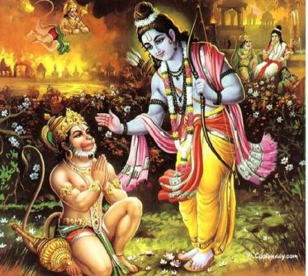The Greatest Bhakta Hanumanji

*sri-bhagavan uvaca*  
*mayy avesya mano ye mam*  
*nitya-yukta upasate*  
*sraddhaya parayopetas*  
*te me yuktatama matah*

*The Blessed Lord said: He whose mind is fixed on My personal form, always engaged in worshiping Me with great and transcendental faith, is considered by Me to be most perfect.*

*ye tu dharmamrtam idam*  
*yathoktam paryupasate*  
*sraddadhana mat-parama*  
*bhaktas te ‘tiva me priyah*

*He who follows this imperishable path of devotional service and who completely engages himself with faith, making Me the supreme goal, is very, very dear to Me.*

Bhakti yoga is based on the doctrine “Love is God and God is Love”. The Deity is the beloved and the devotee is the lover. In Bhakti yoga, everything is but a manifestation of the divine and all else is meaningless, including the Ego. When the Bhakta is blessed by divine grace he feels an undivided union and non-dual consciousness prevails. Bhakti Yoga is regarded as the most direct method to merge in cosmic consciousness.

This path appeals particularly to those of an emotional nature. Through prayer, worship, chanting and ritual one surrenders himself to God or object of faith, channeling and transmuting his emotions into unconditional love and devotion. Continuous meditation of God or object of faith gradually decreases the ego of the practitioner. Suppressed emotions get released and the purification of the inner self takes place. Slowly the practitioner looses the self identity and becomes one with God or the object of faith, this is the state of self-realization.

KARMA YOGA

KARMA YOGA

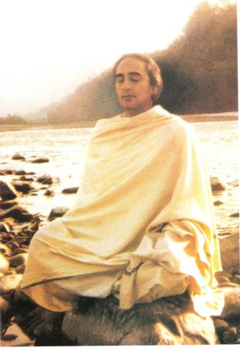*Swami Rama of the Himalayas*,*an exemplary Karma Yogi*

*brahmany adhaya karmani  
sangam tyaktva karoti yah  
lipyate na sa papena  
padma-patram ivambhasa*

*One who performs his duty without attachment, surrendering the results unto the Supreme God, is not affected by sinful action, as the lotus leaf is untouched by water.*

*jneyah sa nitya-sannyasi*  
*yo na dvesti na kanksati*  
*nirdvandvo hi maha-baho*  
*sukham bandhat pramucyate*

*One who neither hates nor desires the fruits of his activities is known to be always renounced. Such a person, liberated from all dualities, easily overcomes material bondage and is completely liberated, O mighty-armed Arjuna.*

Karma Yoga is essentially *Acting, or doing one’s duties in life as per his/her dharma, or duty, without concern of results* – a sort of constant sacrifice of action to the Supreme. It is action done without thought of gain. One cannot live in the world without performing actions, and thus a proper mindset should be established when doing these actions. Karma Yoga purifies the heart by teaching one to act selflessly, without thought of gain or reward. By detaching oneself from the fruits of one’s actions and offering them up to God, one learns to sublimate the ego. This is the difference between simply performing actions for personal gains, and performing actions without attachment (*vairagya*) as a spiritual practice where all fruits are given to God. This is the most arduous of all paths as most of us are attached to the fruits of our actions.

IMPORTANCE OF YOGA FOR HEALTHY LIVING

A car is not just a machine that makes the wheels turn, but it also needs to be in good working order-- so too does our body work. For most people physical fitness can dictate their health and vitality; however mental wellness is equally as important- one cannot live life fully if they are physically fit without happiness on all levels of themselves.

Yoga is one of the many cultural practices that are being revived in modern society. In India, Yoga has existed for centuries and it's been adopted by practitioners all over the world to maintain a healthy lifestyle. For those who have tried yoga before but found themselves unhappy with their day-to-day life style as they aged, there may be an answer: yoga! One study revealed that middle age people live longer because of daily practice which makes this particular demographic more interested than ever before in utilizing these ancient practices such as breathing techniques or meditation exercises on just about any occasion possible - from sitting at home watching TV to office meetings where you can't get up frequently enough without disrupting your work flow.

**CONSCIOUSNESS OF EATING HABITS**

Many of us engage in unhealthy eating habits to avoid feelings like boredom and frustration. However, living a life inspired by yogic principles not only motivates conscious breathing but also creates an opportunity for you to listen more closely your body's needs. By changing up your routine with yoga or meditation, make sure that the food choices you are making are done consciously as well! It will help prevent any overeating tendencies which may be caused from feeling unrested.

**MEDITATION**

Studies show that meditation can help reduce stress levels. If you're looking for something to do during your lunch break, try meditating! You don't need mountains or a river in order to experience the benefits of this practice. All it takes is ten minutes and a quiet space- whether it is at home; work, on public transportation or even just hiding out from friends with him/her in their own room!

**YOGIC REGIMEN**

Yoga is not just a hobby, but rather an integral part of one's life. Practicing yoga regularly can help you feel more connected to your body and mind in ways that are unmatched by any other activity. Yoga postures also provide countless physical benefits such as improved balance, increased flexibility, decreased inflammation and chronic pain from arthritis or injury.

You can do yoga in the morning after you wake up from sleeping. Do not eat anything before you do yoga, and make sure to drink plenty of water so that your body stays healthy and peaceful. If you are not comfortable with anywhere else then find out best yoga center in Mumbai.

YOGA AND ITS RELEVANCE IN THE MODERN TIMES

Yoga is a science of living. It needs to be incorporated in daily life. It works on physical, mental, emotional, social and spiritual levels of human beings. Yoga helps in improving the quality of life. For example, yoga teaches us how to think, behave and grow to become a fully mature person. Yoga brings harmony between body and mind. It is an art and science for healthy living. The word ‘yoga’ is derived from the Sanskrit word ‘yuj’ meaning to join, to yoke, and to unite. It is an ancient system of self-development and natural process of evolution of human beings. Now a days, the word yoga has a strong impact on human life. The ultimate purpose of yoga is the attainment of human growth. Yoga has been established as a new field in education system. It helps in achieving higher state of consciousness on the evolution of an individual’s development. It is the discipline of body and mind. Children face too much stress in their surroundings, such as, school, home, playground, etc. Due to this stress they have many problems such as physical, mental and emotional. When these health hazards create problems for long, they lead to psychosomatic diseases and social unrest. All these problems originate due to imbalance between our physical, mental and spiritual levels. They are closely related to materialistic way of life. Attachment and endless ambitions are the two primary causes of our sufferings. According to the Upanishads, yoga is a higher state of consciousness and a process to ease the mind and manifest the wisdom. Yoga establishes the activities of a healthy state of body, mind and harmonious interpersonal relationships. Due to unhealthy lifestyle, the overall growth of child gets ceased and it leads to ill health. Yoga works on various Fig. 6.1: Yoga mudra Rationalised 2023-24 Yoga and its Relevance in the Modern Times 211 aspects of human body and mind and helps to improve selfawareness, self-control, relaxation, concentration, flexibility and coordination.

TRADITIONS IN YOGA

Today, yoga is a globally recognized system, but what is understood of the purpose, aim, principles and focus of yoga in the classical and traditional sense? From the beginning, the focus of the yogic tradition has actually been on overcoming suffering and imbalance in life, in order to become established in the experience of peace, creativity and harmony. This has been seen in the yogic tradition and teachings throughout the ages.

Yoga can be divided into three distinct periods: an early period, Shiva’s time; a middle period, the time of Patanjali and others; and the present period of yoga’s re-emergence during the last hundred years. The Adiguru or first teacher and exponent of yoga was Shiva. The Pashupat yoga which he expounded focused on the means to overcome or transcend the three types of suffering in life, adhyatmika, adhibautika and adhidaivika. Following Shiva, the early propagators of various forms of yoga were Dattatreya, Vasishtha, Vishwamitra, Matsyendranath and Gorakhnath.

The middle period is the period of Sage Patanjali, Gheranda, Swatmarama and others, who are the reference points for today’s yoga practices. The original yogas from the early period were reclassified and renamed as raja yoga, karma yoga, bhakti yoga, jnana yoga, hatha yoga, kriya yoga, and kundalini yoga by this second group of masters. These rishis and sages also wrote the classical texts and books which are referred to today. Patanjali wrote his Yoga Sutras, a thesis on raja yoga and mind management; Swatmarama developed and propagated the practices of hatha yoga for balancing the lunar and solar forces to promote health and well-being in the text Hatha Yoga Pradipika; Narada and Shandiliya developed the practice and principles of bhakti yoga for emotional management. The Yoga Chudamani Upanishad describes the yogic process related to kundalini and the chakras. The Hamsa Upanishad speaks of ajapa and dharana practice, and the benefits of meditation. A total of twenty-two Yoga Upanishads were written in this period by twenty-two different authors, thinkers and seers. They blended the vedic and upanishadic philosophy and the structures of tantra with the yogic system and philosophy.

The late period is the present age, beginning from the nineteenth century, when yoga re-emerged. One of the first to integrate and talk about the tradition in a language that society could understand was Swami Vivekananda. Another tradition that emerged was associated with a remote Himalayan yogi called Babaji, whose followers included Sri Yukteshwar, Lahiri Mahashaya and Paramahamsa Yogananda. Their contemporaries included Ramana Maharshi and Anandamayi Ma, who followed the paths of jnana yoga and bhakti yoga respectively. Around the 1920s and 1930s, a hatha yoga tradition evolved from Mysore in the South of India, as revived by Krishnamacharya and carried forward by Desikachar and Iyengar.

At the same time, in the late 1920s, Swami Sivananda went to Rishikesh and started to explore other forms of classical yogas and to develop a system of yoga to integrate the faculties of head, heart and hands and awaken the self. In the course of time he established the Divine Life Society which taught integral yoga, and in the 1950s and 60s those he had trained started traveling out of the country, into the world, to disseminate yoga. His disciples founded yoga centers and schools from Sri Lanka to Canada, Germany, New Zealand, Australia, Mauritius, South Africa and the United States. Among them was Swami Satyananda, whose mandate was to spread yoga “from door to door and shore to shore.” In 1963, after traveling for nine years to assess the needs of society, he established the Bihar School of Yoga. Here he began to teach yoga as a system to discover the creative self and enhance the beauty and harmony of life.

PRECAUTIONS PROCEDURE AND BENEFITS OF YOGIC SUKSHMA VYAYAMMA.

Precautions: Avoid knee bending while practicing this vyayama. Keep spine and neck straight while practicing this vyayama as it will increase cervical and back pain if bent. Benefits: This vyayama stretches the legs making them flexible.

Your back, neck and head should be straight. While doing joints movements, if you feel tired, you must relax for few seconds. Relaxation in the sitting posture: Make little gap between your legs. Lie down your feet, bend your back little backward and tilt your neck in any one direction.

**Sukshma Vyayam** is nothing but minor exercise from toes to head. Below I have pasted the whole series of joint movements. Hope that will help.  
  
**Minor exercise from head to toe – Initial Stage**  
  
Before starting asana, you should practice joints movements to make your body flexible and fit for asana.  
The joint movements are classified as:  
• Leg joints movements  
• Hand joints movements  
• Neck and Head movements  
  
**Position/Posture**  
While doing all the joints movements you should sit straight having the angle of 90 degree between your legs and upper portion of your body. Keep hands on either sides of your back. Join your legs. Your back, neck and head should be straight.  
  
**Relaxation**  
While doing joints movements, if you feel tired, you must relax for few seconds.  
Relaxation in the sitting posture: Make little gap between your legs. Lie down your feet, bend your back little backward and tilt your neck in any one direction. Feel relaxed and do normal abdominal breathing.  
  
**Leg joints movements**  
1. Move your toes up and down for 10 times.  
  
2. Move your feet up and down for 10 times.  
  
3. Rotate your feet in both clockwise and anticlockwise direction for 5 times. With the practice, you can gradually increase rotations till 10 times.  
  
4. Keep left leg over your right knee such that your left foot should remain completely out. Rotate your left foot in both clockwise and anticlockwise direction for 5 times. While rotation, you can hold left toes with your right hand and put left hand on the left ankle. Now lift your left leg till it reaches your right thy. Put left hand on the left knee and move it up and down for 10 times. After moving it up and down, in the same position rotate your left leg in both clockwise and anticlockwise direction for 5 times. Again lift your left leg and try to touch heel to your navel. Repeat all these steps with your right leg as well.  
  
5. Bend your left leg vertically. Cross your fingers and put them on your left leg. Press your chest with your left leg and then stretch it (left leg). Do this for 10 times. Leave your left leg in middle and put crossed fingers below the knee over your left thy. Now rotate your left leg in both clockwise and anticlockwise direction for 5 times. After doing this touch left ankle to your forehead (don’t bend your neck while doing this). Repeat all these steps with your right leg.  
  
6. Join your legs. Contract and relax your knees for 20 times.  
  
7. Butterfly flapping – Join the bottoms of your feet, cross your fingers and put them below the feet. Bring your feet closer to you as far as possible and flip your legs up and down for 10 times. Initially you may feel pain in your thigh muscles.  
  
8. Take your legs apart from each other as far as possible. Lift your hands on either side. Turn to your left and try to touch the left toes with your right hand. See towards left. Similarly turn to your right and try to touch the right toes with your left hand. See towards right. Do it for 10 times.  
  
**Hand Joints Movements**  
1. Make fists. While making fist thumb should go inside. Open and close your fists for 10 times. Stretch the fingers when you open the fist.  
  
2. Lift your hands up parallel to your legs. Move your palms up and down for 10 times. While bringing your palms up, feel that you are pushing some heavy object.  
  
3. Rotate fists in both clockwise and anticlockwise direction for 5 times. If you feel pain in your hands, bring them down. Press and rub them till you feel comfortable.  
  
4. Stretch your hands on either sides and then bend them to touch the shoulders. Again stretch your hands and touch your shoulders. Do it for 10 times.  
  
5. Bend your hands horizontally and bring both the palms pointing towards each other. Now move your hands to the back side as far as possible. In this case your chest will expand. Do it for 10 times. This exercise is good for releasing neck and upper back pain.  
  
6. Stretch your hands to front side and invert your palms. Slowly-slowly move your hands inward and outward for 10 times.  
  
7. Turn the fingers of both the hands and lock them. Take this loop to the back of your neck and stretch it in the left and right directions for 5 times.  
  
8. Rotate your shoulders in both clockwise and anticlockwise direction for 5 times. For this put your palms on respective shoulders and bring them up (elbows will touch while doing this) then back and then to the front side.  
  
9. Join both the palms as if you are doing ‘Namaskara’. All the fingers should be over each other. Now clap them for 10 times.  
  
**Neck and Head movements**  
  
**Neck**  
1. Cross your fingers. Put them on the back of your neck and push the neck in forward direction. Do it for 5 times.  
  
2. Sit straight. Slowly-slowly move your neck down. Now Slowly-slowly lift your neck up. Do it for 5 times. Similarly Slowly-slowly move your neck to left side and then to the right side for 5 times. Also do side bending that is bend your neck to left side(left ear will touch the left shoulder) and then to the right side(right ear will touch the right shoulder). Do it for 5 times.  
  
3. Rotate your neck in both clockwise and anticlockwise direction for 5 times. While doing this, it is preferred to close your eyes to avoid giddiness.  
  
**Head**  
Put one hand on your forehead and other on its back. Push them inward for 5 times.  
  
**Eyes**  
1. Sit straight. Your back, neck and head should be straight. Look down. While looking down, only move your eyeball, your neck should be straight. Slowly-slowly look up i.e. move your eyeball upward. Similarly move your eyeball to left and right directions. Repeat it for 5 times. After doing this close your eyes for 10 seconds.  
  
2. Rotate your eyeball in both clockwise and anticlockwise direction for 5 times. After doing this close your eyes for 10 seconds.  
  
3. Close your eyes. Put 1st finger (pointer/index) of both the hands on respective eyelids and move them gently in both clockwise and anticlockwise direction for 5 times.  
  
**Ears**  
With the help of your palms, open and close your ears for 10 times.  
  
**Cheeks**  
Widely open your mouth. Stretch your cheeks and then relax. Repeat it for 10 times.  
  
**Teeth**  
Put the upper series of teeth over the lower series and press it. Repeat it for 10 times.

STULA VYAYAMA

The Micro Yoga exercises benefit all the organs and all the parts from head to waist. Similarly the Macro exercises stimulate and benefit all the organs and the parts from abdomen down to toes. They are practiced in the standing position.

Each Macro Yoga exercise, pertaining to different parts of the body has to be repeated 5 to 10 times with full awareness. All exercises that are done on one side, should also be done on the other side.

* [1. Exercises for the abdomen](https://yogasimplified.com/16-sthula-yoga-vyayam-kriyas-macro-yoga#Abdomen)
* [2. Exercises for the waist](https://yogasimplified.com/16-sthula-yoga-vyayam-kriyas-macro-yoga#Waist)
* [3. Exercises for the excretory organs](https://yogasimplified.com/16-sthula-yoga-vyayam-kriyas-macro-yoga#ExcretoryOrgans)

[– Stool excretory organ (Rectum & anus)](https://yogasimplified.com/16-sthula-yoga-vyayam-kriyas-macro-yoga#StoolExcretoryOrgan)  
[– Urinary organ](https://yogasimplified.com/16-sthula-yoga-vyayam-kriyas-macro-yoga#UrinaryOrgan)

* [4. Exercises for thighs, knees and shanks](https://yogasimplified.com/16-sthula-yoga-vyayam-kriyas-macro-yoga#ThighsKneesShanks)
* [5. Exercises for calves, ankles, heels, soles, feet and toes](https://yogasimplified.com/16-sthula-yoga-vyayam-kriyas-macro-yoga#CalvesAnklesHeelsSolesFeetToes)

**1. Exercises for the abdomen:**

**1.a.** Stand straight and hold the waist at the sides with both the hands, thumbs pointing forward and the four fingers backward. Pratice Bhastrika Pranayaam keeping the head in the straight position. The air is exhaled with force sucking the stomach to its maximum. Inhaling the air the stomach is bulged. This act should be repeated in quick successions from half a minute to one minute. After taking a bit of rest the exercise is repeated.

**b.** Standing in the above position, bend the upper part of the waist and chest a little forward. Keep the head straight i.e. it is not bent. Repeat the above exercise.

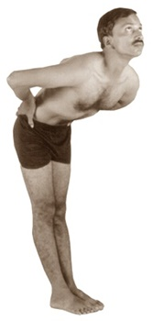

**c.** Standing in the above position bend the entire upper part of the body forward including the chest, looking straight like the shape of number 7 and repeat the exercise.

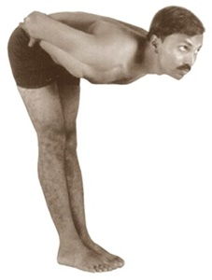

**2.a.** Standing straight breathe out completely. Holding the breath out, move the empty stomach forward and backward without breathing as long as possible. Then straighten slowly breathing in and relax. Repeat 4 – 5 times.

**b.** Standing straight, breathe out completely. Holding the breath out, bend the upper part of the waist a little forward, keeping the head straight and move the stomach as (2.a) above. c. Standing straight, breathe out completely. Holding the breath out bend the upper part of the waist including the chest like the shape of number 7 and move the stomach as above.

**3.** Standing erect, raise the head a little, bring out the tip of the tongue, twisting it round into a cylindrical shape. Suck the air deep through the tongue bulging the stomach full with the air. Bend the head low, keeping the eyes closed. Hold the breath in for some time. Later raising the head breathe out slowly through the nose. Repeat 4 – 5 times. Few may feel giddiness, while practicing this exercise in the beginning. Nothing to worry. They may take the support of either a wall or a door in such a case, or they may perform in sitting position.

**Awareness:**  
The abdomen

**Advantages:**  
Stomach, liver, spleen, pancreas, kidneys, gallbladder and intestines are purified and activated. Unwanted fat is reduced. The stomach problems, indigestion, constipation, acidity and gastric trouble are solved.

**2. Exercises for the waist:**

**a.** Standing erect, hold the waist at the sides with both the hands and bend the body from side to side. Breathe out when the body is bent, breathing in come to central position.

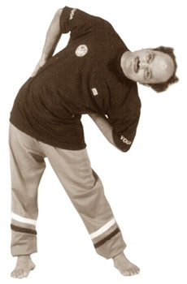

**b.** Hold the waist at the sides with both the hands and twist the upper part of the body from the waist to right side and then to the left side. While twisting, breathe out and while coming to central position breathe in.

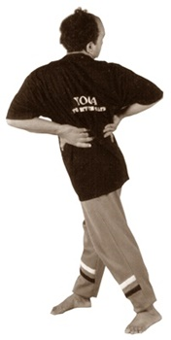

**c.** Holding the waist with both the hands, rotate the stomach, hips and thighs clockwise 8 to 10 times and then in reverse direction for the same number of times.

**Awareness:**  
The waist

**Advantages:**  
This relieves all types of waist and back pains. The unnecessary fat accumulated in the waist is reduced. Waist becomes active, supple and flexible.

**3. Exercises for the excretory organs :**

**1. Stool excretory organ (Rectum & anus):**

**a.** Standing erect, join both the feet and heels. Intensively contract the feet, shanks, knees, thighs and hips pulling the rectum / anus inside. The waist and the other upper parts of the body are let loose freely. Breathing is normal. The anus should be kept in the sucked position for 30 to 60 seconds. Later it should be loosened. This exercise strengthens the outer part of the anus.

**b.** Repeat the above act keeping a three inches parallel distance between the feet. This strengthens the inner part of the anus.

**Awareness:**  
Anus / Rectum

**Advantages:**  
The above exercises prevent and cure piles, fistula, fissure. Constipation is reduced.

**2. Urinary organ:**

Standing erect, keep the legs stretched one foot apart. Intensively contract the feet, legs, shanks, thighs and the hips. Both the anus and urinary organs are sucked in. The upper part from the waist is let loose. Breathing is normal. The body should be in this position at least for 30 to 60 seconds. Later let loose the whole body.

People below 16 years should not attempt this process.

**Awareness:**  
Urinary organ

**Advantages:**  
Apart from the benefits as above, dream discharges and weakness and diseases of urinary organs are cured. If women practice this regularly every day they will be relieved of all the gynec problems like irregular menstruation, leucorrhoea etc.

Note: After the above kriyas, alternate legs should be folded behind to loosen the muscles. Later walk few steps.

**4. Exercises for thighs, knees and shanks:**

While practicing these exercises heels should not be raised.

**a.** Holding the waist from both the sides, bend from the knees – forming a shape of sitting on chair. After 5 to 10 seconds, come to standing position again. Breathing is normal.

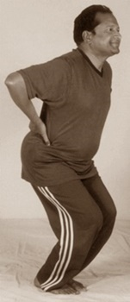

**b.** Holding the waist from both the sides, keep the heels joined and toes apart. Bend from the knees, stretching the knees apart. After 5 to 10 seconds come to standing position again. Breathe out while bending downwards and breathe in as you get up.

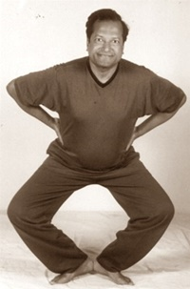

**c.** Holding the waist from both the sides, join the heels. Bending at knees, swing both the knees sidewise.

**d.** Holding the waist, join the toes and heels apart. Bending at knees, swing both the knees sidewise.

**e.** Standing erect, stretch both the hands front, breathing out completely sit on the heels. Breathing in rise to stand.

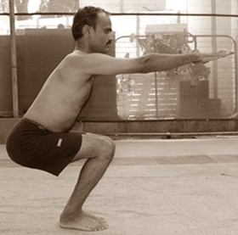

**f.** Stretch both the legs apart. Crossing both the hands hold the left ear by the right hand and the right by the left. Breathing out sit down and breathing in stand up.

**g.** Stretch both the legs apart and also both the hands sidewise. Breathing out sit down and breathing in stand up.

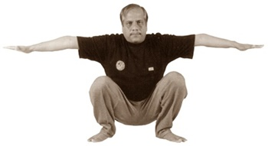

**h.** Stretch both the legs apart, and also both the hands sidewise. Sitting on the heels move the thighs up and down in quick succession.

**i.** Hold both the knees by both the hands in bending position. Rotate the knees and the waist clock wise in a circular form. Later move anti- clockwise also.

**j.** After practicing the above exercises slowly pat and massage the thighs, knees and the knee caps with the palms.

**Awareness:**  
Thighs and knees

**Advantages:**  
Knee pains are prevented and controlled. Thighs and shanks are strengthened and beautified to better shape.

**5. Exercises for calves, ankles, heels, soles, feet and toes:**

**a.** Standing erect, stretch the hands straight with the thumbs folded into the fist. Bend the left hand backwards from the left elbow and the left leg from the left knee. The weight of the entire body is on the right foot. Now change the hands and the legs turn wise. The hands and the legs are stretched front and folded back quickly. When left knee is folded the left hand is bent, similarly when the right knee is folded the right hand is bent. Synchronize the breathing with arms movement with a rhythm i.e. Breathe in when the right arm is stretched front and breathe out when the left hand is stretched front. At the beginning they should be changed slowly, gradually the succession should be increased to the maximum speed. Reaching the peak of the speed, then it should be gradually slowed down to stand still.

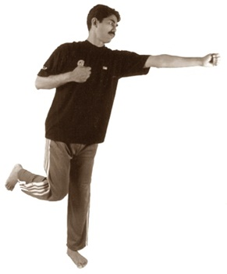

**b.** Standing erect, stretch both the arms front from the elbows. Elbows touch the ribs in the sides. Raise the right knee to touch the stretched right palm where it is patted. Later bring it down. Again raise the left knee up and pat left palm. Knees one after the other are raised and patted in succession. The speed of the changing legs is slowly increased to maximum, then slowed down.

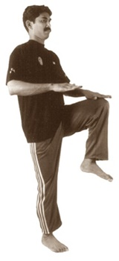

**c.** Standing erect, stretch both the hands up. Raise the right leg crosswise so that it touches the left palm. Then similarly raise the left leg touching the right palm. Repeat this act one after the other slowly.

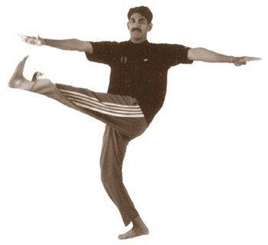

**d.** Standing erect, hold the waist with both the hands. Raise the right knee to left side and immediately jump one step upwards with the left foot. Similarly repeat changing the knee. Repeat this act changing the knee and jumping a step upward in succession.

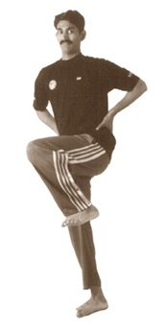

**e.** Standing erect, hold the waist by both the hands. Raise and lower the toes of feet and the heels alternatively. Then the entire body is made to jump on toes. Later while jumping like a spring step front and back and then to right and left with a rhythm.

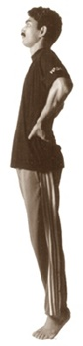

**f.** Keep the hands on both the sides of the waist. Without bending the knees, raise the toes up making the body stand on the heels and then walk on the heels slowly with small steps. After a while, walk on the toes and thereafter on the outer sides of the feet. Also walk on the inner edges of the feet. Breathing is normal.

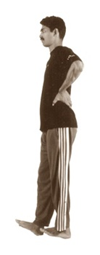

**g.** Contracting the entire body, keep the chest a little bit forward. Place hands firmly at the sides of the thighs. Move forward in such a way that the feet are slowly glided (without lifting) forward one after the other for some distance and again glided backward without turning. Breathing is normal. Heels are not lifted. Eyes are focussed on a point in front, continously.

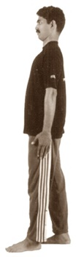

**h.** Standing erect, stretch both the hands side wise and let loose. Swing both the raised heels right and left. The body also moves accordingly. Gradually increase the speed of the movement. Breathing is synchronized with body movement.

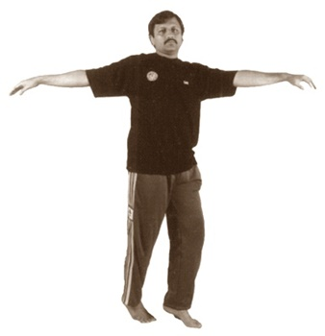

**i.** Raise both the hands joining the palms clapping up. Spreading the feet apart, make the entire body to jump. Breathe in while the body goes up and breathe out when it comes down.

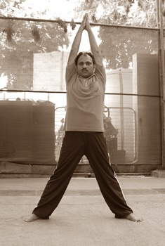

**j.** After performing the above (a to i) exercises, walk few steps leisurely for some times to relax.

**Awareness:**  
From hips down to lower parts of legs upto toes

**Advantages:**  
The calves, ankles, heels, soles, feet and toes are strengthened. People who stand more or walk more get relaxed with this activity. Many people don’t walk in this automobile age. These exercises provide all the benefits of walking, brisk walking, jogging, aerobics and dancing.

 ***After completing the above exercises, the body is bent a little forward, hands and palms are let loose and swung. Swinging the hands, the body is bent a little from the knees and a few steps walked to relax. Later first Nispand-bhavasan and then Shanti asan are postured to have complete rest. Thus the body gets peace and energy.***

***For practicing the above Macro exercises, the body needs some strength. As we start practicing the exercises, the strength automatically is generated in the body. Thus the body is stimulated and becomes active and full of stamina.***  


Yoga: Its Origin, History and Development

Dr. Ishwar V. Basavaraddi (Yoga Scientist and Eminent Yoga Master)

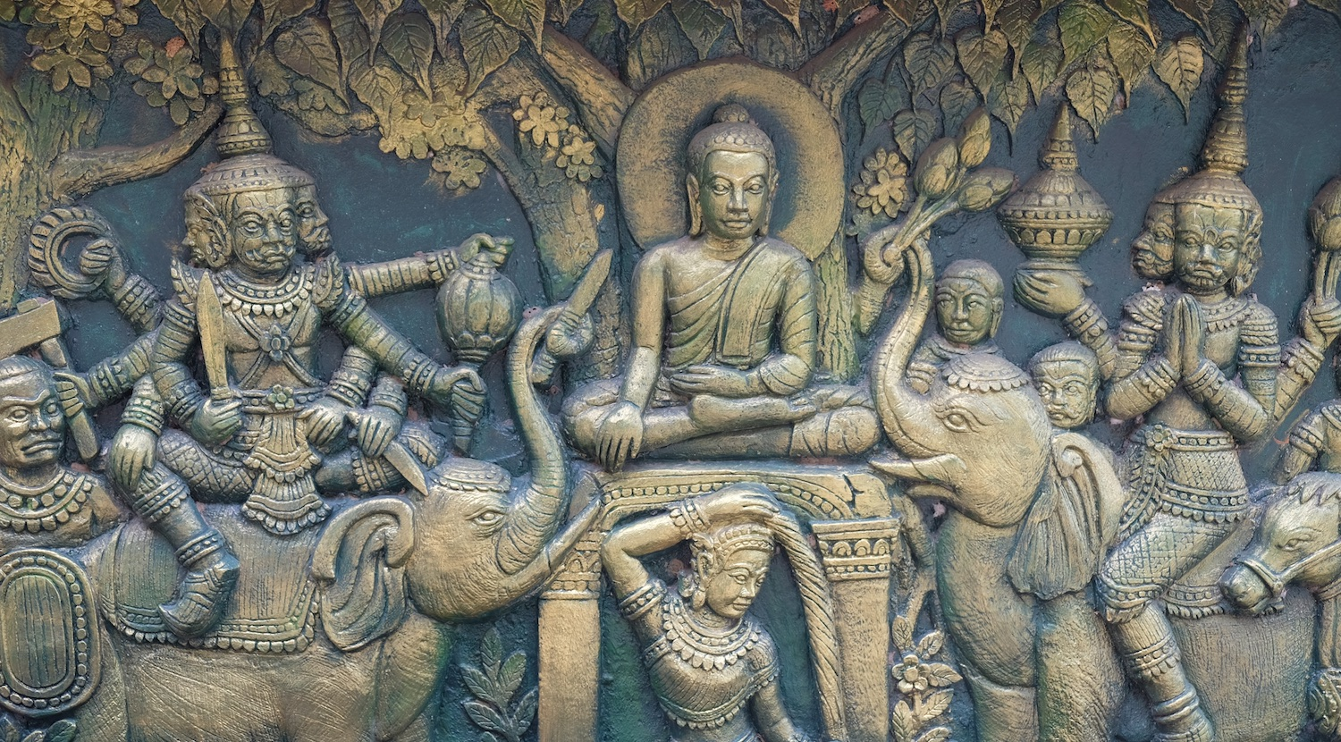

Origin...

Introduction :Yoga is essentially a spiritual discipline based on an extremely subtle science, which focuses on bringing harmony between mind and body. It is an art and scince of healthy living. The word ‘Yoga’ is derived from the Sanskrit root ‘Yuj’, meaning ‘to join’ or ‘to yoke’ or ‘to unite’. As per Yogic scriptures the practice of Yoga leads to the union of individual consciousness with that of the Universal Consciousness, indicating a perfect harmony between the mind and body, Man & Nature. According to modern scientists, everything in the universe is just a manifestation of the same quantum firmament. One who experiences this oneness of existence is said to be in yoga, and is termed as a yogi, having attained to a state of freedom referred to as mukti, nirvana or moksha. Thus the aim of Yoga is Self-realization, to overcome all kinds of sufferings leading to 'the state of liberation' (Moksha) or ‘freedom’ (Kaivalya). Living with freedom in all walks of life, health and harmony shall be the main objectives of Yoga practice."Yoga” also refers to an inner science comprising of a variety of methods through which human beings can realize this union and achieve mastery over their destiny.Yoga, being widely considered as an ‘immortal cultural outcome’ of Indus Saraswati Valley civilization – dating back to 2700 B.C., has proved itself catering to both material and spiritual upliftment of humanity.Basic humane values are the very identity of Yoga Sadhana.

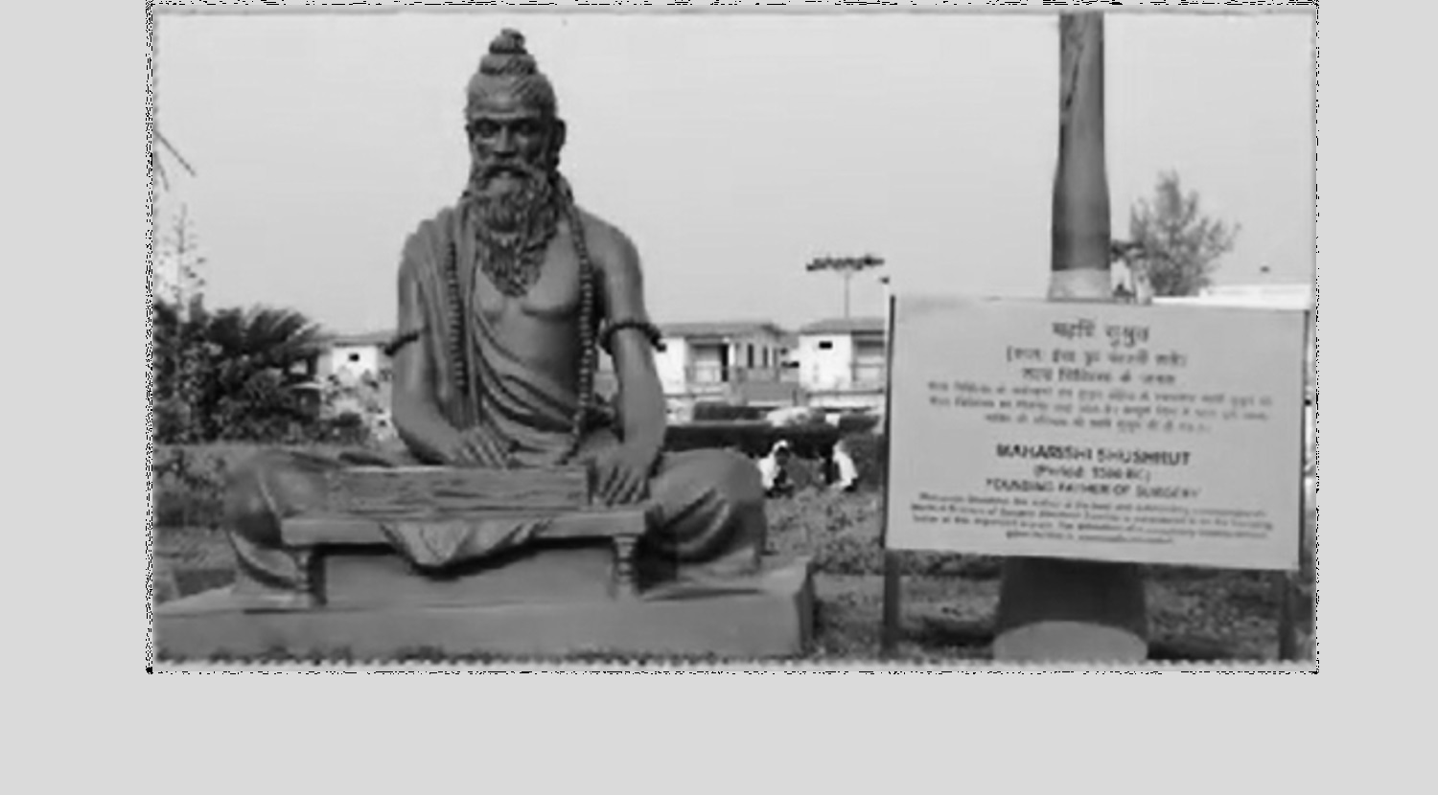

History...

The practice of Yoga is believed to have started with the very dawn of civilization. The science of yoga has its origin thousands of years ago, long before the first religions or belief systems were born. In the yogic lore, Shiva is seen as the first yogi or Adiyogi, and the first Guru or Adi Guru. Several Thousand years ago, on the banks of the lake Kantisarovar in the Himalayas, Adiyogi poured his profound knowledge into the legendary Saptarishis or "seven sages”. The sages carried this powerful yogic science to different parts of the world, including Asia, the Middle East, Northern Africa and South America. Interestingly, modern scholars have noted and marvelled at the close parallels found between ancient cultures across the globe. However, it was in India that the yogic system found its fullest expression. Agastya, the Saptarishi who travelled across the Indian subcontinent, crafted this culture around a core yogic way of life.

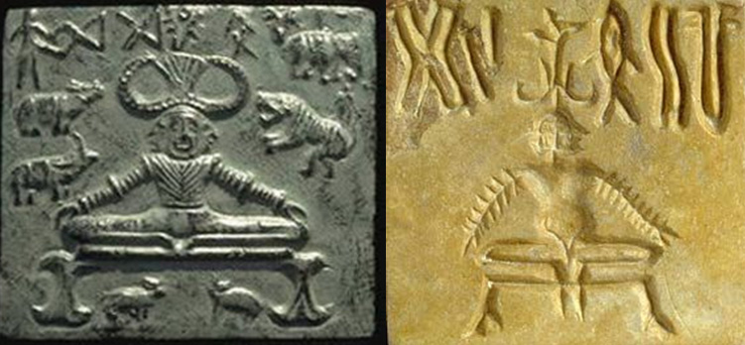

Seals and Fossil

The Number of seals and fossil remains of Indus Saraswati valley civilization with Yogic motives and figures performing Yoga Sadhana suggest the presence of Yoga in ancient India. The phallic symbols, seals of idols of mother Goddess are suggestive of Tantra Yoga. Presence of Yoga is available in folk traditions, Indus valley civilization, Vedic and Upanishadic heritage, Buddhist and Jain traditions, Darshanas, epics of Mahabharat and Ramayana, theistic traditions of Shaivas, Vaishnavas, and Tantric traditions. In addition, there was a primordial or pure Yoga which has been manifested in mystical traditions of South Asia.

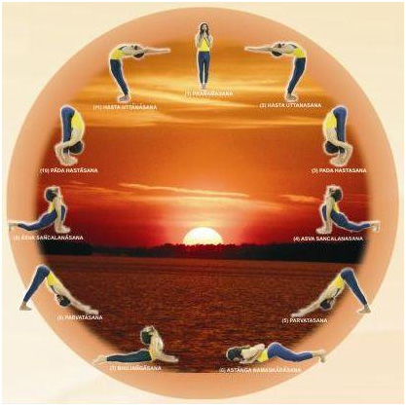

Surya Namaskara

This was the time when Yoga was being practised under the direct guidance of Guru and its spritual value was given special importance. It was a part of Upasana and yoga sadhana was inbuilt in their rituals. Sun was given highest importance during the vedic period. The practice of ‘Surya namaskara’ may have been invented later due to this influence. Pranayama was a part of daily ritual and to offer the oblation. Though Yoga was being practiced in the pre-Vedic period, the great Sage Maharshi Patanjali systematized and codified the then existing practices of Yoga, its meaning and its related knowledge through his Yoga Sutras. After Patanjali, many Sages and Yoga Masters contributed greatly for the preservation and development of the field through their well documented practices and literature.

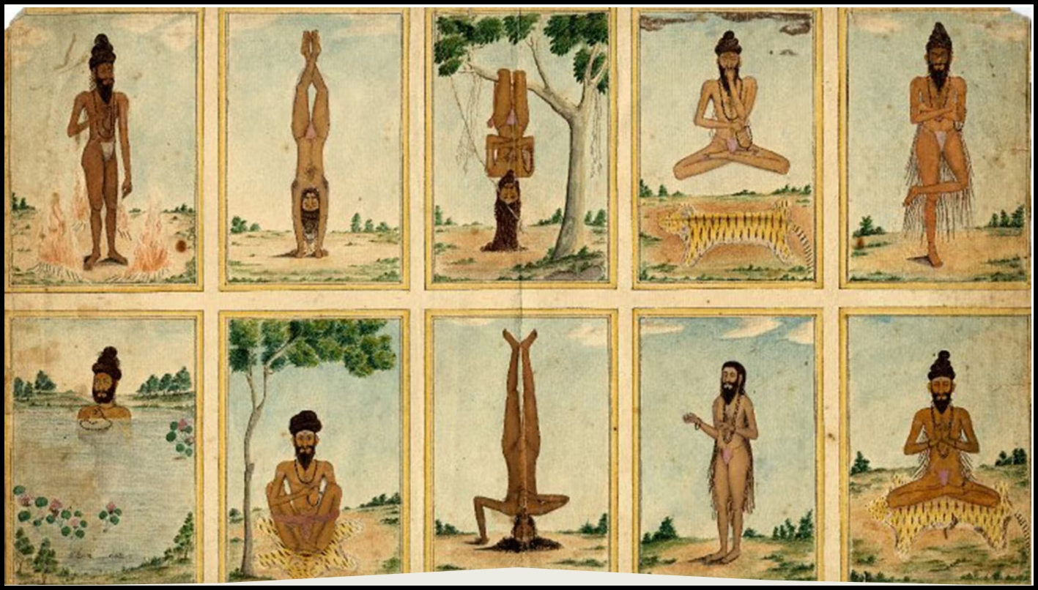

Historical evidences

Historical evidences of the existence of Yoga were seen in the pre-Vedic period (2700 B.C.), and thereafter till Patanjali’s period. The main sources, from which we get the information about Yoga practices and the related literature during this period, are available in Vedas (4), Upanishads(108), Smritis, teachings of Buddhism, Jainism, Panini, Epics (2), Puranas (18) etc..

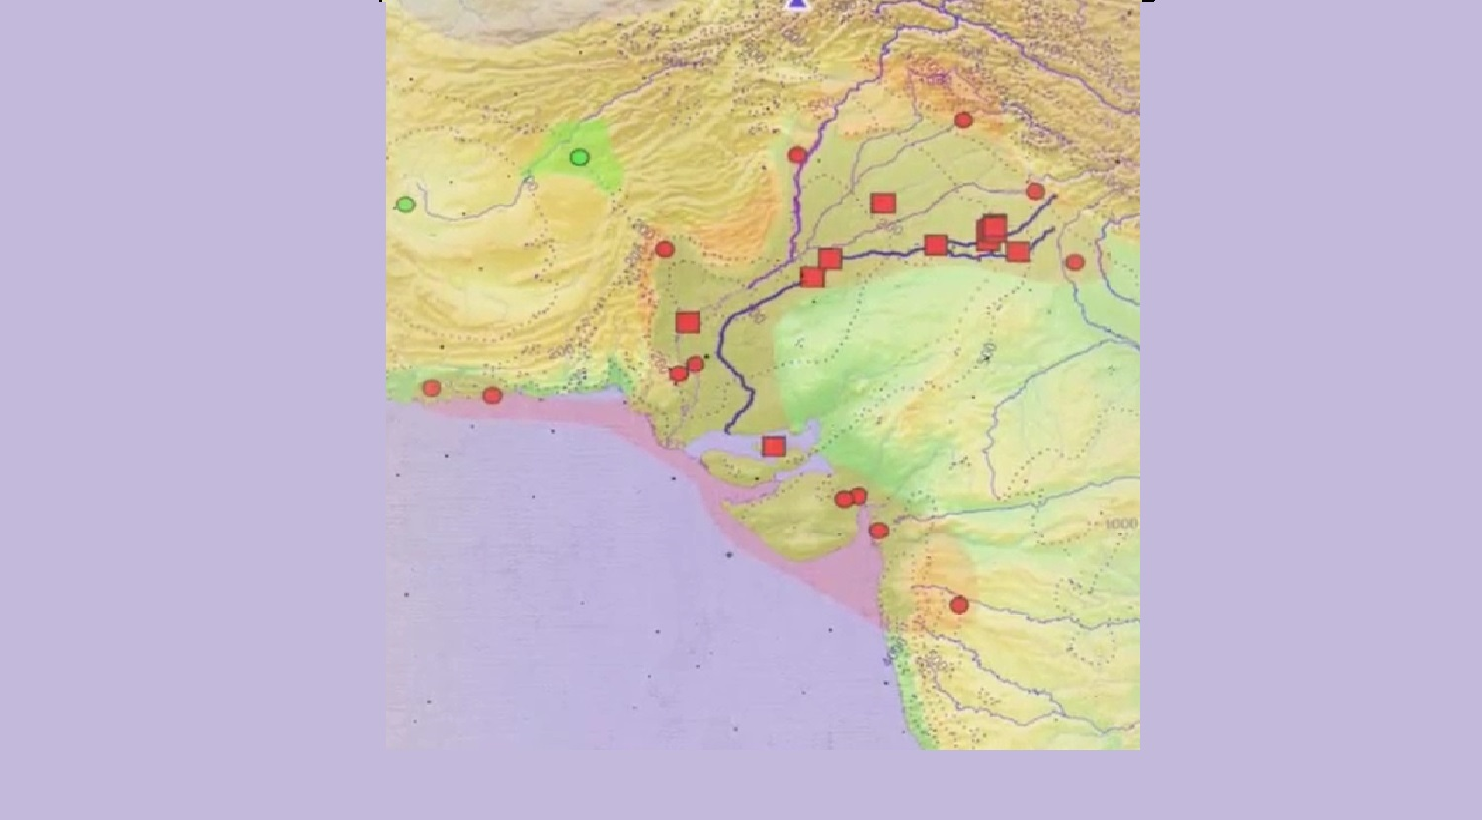

500 BC - 800 A.D.

Tentatively, the period between 500 BC - 800 A.D. is considered as the Classical period which is also considered as the most fertile and prominent period in the history and development of Yoga. During this period, commentaries of Vyasa on Yoga Sutras and Bhagawadgita etc. came into existence.This period can be mainly dedicated to two great religious teachers of India –Mahavir and Buddha. The concept of Five great vows – Pancha mahavrata- by Mahavir and Ashta Magga or eightfold path by Buddha - can be well considered as early nature of Yoga sadhana. We find its more explicit explanation in Bhagawadgita which has elaborately presented the concept of Gyan yoga, Bhakti yoga and Karma Yoga. These three types of yoga are still the highest example of human wisdom and and even to day people find peace by following the methods as shown in Gita. Patanjali’s yoga sutra besides containing various aspects of yoga, is mainly identified with eight fold path of Yoga.

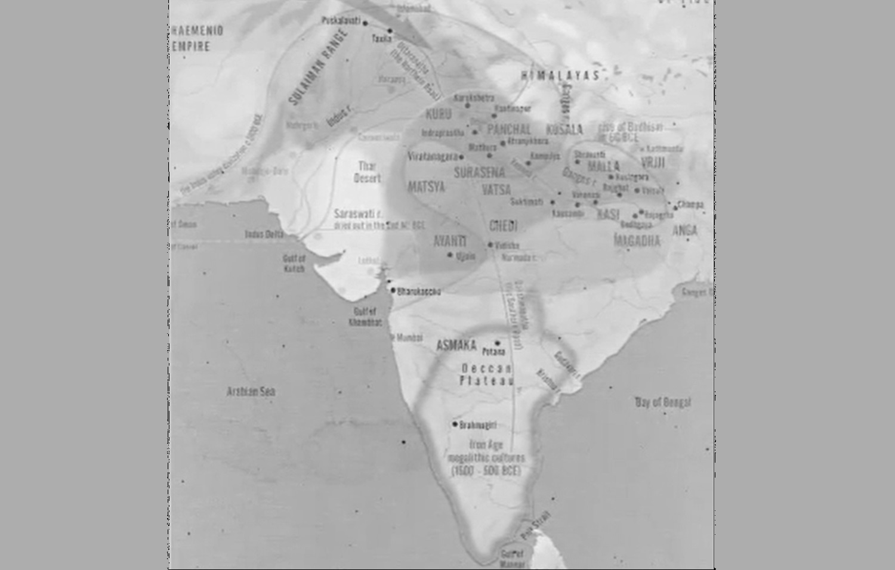

800 A.D. - 1700 A.D.

The very important commentary on Yoga sutra by Vyasa was also written. During this very period the aspect of mind was given importance and it was clearly brought out through Yoga sadhana, Mind and body both can be brought under control to experience equanimity.The period between 800 A.D. - 1700 A.D. has been recognized as the Post Classical period wherein the teachings of great Acharyatrayas-Adi Shankracharya, Ramanujacharya, Madhavacharya-were prominent during this period. The teachings of Suradasa, Tulasidasa, Purandardasa, Mirabai were the great contributors during this period. The Natha Yogis of Hathayoga Tradition like Matsyendaranatha, Gorkshanatha, Cauranginatha, Swatmaram Suri, Gheranda, Shrinivasa Bhatt are some of the great personalities who popularized the Hatha Yoga practices during this period.



1700 - 1900 A.D.

The period between 1700 - 1900 A.D. is considered as Modern period in which the great Yogacharyas- Ramana Maharshi, Ramakrishna Paramhansa, Paramhansa Yogananda, Vivekananda etc. have contributed for the development of Raja Yoga.This was the period when Vedanta, Bhakti yoga, Nathayoga or Hatha-yoga flourished. The Shadanga-yoga of Gorakshashatakam, Chaturanga-yoga of Hathayogapradipika, Saptanga-yoga of Gheranda Samhita, were the main tenents of Hatha-yoga. Now in the contemporary times, everybody has conviction about yoga practices towards the preservation, maintenance and promotion of health. Yoga has spread all over the world by the teachings of great personalities like Swami Shivananda, Shri T.Krishnamacharya, Swami Kuvalayananda, Shri Yogendara, Swami Rama, Sri Aurobindo, Maharshi Mahesh Yogi, Acharya Rajanish, Pattabhijois, BKS. Iyengar, Swami Satyananda Sarasvati and the like.

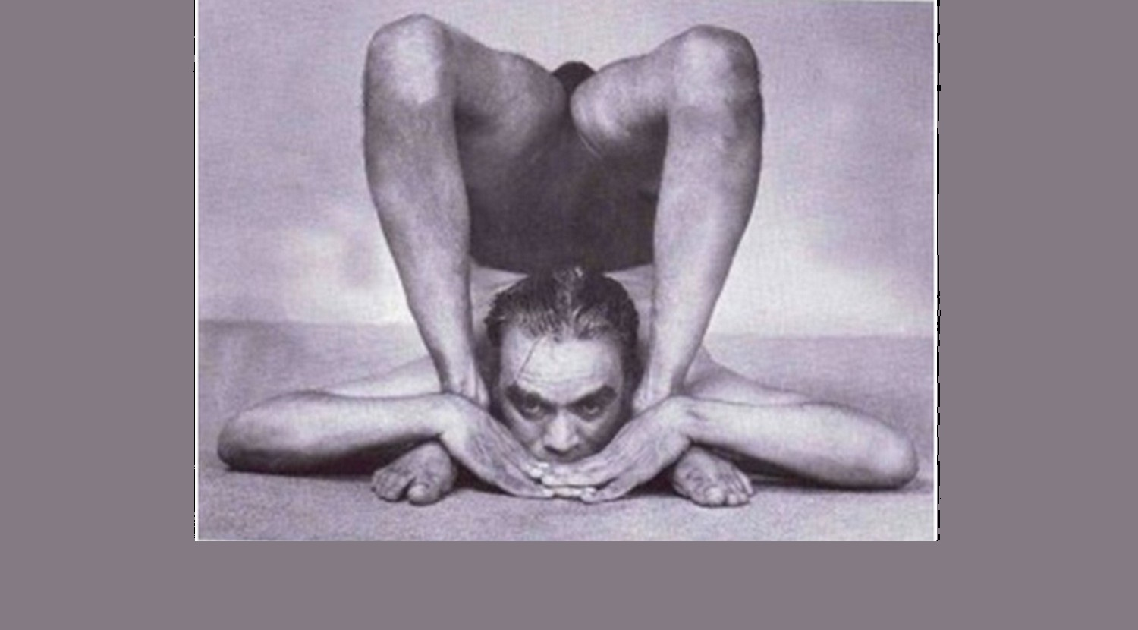

Clearing Misconceptions

B.K.S. Iyengar was the founder of the style of yoga known as "Iyengar Yoga" and was considered one of the foremost yoga teachers in the world, For many, the practice of yoga is restricted to Hatha Yoga and Asanas (postures). However, among the Yoga Sutras, just three sutrasare dedicated to asanas. fundamentally, hatha yoga is a preparatory process so that the body can sustain higher levels of energy. The process begins with the body, then the breath, the mind, and the inner self. Yoga is also commonly understood as a therapy or exercise system for health and fitness. While physical and mental health are natural consequences of yoga, the goal of yoga is more far-reaching. "Yoga is about harmonizing oneself with the universe. It is the technology of aligning individual geometry with the cosmic, to achieve the highest level of perception and harmony.”

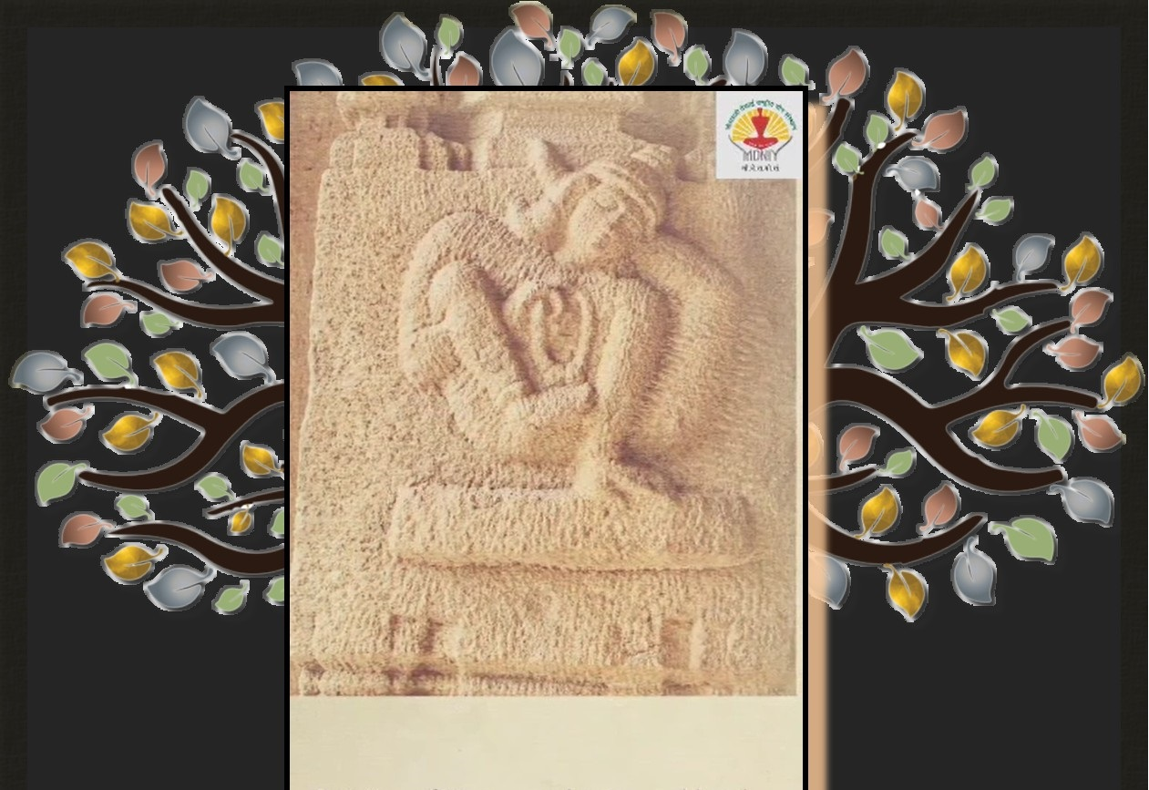

Guru-shishya paramparas

Yoga does not adhere to any particular religion, belief system or community; it has always been approached as a technology for inner wellbeing. Anyone who practices yoga with involvement can reap its benefits, irrespective of one’s faith, ethnicity or culture.Traditional Schools of Yoga :These different Philosophies, Traditions, lineages and Guru-shishya paramparas of Yoga lead to the emergence of differnt Traditional Schools of Yoga e.g. Jnana-yoga, Bhakti-yoga, Karma-yoga, Dhyana-yoga, Patanjala-yoga, Kundalini-yoga, Hatha-yoga, Mantra-yoga, Laya-yoga, Raja-yoga, Jain-yoga, Bouddha-yoga etc. Each school has its own principles and practices leading to altimate aim and objectives of Yoga.

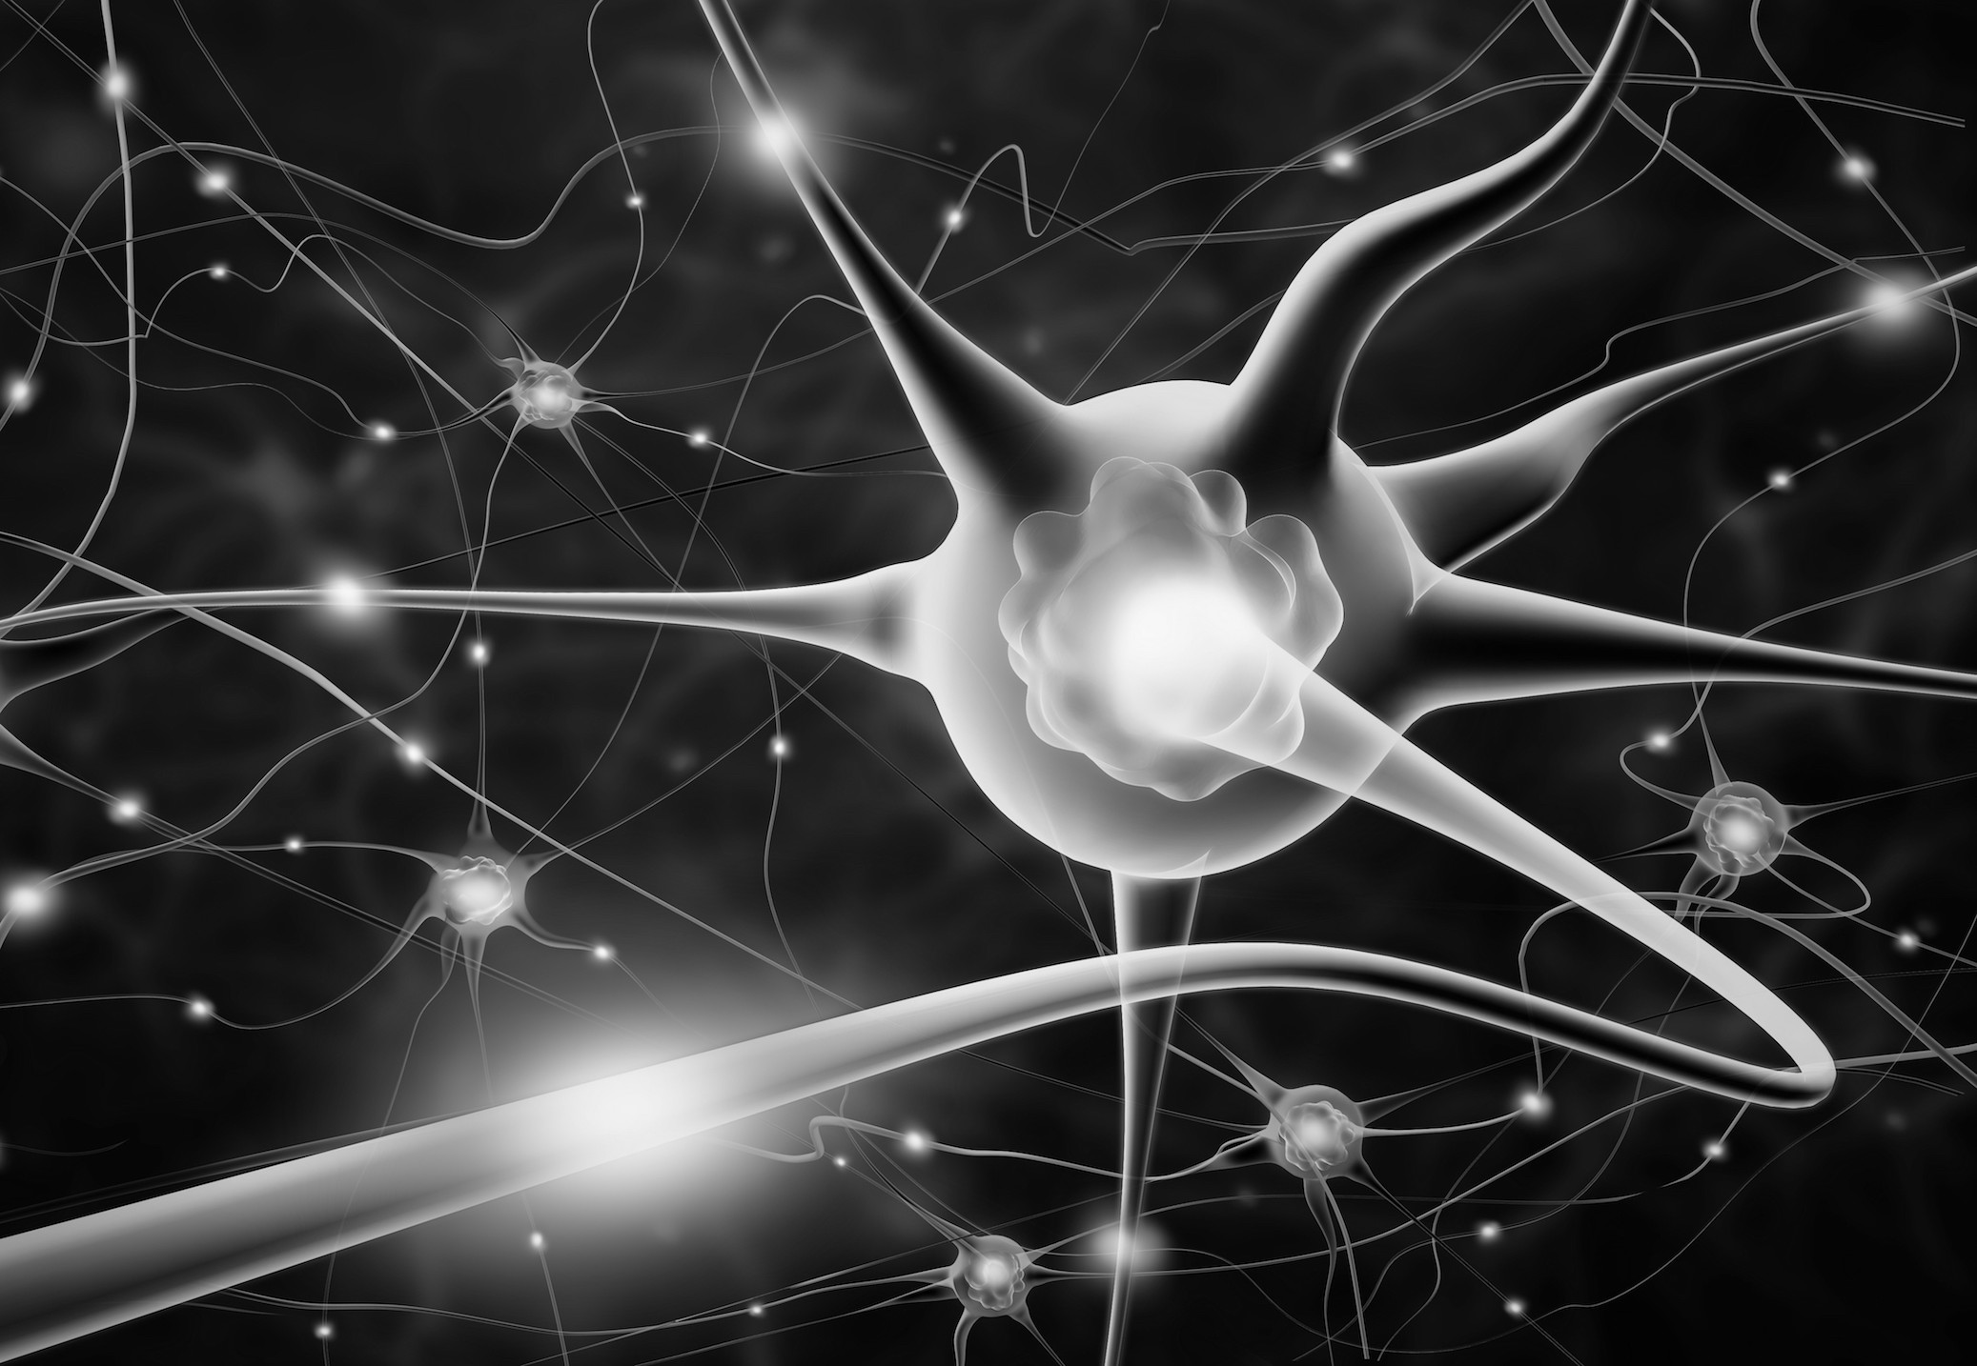

Psycho-Physical

Yogic Practices for Health and Wellness:The widely practiced Yoga Sadhanas (Practices) are: Yama, Niyama, Asana, Pranayama, Pratyahara, Dharana, Dhyana (Meditation), Samadhi /Samyama, Bandhas & Mudras, Shat-karmas, Yukta-ahara, Yukta karma, Mantra japa, etc.Yama's are restraints and Niyama's are observances. These are considered to be pre-requisits for the Yoga Sadhanas (Practices). Asanas, capable of bringing about stability of body and mind ‘ kuryat-tad-asanam-sthairyam...’ , consists in adopting various body (psycho-physical) patterns, giving ability to maintain a body position (a stable awareness of one’s structural existence) for a considerable length and period of time as well.

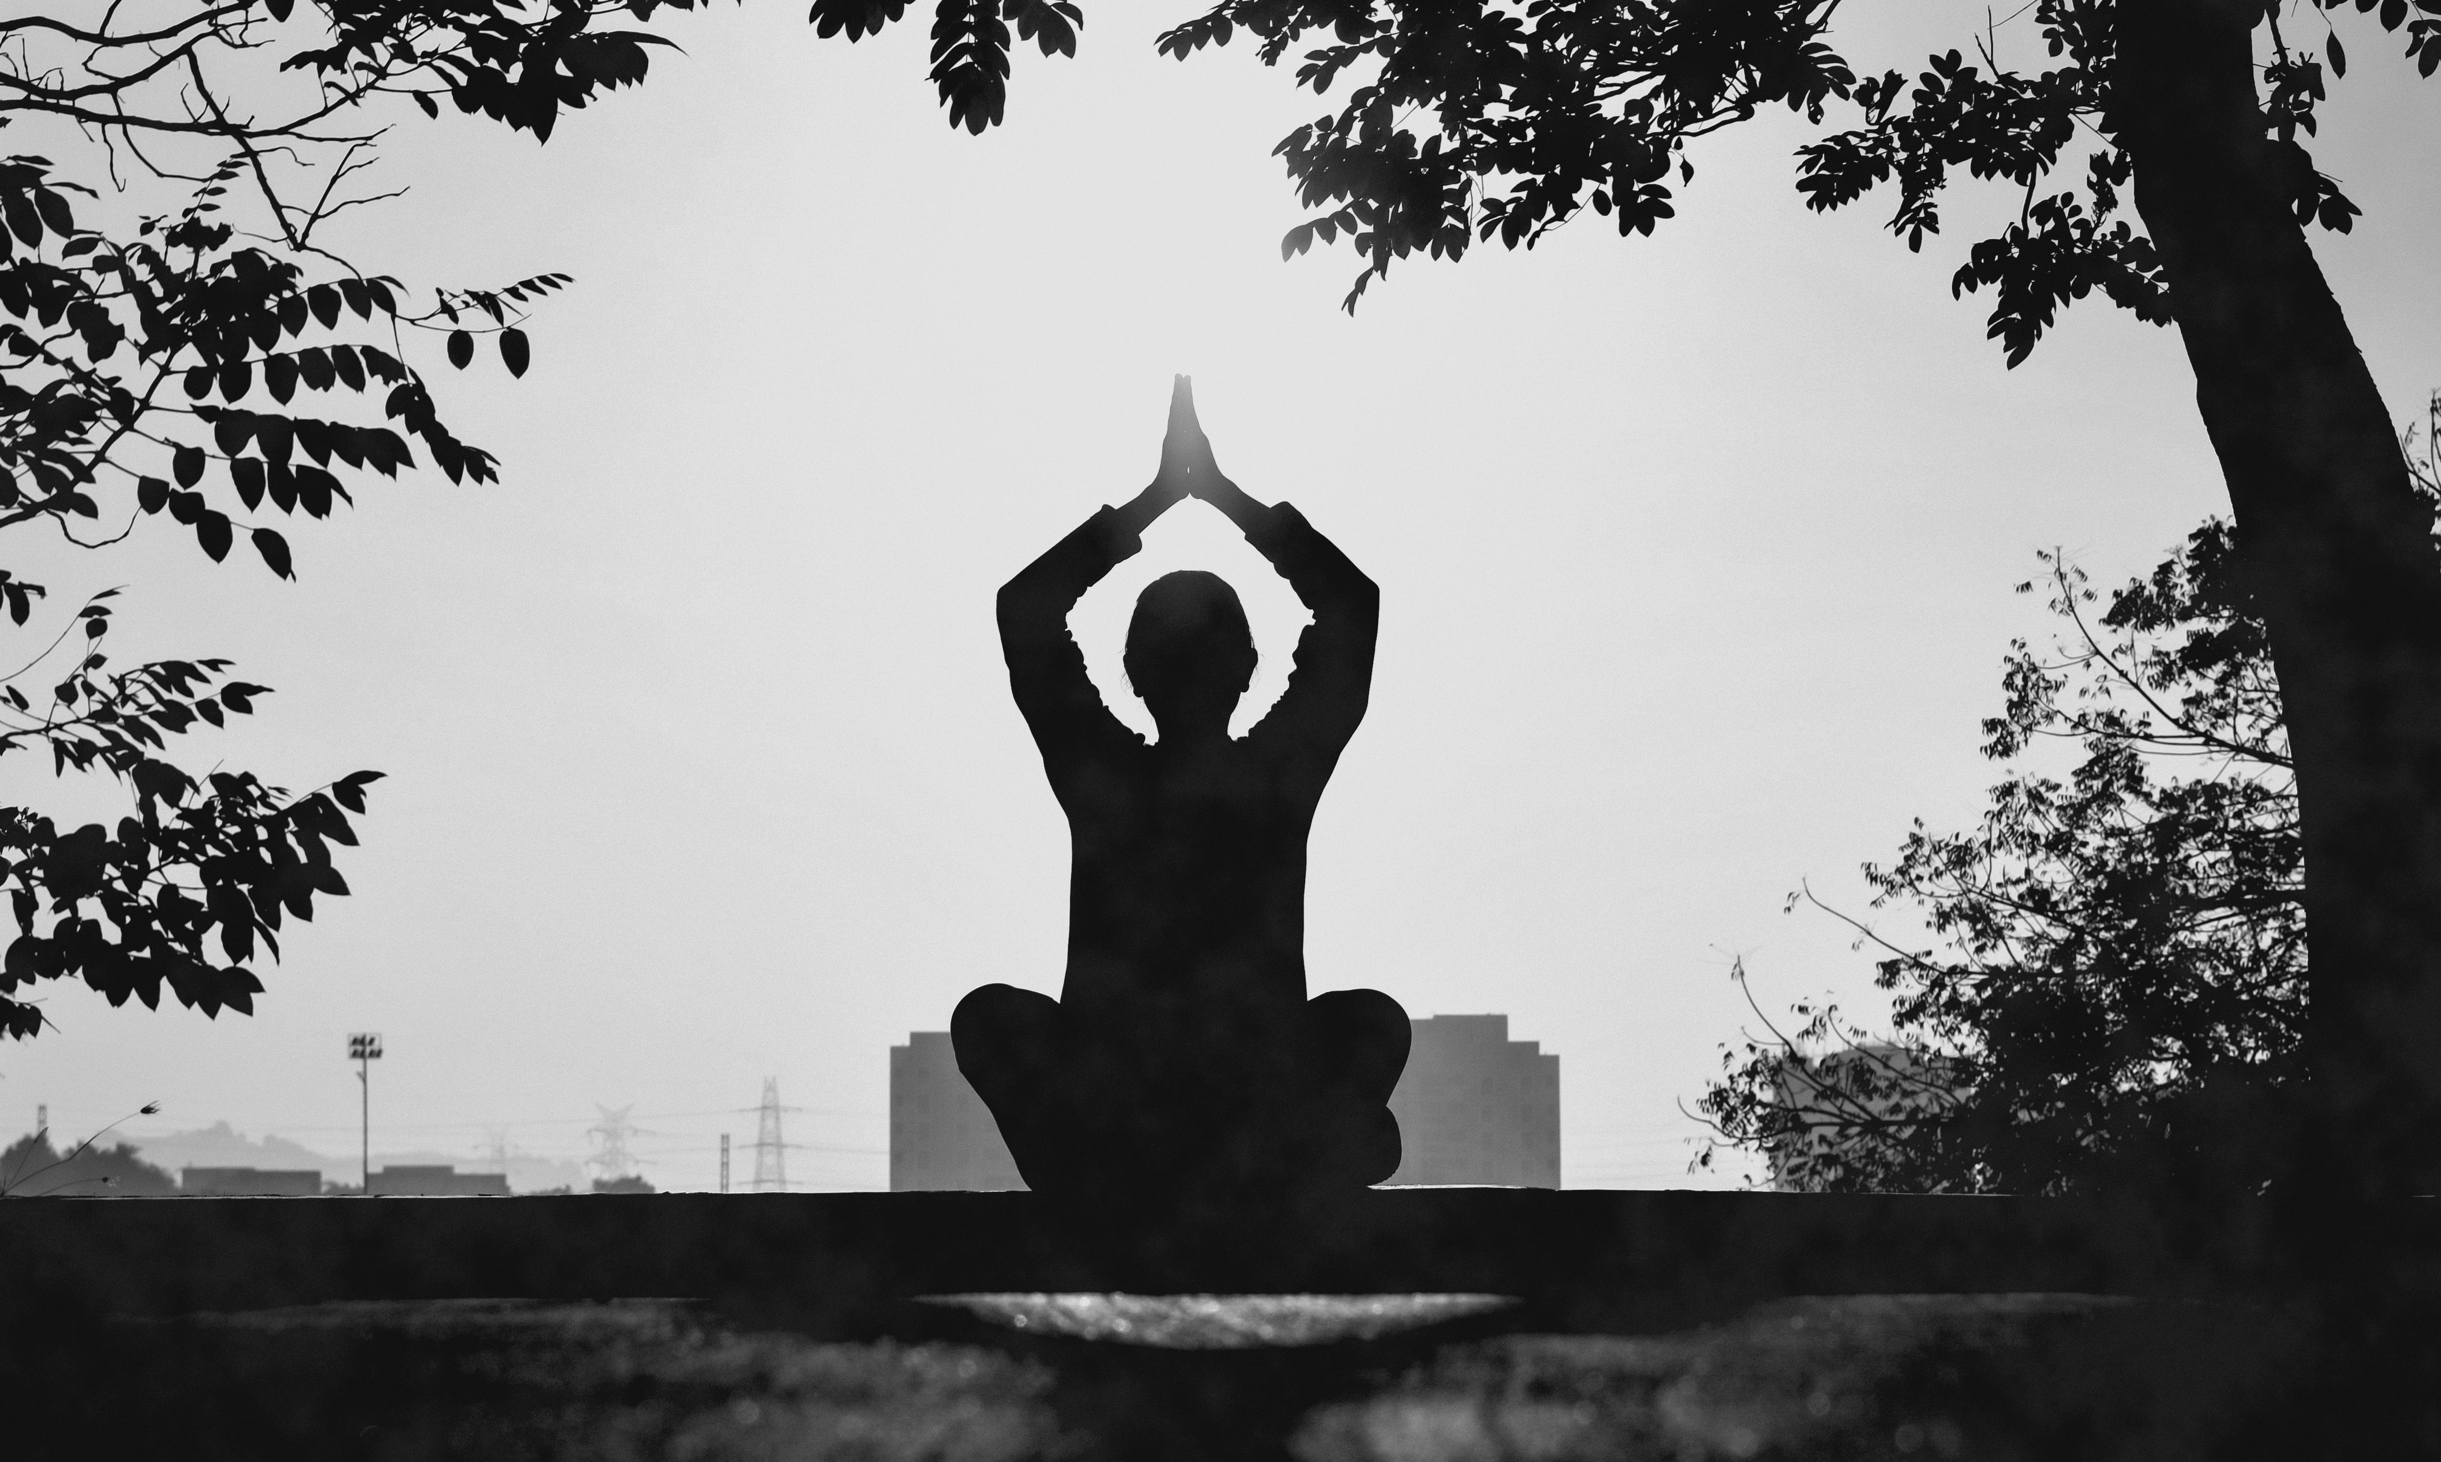

Svasa-Prasvasa

Pranayama consists in developing awareness of one’s breathing followed by willful regulation of respiration as the functional or vital basis of one’s existence. It helps in developing awareness of one’s mind and helps to establish control over the mind. In the initial stages, this is done by developing awareness of the ‘flow of in-breath and out-breath’ (svasa-prasvasa) through nostrils, mouth and other body openings, its internal and external pathways and destinations. Later, this phenomenan is modified, through regulated, controlled and monitored inhalation (svasa) leading to the awareness of the body space/s getting filled (puraka), the space/s remaning in a filled state (kumbhaka) and it’s getting emptied (rechaka) during regulated, controlled and monitored exhalation (prasvasa).



Dhyana (Meditation)

Pratyhara indicates dissociation of one’s consciousness (withdrawal) from the sense organs which helps one to remain connected with the external objects. Dharana indicates broad based field of attetion (inside the body and mind) which is usually understood as concentration. Dhyana (Meditation) is contemplation (focussed attention inside the body and mind) and Samadhi – integration. Bandhas and Mudras are practices associated with pranayama. They are viewed as (the) higher Yogic practices mainly consisting on adopting certain body (psycho-physical) patterns along with (s well as) control over respiration.This further facilitates control over mind and paves way for higher yogic attainment.Shat-karmas are de-toxification procedures, help to remove the toxins acumalated in the body and are clinical in nature. Yuktahara (Right Food and other inputs) advocates appropriate food and food habits for healthy living. However practice of Dhyana (Meditation) helping in self-realization leading to transcendence is considered as the esssence of Yoga Sadhana (The Practice of Yoga).

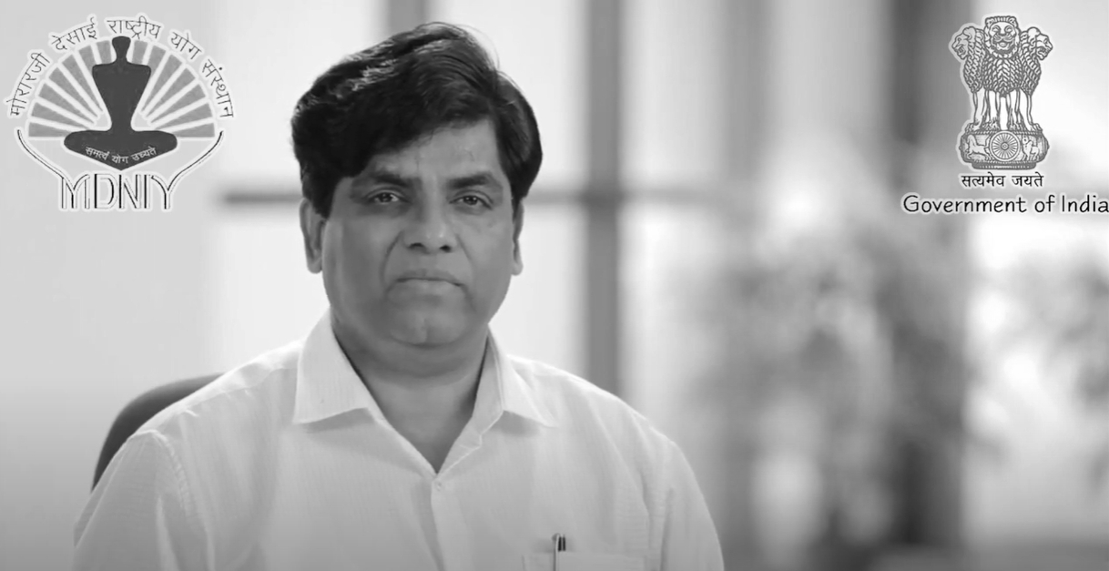

Conclusion

Yoga works on the level of one’s body, mind, emotion and energy. This has given rise to four broad classifications of Yoga: karma yoga, where we utilize the body; bhakti yoga, where we utilize the emotions; gyana yoga, where we utilize the mind and intelect; and kriya yoga, where we utilize the energy. Each system of Yoga we practice would fall within the gamut of one or more of these categories. Every individual is a unique combination of these four factors. "All the ancient commentaries on Yoga have stressed that it is essential to work under the direction of a Guru.” The reason being that only a Guru can mix the appropriate combination of the four fundamental paths, as is necessary for each seeker.Yoga Education:Tradiitionally, Yoga Education was imparted by knowledgeable, experienced, and wise persons in the families (comparable with the education imparted in convents in the west) and then by the Seers (Rishis/Munis/Acharyas) in Ashramas (compared with monastries). Yoga Education, on the other hand, aims at taking care of the individual, the 'Being'. It is presumed that a good, balanced, integrated, truthful, clean, transparent person will be more useful to oneself, family, society, nation, nature and humanity at large. Yoga education is 'Being oriented'. Details of working with 'being oriented' aspect have been outlined in various living traditions and texts and the method contributing to this important field is known as 'Yoga'.

[Source from : Dr. Ishwar V. Basavaraddi (Yoga Scientist and Eminent Yoga Master)](http://www.yogamdniy.nic.in/)



Last Updated : 08-12-2023

### USEFUL LINKS What is Dhyana?

The word Dhyana has been derived from the Sanskrit word 'Dhi', which means to contemplate, reflect, think or be occupied in thought. According to Maharishi Patanjali:

तत्र प्रत्यैकतानता ध्यानम् ।।3.2।।

"*An incessant flow of attention on the concentrated object is called Dhyana.*" Dhyana has been defined by the Samkhya school of Philosophy as "*Dhyanam nirvishayam manah*” which is translated as "the liberation of mind from all disturbing and distracting emotions, thoughts and desires." Dhyana always starts with Dharana, i.e. concentration; the mind becomes steady and one-pointed through concentration and when concentration leads to the uninterrupted flow of thought towards one object that becomes Dhyana.

The two Sanskrit words "*Dhyana*" and "*Nididhyasana*" both are sometimes used for Meditation, but there is a difference as "*Nidhidhyasana*" means "reflection or contemplation," a method used by Monastic tradition of Vedanta Philosophy. Whereas, Dhyana is a conscious and voluntary attempt is made to still the activity of conscious mind. Through withdrawal of senses and concentration, one-pointedness of mind is achieved and then concentration is changed into meditation.

Some Misconceptions about Dhyana

Dhyana is not merely thinking about something or repeating sacred mantras or concentrating on a particular thought or object. It is not a ritualistic worship or prayer for material gains and boons. The word Dhyana has been lucidly used for Dharana and suggests concentration and musings of various kinds with closed eyes. In fact, ordinary students, researchers and thinkers use Dharana and Dhyana indiscriminately. Dhyana cannot be taught. It is not an expressive subject, but an experiencing art where the consciousness of the aspirant is diffused evenly within and without the body, without fading or showing signs of division.

Importance of Place, Season, Time, Diet, Posture and Nadishuddhi Before Practising Dhyana

**PLACE :** Ancient scriptures laid emphasis on various places like under peepal tree, temple, cowshed, holy places, river bank, cave, forest for good meditation. The most important factor for selecting the place for practice is environment. The surroundings of the place should be calm, peaceful and clean. A positive environment in itself charges one with energy, inspiration and the will to strive for the quest for spiritual enlightenment. It is advised that one should always practice in the same place every day to build up the spiritual vibrations.

**SEASON :** Vasanta and Sharad - these two seasons are proper for the practice because too much cold and heat is not in the air and the practitioner does not suffer from the problems generated by the season.

**TIME :** For Dhyana, there are four periods in the whole day of 45 minutes duration each during sandhis (Junctures) - These are before Sunrise (Brahma Muhurta); noon, Sun sets and mid-night. The best time is considered as Brahma Muhurta.

**DIET :** During the practice of Yoga stomach should not be over loaded; it should be half filled with food, one quarter with water and rest with air. The Ancient Scriptures describe three types of food - Satvik, Rajsik and Tamasik. The most important attribute of diet is that it should nourish basic body constituents (Dhatus i.e. skin, flesh, blood, bone, marrow, fat and semen) and should be pleasing to taste buds and agreeable to digestive system. Sattvik diet contains all above mentioned attributes. Rajasik and Tamasik diet are not suitable for the practitioners of Dhyana.

**POSTURE :** Asana is the 3rd limb of Ashtanga Yoga, which is the specific body position, which opens up the energy channels. When asanas are practiced, steadiness develops and Prana moves freely. Asana brings steadiness, health, lightness of limbs, mental equilibrium and prevents fickleness of mind, brings agility, balance, endurance and vitality. The asanas suitable for meditation are: Siddhasana, Padmasana, Muktasana, Swastikasana, Sukhasana and few others. In all these meditation postures, the emphasis is on the erect posture. Dhyan

**The postures used for practicing meditation are:**

**SIDDHASANA (The Accomplished Posture) :** Siddhasana has been rated as the foremost among the 84 lakh asanas. All the other asanas are useful for achieving healthy body but the Siddhasana is useful for meditation, prayer and worship, Pranayama and Samadhi.

While sitting on the ground, the perineum should be pressed with the heel of one foot and should be placed on the other foot on the genitals. Remaining still and steady, with the senses controlled, gaze steadily into the eyebrow centre; it breaks open the door to liberation. This is called Siddhasana. It has been mentioned in scriptures that varying results are obtained by fixing the gaze in different ways.

* **Bhru Madhya drishti :** Gazing at the centre of eyebrows
* **Sama drishti :** Looking straight ahead
* **Nasikagra drishti :** Gazing at the tip of the nose.
* **Ardhonmesha drishti :** Half-open eyelids.
* **Netrabandha drishti :** Closed eyes.

**PADMASANA (The Lotus Posture) :** While sitting on the ground with the heel of the left foot resting on the right thigh so as to be as close as possible to navel. Then the right foot should be placed on the left thigh in such a way that the heels touch each other as near the navel as possible. The vertebral column and the body should be kept erect. Care should be taken that knees touch the ground. The hands should be placed in the lap, palms upward, or on the knees. The whole procedure is to be repeated by altering the sequence in which the feet are placed on the thighs.

This asana, like Siddhasana is used for meditation, prayer, worship and Pranayama, but it has the added distinction in that it is decidedly more effective and useful than Siddhasana for physical well-being.

**SUKHASANA (The easy posture):** While sitting on the ground with cross legs comfortably, the hands should be placed on the knees. Those who cannot perform Padmasana or Siddhasana for meditation, prayers or Pranayama may sit in this posture. This asana is named such that anybody can sit in the posture comfortably for a long period. It is advised for the aspirants who have stiff legs. Position of hands and eyes should be just like Siddhasana or Padmasana.

**NADI SHUDDHI :** It has been mentioned in scriptures that before proceeding with the practice of Yoga it very essential to cleanse the nadis. Shatkarma cleanse the internal system and organs of the body, the asanas makes the body strong, by pratyahara five senses are controlled and by practicing pranayama the body becomes light and radiant. Dhyana helps in self-realization and with Samadhi enlightenment is attained. Hence one should practice in this order; otherwise there is likelihood of getting harmed by the practice of Yoga.

Pranayama is practiced in order to understand and control the pranic process in the body. Breathing is a direct means of absolving prana and the manner in which we breathe sets off pranic Vibrations which influence our entire being. Prana and mind are intricately linked. Fluctuation of one means fluctuation of other. When either the mind or prana becomes balanced the other is steadied. Hatha Yoga says control the prana and the mind is automatically controlled. Hatha Yoga says let the mind be, concentrate on the body functions and vital energy, and the mind becomes quite in itself. When the nervous impulses are steady and rhythmic, the brain functions are regulated and the brain waves become rhythmic. The breathing process is directly connected to mind. While practicing meditation, the fluctuating mental waves create a barrier between the practitioners and the object of Dhyana. So in order to control mind one must have control on breathe. It has been found that through Pranayama, Mudra and Bandha and certain postures which regulate the prana, the mind can be brought under control.

In order to achieve the stage of Dhyana, few Pranayama are very essential to practice - they are Nadishodhana, Bhastrika and Bhramari Pranayama.

Types of Dhyana

Meditation is a very unique universal phenomenon integrating all religions, traditions, languages, cultures, irrespective of caste, creed, color and nation. Every aspect of day to day human living involves one or the other form of meditation. In all religions, namely Hindu, Muslim, Christian, Sikh, Jain, Buddhist, Jewish meditation appears to be an integral part of prayer. Eminent sages and others have described meditation in different ways, depending evidently on their own experiences. This goes to confirm the Vedic saying - Truth is one, but the wise interpret it differently.

**DHYANA IN BUDDHISM :** Buddhism offers two traditional meditation forms: the first is called Samatha Meditation, its purpose is to develop concentration; and the second is called Vipassana meditation, its purpose is to develop understanding. The purpose of Samatha meditation is to reach a state of connection, whereas the aim of Vipassana meditation is closely related to the process of enlightenment.

**DHYANA IN JAINISM : Preksha Dhyana :** Preksha literally means "to look". It means to gather the attention of mind inward and constantly looking within which allows the practitioner to become free from the world of name and form, and abide in Absolute Truth Consciousness. Preksha Dhyana can be practiced anytime, anywhere but regular practice at fixed time daily brings speedier results. The steps that follow in this meditation are Shwasa Preksha (Breath awareness), Animesh Preksha (gazing at an object). Sharira - Preksha (Body-awareness), Vartmana Preksha (Awareness of present), Ekagrata. This can be practiced while sitting lying or standing. This Dhyana gradually releases tension and bring relaxation to body, develops a deep-silent and slow breathing pattern, sublimates the effort to speak undesirable things transforms the mind and brings quiet, calm and relaxation.

**TRANSCENDENTAL MEDITATION :** It means meditation on the Transcendent and not any extra ordinary transcendental type of meditation as made out by many, distinct from the traditional age old technique of AJAPA JAPA. Constant - continuous repetition or recitation of special Seed [Beeja] Mantras in a monotonous manner with concentration upon the incoming and outgoing Prana. The mind - thought travel with and is identified with breath, the Life Force. Dhyan

**According to Gheranda Samhita - Dhyana is said to be of three kinds:**

* **Sthula Dhyana :** Contemplating either on the Murthi (image) of one's Guru or of God (Ishta Devata) is known as Sthula Dhyana. The object of Sthula Dhyana can be vividly visualized; this type of Dhyana is for beginners.
* **Sukshma Dhyana :** The object at this Dhyana is Kundalini, the Serpent Power, after it has crossed the region of the eyes. Then it becomes imperceptible.
* **Jyotirmaya Dhyana :** Tejodhyana is said to be 100 times superior to Sthula Dhyana. In this Dhyana while the yogi is meditating, he sees a light and fixes his mind on that. The light which the yogi sees is an inner light and not a light outside, which he can perceive. Strictly speaking, this light is neither an image nor a precept. A yogi who is successful in Bhramari Kumbhaka hears certain inner sounds which blend with the light that he sees and the yogi's mind is fixed on the blend. Thus, the sound, the light and the knowing mind becomes one.

Gorakshapaddhati describes two types of Dhyana: Sakala and Nishkala. These two are akin to the Sthula and Sukshma Dhyana of Gheranda Samhita.

Aumkara Dhyana

There is one type of Dhyana which is very popular among the yoga practitioner i.e. Aumkara Dhyana, which is performed as follows :

For practicing Dhyana one must move to an isolated place or in a room and sit in any meditative posture. By keeping the body erect, eyes closed and the hands in Jnana Mudra on the knees, one should start chanting “OM” loudly. The word OM has to be repeated again and again loudly. The vibrations of the sound should affect the body as well as the surroundings of the place, so that one feels that it is not only the mouth but the whole body from head to toe is repeating it; and not only gets that room the whole atmosphere filled with the Aumkar sound. These affect the body and mind equally. Body gets relaxed, peaceful, happy and healthy. This process influences both Annamaya and Pranamaya kosha equally. The practice involves lot of patience and energy. Initial practice should start with 10-15 minutes depending on the person's physical and mental capacity. This state is very important because this is the foundation of Aumkar Dhyana.

The second step consists of closing one's mouth and repeating and chanting the word mentally. The chanting should continue only in the mind. This will saturate the mind, like the oral chanting saturated the body. This process is slightly difficult than the first step, but the regular practice of the first step makes it easier to chant mentally. While chanting bodily, the room gets vibrated but while mental chanting the body becomes room for the person chanting and his whole body starts vibrating with AUM sound. This also can be practiced initially 10-15 minutes and increase the duration gradually. This practice can be continued for few months. With the practice the mind and body are soothed and becomes calm and peaceful. When the process of mental chanting becomes effortless the state of Dharana is achieved, i.e. concentration or Ekagrata, which will lead to Dhyana.

The third step of AUM Dhyana is simply listening to AUM. After saturating the mind with AUM chanting mentally one starts with the third step. In this step neither body nor mind is to be used, but simply listen. The chanting of OM physically and after mentally, it becomes very easy to hear a sound of "AUM" which comes from one's own heart.

It appears that the sound is emanating by itself and no effort is required to chant physically or mentally. This is called Ajapa Japa.

Whatever is mentioned above this state of Dhyana is not very easy to attain. It requires patience and practice to achieve the results. There is progressive evolution. Practice of various components of Yoga cannot make one adept in Yoga in a couple of months. The senses have to be thoroughly subjugated. Divine virtues have to be cultivated. The mind has to be controlled thoroughly. It is an uphill task.

Benefits of Dhyana

The relation between body and mind was widely accepted by the ancient scholars. It is a well accepted fact that the regular practice of certain asanas, mudras, pranayamas, dhyana etc. bestows remarkable changes in the physical and mental functions. The psychosomatic linkage is being increasingly recognized by the practitioners of modern medicine, in a sense that unless mind is involved the body cannot be treated and vice-versa.

Dhyana is an important Yogic technique. The regular practice of Dhyana bestows many benefits to the practitioner - some direct and some indirect. It not only helps the practitioner to control many mental problems but also help a person to rise to the highest level of spiritual experience. Negative emotions like fear, anger, depression, stress & tension, panic, anxiety, reactions, worry etc are reduced and a calm state of mind is developed. Total personality and outlook of the aspirant changes for the better, so that he manages to face adverse situations in life in a better manner and discharge his duties more efficiently. The practice of Dhyana makes the person a positive personality, having positive thoughts and doing positive acts. Dhyana also increases the concentration, memory, confidence, clarity of thoughts, and will-power receiving power of brain and decrease the level of fatigue.

A yogi who meditates regularly develops a magnetic and charming personality. Those who come in contact with him are much influenced by his sweet voice, powerful speech, lustrous eyes, brilliant complexion, strong healthy body, good behavior, virtuous qualities and divine nature. Just as a grain of salt dropped in water dissolves in the mater, just as the sweet fragrance of Jasmine pervades the air, so also spiritual aura of a Yogi becomes infiltrated to the minds of others.

In his Yoga Sutras Maharishi Patanjali has mentioned certain powers a Yogi may acquire through concentration and Meditation. For example, through sustained and prolonged concentration on the hollow of the throat a Yogi can transcend hunger and thirst. Such a claim can be verified only by practicing the specified concentration method.

Many scientific studies have been conducted and are being conducted to prove the claims made by the ancient scholars. It has been revealed by the studies that application of Dhyana is highly effective tool not only for health rejuvenation, but also helps tremendously to cope up with stressful situations faced by present day society.

**Sourc**

## [YogYOGIC SHATKARMA](https://yoga.ayush.gov.in/Yoga-Course)

[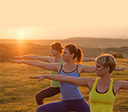](https://yoga.ayush.gov.in/Yoga-Course)

[The Shatkarma or the six purification techniques in Hatha Yoga are designed to make the body strong and healthy. ‘Shat’ means six and ‘Karma’ here means a method or technique. Shatkarmas are considered preparatory steps towards higher practices of pranayama and meditation. The ancient Rishis recognized the importance of a healthy body for all activities.](https://yoga.ayush.gov.in/Yoga-Course)

[Hatha Yoga, as described in the early Yoga Upanishads, was made up of the shatkarmas and is a very precise and systematic science.](https://yoga.ayush.gov.in/Yoga-Course)

[The Shatkarmas consist of six techniques. It can make the body clean and strong, free of diseases, remove toxins and improve concentration. It can also improve the flow of prana into the organs and the pranic meridians or nadis. The six techniques are –](https://yoga.ayush.gov.in/Yoga-Course)*[Neti, Dhauti, Nauli, Bhasti, Kapalabhati and Trataka](https://yoga.ayush.gov.in/Yoga-Course)*[.](https://yoga.ayush.gov.in/Yoga-Course)

[The aim of hatha yoga and, therefore, of the shatkarmas is to create harmony between the two major pranic flows, ida and pingala, thereby, attaining physical and mental purification and balance.](https://yoga.ayush.gov.in/Yoga-Course)

[The shatkarmas are also used to balance the three doshas or humours in the body: kapha, mucus; pitta, bile; and vata, wind. According to both ayurveda and hatha yoga, an imbalance in the doshas will result in illness. These practices are also used before pranayama and other higher yoga practices in order to purify the body of toxins and to ensure safe and successful progression along the spiritual path.](https://yoga.ayush.gov.in/Yoga-Course)

[These powerful techniques should never be learned from books or taught by inexperienced people. According to the tradition, only those instructed by a guru may teach others. It is essential to be personally instructed as to how and when to perform the shatkarmas, according to individual limitations and needs.](https://yoga.ayush.gov.in/Yoga-Course)

[These kriyas (processes) clean the eyes, respiratory system, food pipes, and tone up abdominal viscera and the small intestine.](https://yoga.ayush.gov.in/Yoga-Course)

[The body works like a machine and has to be continuously cleaned and maintained. The body releases toxins in the form of mucus, gas, acid, sweat, urine and stool. It is these toxins that have to be removed and cleaned for the proper functioning of the body.](https://yoga.ayush.gov.in/Yoga-Course)

[Earlier, these practices were undertaken by yogis to prepare their bodies for advanced practices of yoga. They were not designed for therapy alone, but to create harmony of body and mind. As shatkarmas detoxify the body, resulting in many benefits, they are very relevant to us today and make a lot of sense if we learn and follow them.](https://yoga.ayush.gov.in/Yoga-Course)

*[The six techniques are – Neti, Dhauti, Nauli, Bhasti, Kapalabhati and Trataka](https://yoga.ayush.gov.in/Yoga-Course)*

**[Neti](https://yoga.ayush.gov.in/Yoga-Course)**

[Neti is the process of nasal cleaning done using a small pot called Neti pot. It has a long spout on one side. It is filled with warm salt water. Then the spout is inserted into the left nostril. The practitioner bends his head to right side and lets the water from the left nostril into the nasal cavity, which then comes out of the right nostril. The pot is again filled with salt water and the process is repeated by inserting the spout in the right nostril and tilting the head to the left. This process cleans the nose and the sinus cavities, thus, helping in relieving allergies, sinusitis, mild headaches and migraine. Neti can also be done using a rubber catheter. It is called Sutra Neti, where the catheter is inserted into one nostril and pulled out from the throat and out of the mouth. Then using gentle to and fro motion of the catheter tube, the nostril passage is cleaned. This it is repeated for the other nostril. Both forms of Neti have a de-sensitizing effect on the membranes inside the nose, thus, relieving allergies, rhinitis, etc. It is said that Neti also stimulates certain nerve centers in the upper nasal passage.](https://yoga.ayush.gov.in/Yoga-Course)

**[Dhauti](https://yoga.ayush.gov.in/Yoga-Course)**

[Dhauti is the practice of cleaning the stomach. It is done on an empty stomach in the early morning. It is a method of removing undigested particles of food from the previous day’s meal, which continue to stick to the stomach lining and cause problems with digestion. The practitioner drinks about 1 – 1 ½ litres of warm saline water (roughly one table spoon of salt to be added to 1 litre of water). Then he vomits the whole water out. To vomit, the best position is to bend over and put two fingers at the root of the tongue. By stimulating the root of the tongue, the vomiting reflux is induced, which throws the salt water out of the stomach along with the impurities. Continue till all the water is removed. There is another practice called Vastra Dhauti. Here, a 30 feet long cotton cloth is first dipped in saline water and then swallowed carefully. Then it is pulled out slowly, thereby cleaning the inner linings of the stomach and food pipe. This has to be learned under an expert.](https://yoga.ayush.gov.in/Yoga-Course)

**[Nauli](https://yoga.ayush.gov.in/Yoga-Course)**

[Nauli is the practice of churning the abdominal muscles to the left and right repeatedly. Rotation of the muscles, clockwise as well as anti-clockwise is also practiced. This tones up all the organs in the abdomen and removes digestive disorders. It is a difficult practice in the beginning and may take a few months to master. The process involves isolating the ‘Abs’ muscles (also called the rectus abdominus muscle) on both sides of the abdomen and then using it to move and churn the internal organs. This improves the functioning of all organs in the abdomen. The four forms of Nauli practiced are Vama Nauli (using left Abs muscles), Dakshina Nauli (using right Abs muscles), Madhya Nauli (using both Abs muscles) and churning (rotation – clockwise as well as anti-clock wise) of the Abs muscles.](https://yoga.ayush.gov.in/Yoga-Course)

**[Bhasti](https://yoga.ayush.gov.in/Yoga-Course)**

[Bhasti is the cleaning of the bowels. In this practice, traditionally water is drawn in from the anus into the colon by contacting the abdominal muscles. A rubber tube can also be used to aid the process. Then the water is thrown out of the anus, thus cleaning the colon of particles that might have been stuck in the large intestine for a long period of time. This is a yogi’s method of enema. Today, easier methods are available for cleaning the intestines. Taking an enema at home does the job. All you need is an enema kit. There is another technique in yoga to clean the intestines. It is called ‘Sankha Prakshalana’. It involves drinking about 5 litres of slightly warm saline water. The saline water does not get absorbed by the intestine. Instead it pulls out waste and toxins from the intestinal walls and throws it out through the rectum. A common practice today is to do the smaller version of Shanka Prakshalana called Laghu Shanka Prakshalana where only 2 litres of saline water is used. One has to go to the toilet multiple times (say 3 – 5 times) till plain water comes out of the rectum. This gives a complete cleaning of the intestinal tract.](https://yoga.ayush.gov.in/Yoga-Course)

**[Kapalabhati](https://yoga.ayush.gov.in/Yoga-Course)**

[Though many include Kapalabhati as a type of pranayama, in the Hatha Yoga texts, it is classified under the Shatkarmas. It is a powerful cleaning process where the air is forcefully expelled from the lungs, removing any stagnant carbon dioxide accumulated in the lower parts of the lungs. In kapalabhati, the exhalation is forceful while the inhalation is normal. This process is repeated few rounds. It is said to be a cure for many diseases.](https://yoga.ayush.gov.in/Yoga-Course)

**[Trataka](https://yoga.ayush.gov.in/Yoga-Course)**

[Trataka develops concentration and removes mental disturbances. It involves gazing steadily at a point. Gazing on a steady candle flame is also practiced without blinking the eyes. This practice also improves eyesight and gives steadiness of mind.](https://yoga.ayush.gov.in/Yoga-Course)

*[Although there are six shatkarmas, each one consists of a variety of practices. In this chapter only the most commonly used practices are described in detail.](https://yoga.ayush.gov.in/Yoga-Course)*

[Advice, precautions and contra-indications are given for each practice individually and should be carefully observed. During pregnancy, only jala neti and trataka are recommended.](https://yoga.ayush.gov.in/Yoga-Course)

[Although the cleansing and strengthening effects of shatkarmas may be beneficial therapeutically, this is not their purpose. Shatkarmas are practices to promote the health of yoga practitioners and to awaken and direct the energies in the body, mind and deeper psyche.](https://yoga.ayush.gov.in/Yoga-Course)

**[Benefits:](https://yoga.ayush.gov.in/Yoga-Course)**

* [Helps to build resistance to diseases by eliminating the toxins](https://yoga.ayush.gov.in/Yoga-Course)
* [Sharpens the mind](https://yoga.ayush.gov.in/Yoga-Course)
* [Washes the colon, sinus tracts, the stomach, etc.](https://yoga.ayush.gov.in/Yoga-Course)
* [Provides massaging effects to the areas applied](https://yoga.ayush.gov.in/Yoga-Course)
* [Increases vital capacity](https://yoga.ayush.gov.in/Yoga-Course)
* [One's capacity to think, digest, taste, feel, express, etc. increases and greater awareness develops.](https://yoga.ayush.gov.in/Yoga-Course)

**[Precautions to be taken for cleansing processes:](https://yoga.ayush.gov.in/Yoga-Course)**

* [People suffering from any medical condition, who wish to utilize any of these practices, should seek the advice of Doctor.](https://yoga.ayush.gov.in/Yoga-Course)
* [The water used in these practices should be pure. If necessary, use an ultraviolet filter or boil the water for several minutes and then allow it to cool to the desired temperature.](https://yoga.ayush.gov.in/Yoga-Course)
* [These are very effective practices that can never be learned from books or taught by inexperienced people, it should be learned and practised under the supervision of a qualified Yoga Teacher.](https://yoga.ayush.gov.in/Yoga-Course)
* [All the practices require patience and dedication.](https://yoga.ayush.gov.in/Yoga-Course)

*[These practices activate almost all vital systems in the body, especially the digestive, respiratory, circulatory and nervous systems. These purificatory processes are both - preventive and curative.](https://yoga.ayush.gov.in/Yoga-Course)*

[SYSTEMS OF HUMAN BODY(CC) 2021](https://yoga.ayush.gov.in/Yoga-Course)

[a Courses](https://yoga.ayush.gov.in/Yoga-Course)

Ten major systems include the skeletal, muscular, nervous, endocrine, cardiovascular, lymphatic, respiratory, digestive, urinary, and the reproductive system. Body functions are the physiological or psychological functions of body systems.

DIGESTIVE SYSTEEM

Human digestive system

118 languages

* [Article](https://en.wikipedia.org/wiki/Human_digestive_system)
* [Talk](https://en.wikipedia.org/wiki/Talk:Human_digestive_system)
* [Read](https://en.wikipedia.org/wiki/Human_digestive_system)
* [View source](https://en.wikipedia.org/w/index.php?title=Human_digestive_system&action=edit)
* [View history](https://en.wikipedia.org/w/index.php?title=Human_digestive_system&action=history)

Tools

[](https://en.wikipedia.org/wiki/Wikipedia:Protection_policy#semi)

From Wikipedia, the free encyclopedia

*See also*[*gastrointestinal tract*](https://en.wikipedia.org/wiki/Gastrointestinal_tract)*.*

*"Digestive system" and "alimentary system" redirect here. For digestive systems of non-human animals, see*[*Digestion*](https://en.wikipedia.org/wiki/Digestion)*.*

|  |  |
| --- | --- |
| **Human digestive system** | |
| [https://upload.wikimedia.org/wikipedia/commons/thumb/c/c5/Digestive_system_diagram_en.svg/250px-Digestive_system_diagram_en.svg.png](https://en.wikipedia.org/wiki/File:Digestive_system_diagram_en.svg)  Human digestive system | |
| **Details** | |
| **Identifiers** | |
| [**Latin**](https://en.wikipedia.org/wiki/Latin) | *systema digestorium* |
| [**MeSH**](https://en.wikipedia.org/wiki/Medical_Subject_Headings) | [D004064](https://meshb.nlm.nih.gov/record/ui?ui=D004064) |
| [**TA98**](https://en.wikipedia.org/wiki/Terminologia_Anatomica) | [A05.0.00.000](https://ifaa.unifr.ch/Public/EntryPage/TA98%20Tree/Entity%20TA98%20EN/05.0.00.000%20Entity%20TA98%20EN.htm) |
| [**TA2**](https://en.wikipedia.org/wiki/Terminologia_Anatomica) | [2773](https://ta2viewer.openanatomy.org/?id=2773) |
| [**FMA**](https://en.wikipedia.org/wiki/Foundational_Model_of_Anatomy) | [7152](https://bioportal.bioontology.org/ontologies/FMA/?p=classes&conceptid=http%3A%2F%2Fpurl.org%2Fsig%2Font%2Ffma%2Ffma7152) |
| [Anatomical terminology](https://en.wikipedia.org/wiki/Anatomical_terminology)  [[edit on Wikidata](https://www.wikidata.org/wiki/Q9649)] | |

The **human digestive system** consists of the [gastrointestinal tract](https://en.wikipedia.org/wiki/Gastrointestinal_tract) plus the accessory organs of digestion (the [tongue](https://en.wikipedia.org/wiki/Tongue), [salivary glands](https://en.wikipedia.org/wiki/Salivary_gland), [pancreas](https://en.wikipedia.org/wiki/Pancreas), [liver](https://en.wikipedia.org/wiki/Liver), and [gallbladder](https://en.wikipedia.org/wiki/Gallbladder)). [Digestion](https://en.wikipedia.org/wiki/Digestion) involves the breakdown of food into smaller and smaller components, until they can be absorbed and assimilated into the body. The process of digestion has three stages: the [cephalic phase](https://en.wikipedia.org/wiki/Cephalic_phase), the [gastric phase](https://en.wikipedia.org/wiki/Regulation_of_gastric_function#Gastric_phase), and the [intestinal phase](https://en.wikipedia.org/wiki/Regulation_of_gastric_function#Intestinal_phase).

The first stage, the cephalic phase of digestion, begins with secretions from [gastric glands](https://en.wikipedia.org/wiki/Gastric_gland) in response to the sight and smell of food. This stage includes the mechanical breakdown of food by [chewing](https://en.wikipedia.org/wiki/Chewing), and the chemical breakdown by [digestive enzymes](https://en.wikipedia.org/wiki/Digestive_enzyme), that takes place in the [mouth](https://en.wikipedia.org/wiki/Human_mouth). [Saliva](https://en.wikipedia.org/wiki/Saliva) contains the digestive enzymes [amylase](https://en.wikipedia.org/wiki/Amylase), and [lingual lipase](https://en.wikipedia.org/wiki/Lingual_lipase), secreted by the [salivary](https://en.wikipedia.org/wiki/Salivary_gland) and [serous glands](https://en.wikipedia.org/wiki/Serous_glands) on the [tongue](https://en.wikipedia.org/wiki/Tongue). Chewing, in which the food is mixed with saliva, begins the mechanical process of digestion. This produces a [bolus](https://en.wikipedia.org/wiki/Bolus_(digestion)) which is swallowed down the [esophagus](https://en.wikipedia.org/wiki/Esophagus) to enter the [stomach](https://en.wikipedia.org/wiki/Stomach).

The second stage, the gastric phase, happens in the stomach. Here the food is further broken down by mixing with [gastric acid](https://en.wikipedia.org/wiki/Gastric_acid) until it passes into the [duodenum](https://en.wikipedia.org/wiki/Duodenum), the first part of the [small intestine](https://en.wikipedia.org/wiki/Small_intestine).

The third stage, the intestinal phase, begins in the duodenum. Here the partially digested food is mixed with a number of [enzymes](https://en.wikipedia.org/wiki/Enzyme) produced by the [pancreas](https://en.wikipedia.org/wiki/Pancreas).

Digestion is helped by the chewing of food carried out by the [muscles of mastication](https://en.wikipedia.org/wiki/Muscles_of_mastication), the tongue, and the [teeth](https://en.wikipedia.org/wiki/Human_tooth), and also by the [contractions](https://en.wikipedia.org/wiki/Muscle_contraction) of [peristalsis](https://en.wikipedia.org/wiki/Peristalsis), and [segmentation](https://en.wikipedia.org/wiki/Segmentation_contractions). [Gastric acid](https://en.wikipedia.org/wiki/Gastric_acid), and the production of [mucus](https://en.wikipedia.org/wiki/Mucus#Digestive_system) in the stomach, are essential for the continuation of digestion.

Peristalsis is the rhythmic contraction of [muscles](https://en.wikipedia.org/wiki/Muscle) that begins in the esophagus and continues along the wall of the stomach and the rest of the gastrointestinal tract. This initially results in the production of [chyme](https://en.wikipedia.org/wiki/Chyme) which when fully broken down in the small intestine is absorbed as [chyle](https://en.wikipedia.org/wiki/Chyle) into the [lymphatic system](https://en.wikipedia.org/wiki/Lymphatic_system). Most of the digestion of food takes place in the small intestine. Water and some [minerals](https://en.wikipedia.org/wiki/Minerals) are reabsorbed back into the blood in the colon of the [large intestine](https://en.wikipedia.org/wiki/Large_intestine). The waste products of digestion ([feces](https://en.wikipedia.org/wiki/Human_feces)) are [defecated](https://en.wikipedia.org/wiki/Defecation) from the [rectum](https://en.wikipedia.org/wiki/Rectum) via the [anus](https://en.wikipedia.org/wiki/Human_anus).

Components

[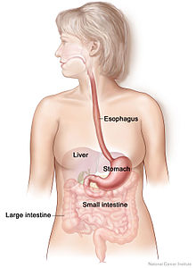](https://en.wikipedia.org/wiki/File:GI_normal.jpg)Adult digestive system

There are several organs and other components involved in the digestion of food. The organs known as the **accessory digestive organs** are the [liver](https://en.wikipedia.org/wiki/Liver), [gall bladder](https://en.wikipedia.org/wiki/Gall_bladder) and [pancreas](https://en.wikipedia.org/wiki/Pancreas). Other components include the [mouth](https://en.wikipedia.org/wiki/Human_mouth), [salivary glands](https://en.wikipedia.org/wiki/Salivary_gland), [tongue](https://en.wikipedia.org/wiki/Tongue), [teeth](https://en.wikipedia.org/wiki/Human_tooth) and [epiglottis](https://en.wikipedia.org/wiki/Epiglottis).

The largest structure of the digestive [system](https://en.wikipedia.org/wiki/Biological_system) is the [gastrointestinal tract](https://en.wikipedia.org/wiki/Gastrointestinal_tract) (GI tract). This starts at the mouth and ends at the [anus](https://en.wikipedia.org/wiki/Human_anus), covering a distance of about nine metres.[[1]](https://en.wikipedia.org/wiki/Human_digestive_system#cite_note-KongSingh2008-1)

A major digestive organ is the [stomach](https://en.wikipedia.org/wiki/Stomach). Within its [mucosa](https://en.wikipedia.org/wiki/Gastric_mucosa) are millions of embedded [gastric glands](https://en.wikipedia.org/wiki/Gastric_glands). Their secretions are vital to the functioning of the organ.

Most of the digestion of food takes place in the [small intestine](https://en.wikipedia.org/wiki/Small_intestine) which is the longest part of the GI tract.

The largest part of the GI tract is the colon or [large intestine](https://en.wikipedia.org/wiki/Large_intestine). Water is absorbed here and the remaining waste matter is stored prior to [defecation](https://en.wikipedia.org/wiki/Defecation).[[2]](https://en.wikipedia.org/wiki/Human_digestive_system#cite_note-eb-2)

There are many specialised [cells](https://en.wikipedia.org/wiki/Cell_(biology)) of the GI tract. These include the various cells of the gastric glands, [taste cells](https://en.wikipedia.org/wiki/Taste_receptor), [pancreatic duct cells](https://en.wikipedia.org/wiki/Pancreatic_duct_cell), [enterocytes](https://en.wikipedia.org/wiki/Enterocyte) and [microfold cells](https://en.wikipedia.org/wiki/Microfold_cell).

Some parts of the digestive system are also part of the [excretory system](https://en.wikipedia.org/wiki/Excretory_system), including the large intestine.[[2]](https://en.wikipedia.org/wiki/Human_digestive_system#cite_note-eb-2)

**Mouth**

[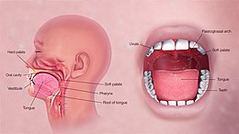](https://en.wikipedia.org/wiki/File:3D_Medical_Animation_Oral_Cavity.jpg)3D medical illustration explaining the oral digestive system

The [mouth](https://en.wikipedia.org/wiki/Human_mouth) is the first part of the [upper gastrointestinal tract](https://en.wikipedia.org/wiki/Gastrointestinal_tract) and is equipped with several structures that begin the first processes of digestion.[[3]](https://en.wikipedia.org/wiki/Human_digestive_system#cite_note-3) These include salivary glands, teeth and the tongue. The mouth consists of two regions; the vestibule and the oral cavity proper. The vestibule is the area between the teeth, lips and cheeks,[[4]](https://en.wikipedia.org/wiki/Human_digestive_system" \l "cite_note-4) and the rest is the oral cavity proper. Most of the oral cavity is lined with [oral mucosa](https://en.wikipedia.org/wiki/Oral_mucosa), a [mucous membrane](https://en.wikipedia.org/wiki/Mucous_membrane) that produces a lubricating [mucus](https://en.wikipedia.org/wiki/Mucus), of which only a small amount is needed. Mucous membranes vary in structure in the different regions of the body but they all produce a lubricating mucus, which is either secreted by surface cells or more usually by underlying glands. The mucous membrane in the mouth continues as the thin mucosa which lines the bases of the teeth. The main component of mucus is a [glycoprotein](https://en.wikipedia.org/wiki/Glycoprotein) called [mucin](https://en.wikipedia.org/wiki/Mucin) and the type secreted varies according to the region involved. Mucin is viscous, clear, and clinging. Underlying the mucous membrane in the mouth is a thin layer of [smooth muscle tissue](https://en.wikipedia.org/wiki/Smooth_muscle_tissue) and the loose connection to the membrane gives it its great elasticity.[[5]](https://en.wikipedia.org/wiki/Human_digestive_system#cite_note-Macpherson1999-5) It covers the cheeks, inner surfaces of the [lips](https://en.wikipedia.org/wiki/Lip), and floor of the mouth, and the mucin produced is highly protective against [tooth decay](https://en.wikipedia.org/wiki/Tooth_decay).[[6]](https://en.wikipedia.org/wiki/Human_digestive_system#cite_note-Frenkel-6)

The roof of the mouth is termed the [palate](https://en.wikipedia.org/wiki/Palate) and it separates the oral cavity from the nasal cavity. The palate is hard at the front of the mouth since the overlying mucosa is covering a plate of [bone](https://en.wikipedia.org/wiki/Bone); it is softer and more pliable at the back being made of muscle and connective tissue, and it can move to swallow food and liquids. The [soft palate](https://en.wikipedia.org/wiki/Soft_palate) ends at the [uvula](https://en.wikipedia.org/wiki/Palatine_uvula).[[7]](https://en.wikipedia.org/wiki/Human_digestive_system#cite_note-7) The surface of the [hard palate](https://en.wikipedia.org/wiki/Hard_palate) allows for the pressure needed in eating food, to leave the nasal passage clear.[[8]](https://en.wikipedia.org/wiki/Human_digestive_system#cite_note-Britannica2007-8) The opening between the lips is termed the oral fissure, and the opening into the throat is called the [fauces](https://en.wikipedia.org/wiki/Fauces_(anatomy)).[[9]](https://en.wikipedia.org/wiki/Human_digestive_system#cite_note-Saladin2-9)

At either side of the soft palate are the [palatoglossus muscles](https://en.wikipedia.org/wiki/Palatoglossus_muscle) which also reach into regions of the tongue. These muscles raise the back of the tongue and also close both sides of the fauces to enable food to be swallowed.[[10]](https://en.wikipedia.org/wiki/Human_digestive_system#cite_note-Dorland's-10): 1208 Mucus helps in the mastication of food in its ability to soften and collect the food in the formation of the bolus.

**Salivary glands**

[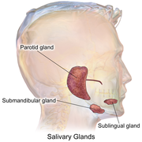](https://en.wikipedia.org/wiki/File:Blausen_0780_SalivaryGlands.png)The main salivary glands

There are three pairs of main [salivary glands](https://en.wikipedia.org/wiki/Salivary_gland) and between 800 and 1,000 minor salivary glands, all of which mainly serve the digestive process, and also play an important role in the maintenance of dental health and general mouth lubrication, without which speech would be impossible.[[11]](https://en.wikipedia.org/wiki/Human_digestive_system#cite_note-Ten_Cate_2013-11) The main glands are all [exocrine glands](https://en.wikipedia.org/wiki/Exocrine_gland), secreting via ducts. All of these glands terminate in the mouth. The largest of these are the [parotid glands](https://en.wikipedia.org/wiki/Parotid_gland)—their secretion is mainly [serous](https://en.wikipedia.org/wiki/Serous). The next pair are underneath the jaw, the [submandibular glands](https://en.wikipedia.org/wiki/Submandibular_gland), these produce both [serous fluid](https://en.wikipedia.org/wiki/Serous_fluid) and [mucus](https://en.wikipedia.org/wiki/Mucus). The serous fluid is produced by [serous glands](https://en.wikipedia.org/wiki/Serous_gland) in these salivary glands which also produce [lingual lipase](https://en.wikipedia.org/wiki/Lingual_lipase). They produce about 70% of the oral cavity saliva. The third pair are the [sublingual glands](https://en.wikipedia.org/wiki/Sublingual_gland) located underneath the tongue and their secretion is mainly mucous with a small percentage of saliva.

Within the [oral mucosa](https://en.wikipedia.org/wiki/Oral_mucosa), and also on the tongue, palates, and floor of the mouth, are the minor salivary glands; their secretions are mainly mucous and they are innervated by the [facial nerve](https://en.wikipedia.org/wiki/Facial_nerve) ([CN7](https://en.wikipedia.org/wiki/Cranial_nerve)).[[12]](https://en.wikipedia.org/wiki/Human_digestive_system#cite_note-Neck_2012,_p._157-12) The glands also secrete [amylase](https://en.wikipedia.org/wiki/Amylase) a first stage in the breakdown of food acting on the carbohydrate in the food to transform the starch content into maltose. There are other [serous glands](https://en.wikipedia.org/wiki/Serous_gland) on the surface of the tongue that encircle [taste buds](https://en.wikipedia.org/wiki/Taste_bud) on the back part of the tongue and these also produce lingual lipase. [Lipase](https://en.wikipedia.org/wiki/Lipase) is a [digestive enzyme](https://en.wikipedia.org/wiki/Digestive_enzyme) that catalyses the [hydrolysis](https://en.wikipedia.org/wiki/Hydrolysis) of [lipids](https://en.wikipedia.org/wiki/Lipid) (fats). These glands are termed [Von Ebner's glands](https://en.wikipedia.org/wiki/Von_Ebner%27s_glands) which have also been shown to have another function in the secretion of [histatins](https://en.wikipedia.org/wiki/Histatin) which offer an early defense (outside of the immune system) against microbes in food, when it makes contact with these glands on the tongue tissue.[[11]](https://en.wikipedia.org/wiki/Human_digestive_system#cite_note-Ten_Cate_2013-11)[[13]](https://en.wikipedia.org/wiki/Human_digestive_system#cite_note-13) Sensory information can stimulate the secretion of saliva providing the necessary fluid for the tongue to work with and also to ease swallowing of the food.

**Saliva**

*Main article:*[*Saliva*](https://en.wikipedia.org/wiki/Saliva)

[Saliva](https://en.wikipedia.org/wiki/Saliva) moistens and softens food, and along with the chewing action of the teeth, transforms the food into a smooth [bolus](https://en.wikipedia.org/wiki/Bolus_(digestion)). The bolus is further helped by the lubrication provided by the saliva in its passage from the mouth into the esophagus. Also of importance is the presence in saliva of the digestive enzymes [amylase](https://en.wikipedia.org/wiki/Amylase) and [lipase](https://en.wikipedia.org/wiki/Lipase). Amylase starts to work on the [starch](https://en.wikipedia.org/wiki/Starch) in [carbohydrates](https://en.wikipedia.org/wiki/Carbohydrate), breaking it down into the simple [sugars](https://en.wikipedia.org/wiki/Sugars) of [maltose](https://en.wikipedia.org/wiki/Maltose) and [dextrose](https://en.wikipedia.org/wiki/Dextrose) that can be further broken down in the small intestine. Saliva in the mouth can account for 30% of this initial starch digestion. Lipase starts to work on breaking down [fats](https://en.wikipedia.org/wiki/Fat). Lipase is further produced in the [pancreas](https://en.wikipedia.org/wiki/Pancreas) where it is released to continue this digestion of fats. The presence of salivary lipase is of prime importance in young babies whose pancreatic lipase has yet to be developed.[[14]](https://en.wikipedia.org/wiki/Human_digestive_system#cite_note-14)

As well as its role in supplying [digestive enzymes](https://en.wikipedia.org/wiki/Digestive_enzyme), saliva has a cleansing action for the teeth and mouth.[[15]](https://en.wikipedia.org/wiki/Human_digestive_system#cite_note-Edgar-15) It also has an [immunological](https://en.wikipedia.org/wiki/Immunology) role in supplying antibodies to the system, such as [immunoglobulin A](https://en.wikipedia.org/wiki/Immunoglobulin_A).[[16]](https://en.wikipedia.org/wiki/Human_digestive_system#cite_note-16) This is seen to be key in preventing [infections](https://en.wikipedia.org/wiki/Infection) of the salivary glands, importantly that of [parotitis](https://en.wikipedia.org/wiki/Parotitis).

Saliva also contains a [glycoprotein](https://en.wikipedia.org/wiki/Glycoprotein) called [haptocorrin](https://en.wikipedia.org/wiki/Haptocorrin) which is a binding protein to vitamin B12.[[17]](https://en.wikipedia.org/wiki/Human_digestive_system#cite_note-isbn1-4051-3649-9-17) It binds with the vitamin in order to carry it safely through the acidic content of the stomach. When it reaches the duodenum, pancreatic enzymes break down the glycoprotein and free the vitamin which then binds with [intrinsic factor](https://en.wikipedia.org/wiki/Intrinsic_factor).

**Tongue**

[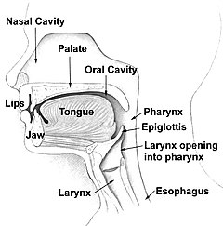](https://en.wikipedia.org/wiki/File:Illu01_head_neck.jpg)

Food enters the mouth where the first stage in the digestive process takes place, with the action of the [tongue](https://en.wikipedia.org/wiki/Tongue) and the secretion of saliva. The tongue is a fleshy and [muscular](https://en.wikipedia.org/wiki/Muscular_hydrostat) [sensory organ](https://en.wikipedia.org/wiki/Sensory_organ), and the first sensory information is received via the taste buds in the [papillae](https://en.wikipedia.org/wiki/Lingual_papillae) on its surface. If the taste is agreeable, the tongue will go into action, manipulating the food in the mouth which stimulates the secretion of saliva from the salivary glands. The liquid quality of the saliva will help in the softening of the food and its enzyme content will start to break down the food whilst it is still in the mouth. The first part of the food to be broken down is the starch of carbohydrates (by the [enzyme](https://en.wikipedia.org/wiki/Digestive_enzyme) [amylase](https://en.wikipedia.org/wiki/Amylase) in the saliva).

The tongue is attached to the floor of the mouth by a ligamentous band called the [frenum](https://en.wikipedia.org/wiki/Frenulum_of_the_tongue)[[5]](https://en.wikipedia.org/wiki/Human_digestive_system#cite_note-Macpherson1999-5) and this gives it great mobility for the manipulation of food (and [speech](https://en.wikipedia.org/wiki/Speech)); the range of manipulation is optimally controlled by the action of several muscles and limited in its external range by the stretch of the frenum. The tongue's two sets of muscles, are four [intrinsic muscles](https://en.wikipedia.org/wiki/Tongue#Intrinsic_muscles) that originate in the tongue and are involved with its shaping, and four [extrinsic muscles](https://en.wikipedia.org/wiki/Tongue#extrinsic_muscles) originating in [bone](https://en.wikipedia.org/wiki/Bone) that are involved with its movement.

**Taste**

*Main article:*[*Taste*](https://en.wikipedia.org/wiki/Taste)

[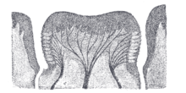](https://en.wikipedia.org/wiki/File:Gray1015.png)Cross section of [circumvallate papilla](https://en.wikipedia.org/wiki/Circumvallate_papilla) showing arrangement of nerves and taste buds

[Taste](https://en.wikipedia.org/wiki/Taste) is a form of [chemoreception](https://en.wikipedia.org/wiki/Chemoreceptor) that takes place in the specialised [taste receptors](https://en.wikipedia.org/wiki/Taste_receptor), contained in structures called [taste buds](https://en.wikipedia.org/wiki/Taste_buds) in the mouth. Taste buds are mainly on the upper surface (dorsum) of the tongue. The function of taste perception is vital to help prevent harmful or rotten foods from being consumed. There are also taste buds on the [epiglottis](https://en.wikipedia.org/wiki/Epiglottis) and upper part of the [esophagus](https://en.wikipedia.org/wiki/Esophagus). The taste buds are innervated by a branch of the facial nerve the [chorda tympani](https://en.wikipedia.org/wiki/Chorda_tympani), and the [glossopharyngeal nerve](https://en.wikipedia.org/wiki/Glossopharyngeal_nerve). Taste messages are sent via these [cranial nerves](https://en.wikipedia.org/wiki/Cranial_nerves) to the [brain](https://en.wikipedia.org/wiki/Human_brain). The brain can distinguish between the chemical qualities of the food. The five [basic tastes](https://en.wikipedia.org/wiki/Taste#Basic_tastes) are referred to as those of [saltiness](https://en.wikipedia.org/wiki/Taste#Saltiness), [sourness](https://en.wikipedia.org/wiki/Taste#Sourness), [bitterness](https://en.wikipedia.org/wiki/Taste#Bitterness), [sweetness](https://en.wikipedia.org/wiki/Sweetness), and [umami](https://en.wikipedia.org/wiki/Umami). The detection of saltiness and sourness enables the control of salt and acid balance. The detection of bitterness warns of poisons—many of a plant's defences are of poisonous compounds that are bitter. Sweetness guides to those foods that will supply energy; the initial breakdown of the energy-giving carbohydrates by salivary amylase creates the taste of sweetness since simple sugars are the first result. The taste of umami is thought to signal protein-rich food. Sour tastes are acidic which is often found in bad food. The brain has to decide very quickly whether the food should be eaten or not. It was the findings in 1991, describing the first [olfactory](https://en.wikipedia.org/wiki/Olfactory) receptors that helped to prompt the research into taste. The olfactory receptors are located on cell surfaces in the [nose](https://en.wikipedia.org/wiki/Human_nose) which bind to chemicals enabling the detection of smells. It is assumed that signals from taste receptors work together with those from the nose, to form an idea of complex food flavours.[[18]](https://en.wikipedia.org/wiki/Human_digestive_system#cite_note-18)

**Teeth**

*Main article:*[*Human tooth*](https://en.wikipedia.org/wiki/Human_tooth)

[Teeth](https://en.wikipedia.org/wiki/Human_tooth) are complex structures made of materials specific to them. They are made of a bone-like material called [dentin](https://en.wikipedia.org/wiki/Dentin), which is covered by the hardest tissue in the body—[enamel](https://en.wikipedia.org/wiki/Tooth_enamel).[[8]](https://en.wikipedia.org/wiki/Human_digestive_system#cite_note-Britannica2007-8) Teeth have different shapes to deal with different aspects of [mastication](https://en.wikipedia.org/wiki/Mastication) employed in tearing and chewing pieces of food into smaller and smaller pieces. This results in a much larger surface area for the action of digestive enzymes. The teeth are named after their particular roles in the process of mastication—[incisors](https://en.wikipedia.org/wiki/Incisors) are used for cutting or biting off pieces of food; [canines](https://en.wikipedia.org/wiki/Canine_tooth), are used for tearing, [premolars](https://en.wikipedia.org/wiki/Premolars) and [molars](https://en.wikipedia.org/wiki/Molars) are used for chewing and grinding. Mastication of the food with the help of saliva and mucus results in the formation of a soft bolus which can then be [swallowed](https://en.wikipedia.org/wiki/Swallowed) to make its way down the [upper gastrointestinal tract](https://en.wikipedia.org/wiki/Upper_gastrointestinal_tract) to the stomach.[[19]](https://en.wikipedia.org/wiki/Human_digestive_system#cite_note-19) The digestive enzymes in saliva also help in keeping the teeth clean by breaking down any lodged food particles.[[20]](https://en.wikipedia.org/wiki/Human_digestive_system#cite_note-Baelum-20)[[15]](https://en.wikipedia.org/wiki/Human_digestive_system#cite_note-Edgar-15)

**Epiglottis**

*Main article:*[*Epiglottis*](https://en.wikipedia.org/wiki/Epiglottis)

[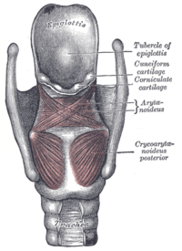](https://en.wikipedia.org/wiki/File:Gray958.png)

The [epiglottis](https://en.wikipedia.org/wiki/Epiglottis) is a flap of [elastic cartilage](https://en.wikipedia.org/wiki/Elastic_cartilage) attached to the entrance of the [larynx](https://en.wikipedia.org/wiki/Larynx). It is covered with a mucous membrane and there are taste buds on its lingual surface which faces into the mouth.[[21]](https://en.wikipedia.org/wiki/Human_digestive_system#cite_note-21) Its laryngeal surface faces into the larynx. The epiglottis functions to guard the entrance of the [glottis](https://en.wikipedia.org/wiki/Glottis), the opening between the [vocal folds](https://en.wikipedia.org/wiki/Vocal_folds). It is normally pointed upward during breathing with its underside functioning as part of the pharynx, but during swallowing, the epiglottis folds down to a more horizontal position, with its upper side functioning as part of the pharynx. In this manner it prevents food from going into the trachea and instead directs it to the esophagus, which is behind. During swallowing, the backward motion of the tongue forces the epiglottis over the glottis' opening to prevent any food that is being swallowed from entering the larynx which leads to the lungs; the larynx is also pulled upwards to assist this process. Stimulation of the larynx by ingested matter produces a strong [cough reflex](https://en.wikipedia.org/wiki/Cough_reflex) in order to protect the lungs.

**Pharynx**

*Main article:*[*Pharynx*](https://en.wikipedia.org/wiki/Pharynx)

The [pharynx](https://en.wikipedia.org/wiki/Pharynx) is a part of the [conducting zone](https://en.wikipedia.org/wiki/Conducting_zone) of the [respiratory system](https://en.wikipedia.org/wiki/Respiratory_system) and also a part of the digestive system. It is the part of the throat immediately behind the [nasal cavity](https://en.wikipedia.org/wiki/Nasal_cavity) at the back of the mouth and above the esophagus and [larynx](https://en.wikipedia.org/wiki/Larynx). The pharynx is made up of three parts. The lower two parts—the [oropharynx](https://en.wikipedia.org/wiki/Pharynx#Oropharynx) and the [laryngopharynx](https://en.wikipedia.org/wiki/Pharynx#Laryngopharynx) are involved in the digestive system. The laryngopharynx connects to the esophagus and it serves as a passageway for both air and food. Air enters the larynx anteriorly but anything swallowed has priority and the passage of air is temporarily blocked. The pharynx is innervated by the [pharyngeal plexus of the vagus nerve](https://en.wikipedia.org/wiki/Pharyngeal_plexus_of_vagus_nerve).[[10]](https://en.wikipedia.org/wiki/Human_digestive_system#cite_note-Dorland's-10): 1465 [Muscles in the pharynx](https://en.wikipedia.org/wiki/Pharyngeal_muscles" \o "Pharyngeal muscles) push the food into the esophagus. The pharynx joins the esophagus at the oesophageal inlet which is located behind the [cricoid cartilage](https://en.wikipedia.org/wiki/Cricoid_cartilage).

**Esophagus**

*Main article:*[*Esophagus*](https://en.wikipedia.org/wiki/Esophagus)

[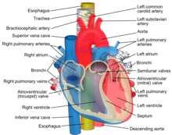](https://en.wikipedia.org/wiki/File:Relations_of_the_aorta,_trachea,_esophagus_and_other_heart_structures.png)Esophagus shown in yellow passing behind the trachea and the heart

The [esophagus](https://en.wikipedia.org/wiki/Esophagus), commonly known as the foodpipe or gullet, consists of a muscular tube through which food passes from the pharynx to the stomach. The esophagus is continuous with the laryngopharynx. It passes through the posterior [mediastinum](https://en.wikipedia.org/wiki/Mediastinum) in the [thorax](https://en.wikipedia.org/wiki/Thorax) and enters the [stomach](https://en.wikipedia.org/wiki/Stomach) through a hole in the [thoracic diaphragm](https://en.wikipedia.org/wiki/Thoracic_diaphragm)—the [esophageal hiatus](https://en.wikipedia.org/wiki/Esophageal_hiatus), at the level of the tenth [thoracic vertebra](https://en.wikipedia.org/wiki/Thoracic_vertebra) (T10). Its length averages 25 cm, varying with an individual's height. It is divided into cervical, [thoracic](https://en.wikipedia.org/wiki/Thoracic) and [abdominal](https://en.wikipedia.org/wiki/Abdominal) parts. The pharynx joins the esophagus at the esophageal inlet which is behind the [cricoid cartilage](https://en.wikipedia.org/wiki/Cricoid_cartilage).

At rest the esophagus is closed at both ends, by the [upper and lower esophageal sphincters](https://en.wikipedia.org/wiki/Esophagus#Sphincters). The opening of the upper sphincter is triggered by the [swallowing reflex](https://en.wikipedia.org/wiki/Swallowing_reflex) so that food is allowed through. The sphincter also serves to prevent back flow from the esophagus into the pharynx. The esophagus has a mucous membrane and the epithelium which has a protective function is continuously replaced due to the volume of food that passes inside the esophagus. During swallowing, food passes from the mouth through the pharynx into the esophagus. The epiglottis folds down to a more horizontal position to direct the food into the esophagus, and away from the [trachea](https://en.wikipedia.org/wiki/Trachea).

Once in the esophagus, the bolus travels down to the stomach via rhythmic contraction and relaxation of muscles known as [peristalsis](https://en.wikipedia.org/wiki/Peristalsis). The lower esophageal sphincter is a muscular sphincter surrounding the lower part of the esophagus. The [gastroesophageal junction](https://en.wikipedia.org/wiki/Stomach#Sections) between the esophagus and the stomach is controlled by the lower esophageal sphincter, which remains constricted at all times other than during swallowing and vomiting to prevent the contents of the stomach from entering the esophagus. As the esophagus does not have the same protection from acid as the stomach, any failure of this sphincter can lead to heartburn.

**Diaphragm**

The [diaphragm](https://en.wikipedia.org/wiki/Thoracic_diaphragm) is an important part of the body's digestive system. The muscular diaphragm separates the [thoracic cavity](https://en.wikipedia.org/wiki/Thoracic_cavity) from the [abdominal cavity](https://en.wikipedia.org/wiki/Abdominal_cavity) where most of the digestive organs are located. The [suspensory muscle](https://en.wikipedia.org/wiki/Suspensory_muscle_of_the_duodenum) attaches the ascending duodenum to the diaphragm. This muscle is thought to be of help in the digestive system in that its attachment offers a wider angle to the [duodenojejunal flexure](https://en.wikipedia.org/wiki/Duodenojejunal_flexure) for the easier passage of digesting material. The diaphragm also attaches to, and anchors the liver at its [bare area](https://en.wikipedia.org/wiki/Bare_area_of_the_liver). The esophagus enters the abdomen through a [hole in the diaphragm](https://en.wikipedia.org/wiki/Esophageal_hiatus) at the level of [T10](https://en.wikipedia.org/wiki/Thoracic_vertebrae).

**Stomach**

*Main article:*[*Stomach*](https://en.wikipedia.org/wiki/Stomach)

[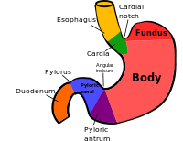](https://en.wikipedia.org/wiki/File:Regions_of_stomach.svg)Areas of the stomach

The [stomach](https://en.wikipedia.org/wiki/Stomach) is a major organ of the gastrointestinal tract and digestive system. It is a consistently J-shaped organ joined to the esophagus at its upper end and to the duodenum at its lower end. [Gastric acid](https://en.wikipedia.org/wiki/Gastric_acid) (informally *gastric juice*), produced in the stomach plays a vital role in the digestive process, and mainly contains [hydrochloric acid](https://en.wikipedia.org/wiki/Hydrochloric_acid) and [sodium chloride](https://en.wikipedia.org/wiki/Sodium_chloride). A [peptide hormone](https://en.wikipedia.org/wiki/Peptide_hormone), [gastrin](https://en.wikipedia.org/wiki/Gastrin), produced by [G cells](https://en.wikipedia.org/wiki/G_cell) in the [gastric glands](https://en.wikipedia.org/wiki/Gastric_glands), stimulates the production of gastric juice which activates the [digestive enzymes](https://en.wikipedia.org/wiki/Digestive_enzyme). [Pepsinogen](https://en.wikipedia.org/wiki/Pepsinogen) is a precursor enzyme ([zymogen](https://en.wikipedia.org/wiki/Zymogen)) produced by the [gastric chief cells](https://en.wikipedia.org/wiki/Gastric_chief_cell), and gastric acid activates this to the enzyme [pepsin](https://en.wikipedia.org/wiki/Pepsin) which begins the digestion of [proteins](https://en.wikipedia.org/wiki/Protein). As these two chemicals would damage the stomach wall, mucus is secreted by innumerable gastric glands in the stomach, to provide a slimy protective layer against the damaging effects of the chemicals on the inner layers of the stomach.

At the same time that protein is being digested, mechanical churning occurs through the action of [peristalsis](https://en.wikipedia.org/wiki/Peristalsis), waves of muscular contractions that move along the stomach wall. This allows the mass of food to further mix with the [digestive enzymes](https://en.wikipedia.org/wiki/Digestive_enzymes). [Gastric lipase](https://en.wikipedia.org/wiki/Gastric_lipase) secreted by the chief cells in the [fundic glands](https://en.wikipedia.org/wiki/Gastric_glands) in the [gastric mucosa](https://en.wikipedia.org/wiki/Gastric_mucosa) of the stomach, is an acidic lipase, in contrast with the alkaline pancreatic lipase. This breaks down fats to some degree though is not as efficient as the pancreatic lipase.

The [pylorus](https://en.wikipedia.org/wiki/Pylorus), the lowest section of the stomach which attaches to the [duodenum](https://en.wikipedia.org/wiki/Duodenum) via the [pyloric canal](https://en.wikipedia.org/wiki/Pyloric_canal), contains countless glands which secrete digestive enzymes including gastrin. After an hour or two, a thick semi-liquid called [chyme](https://en.wikipedia.org/wiki/Chyme) is produced. When the [pyloric sphincter](https://en.wikipedia.org/wiki/Pyloric_sphincter), or valve opens, chyme enters the duodenum where it mixes further with digestive enzymes from the pancreas, and then passes through the small intestine, where digestion continues.

The [parietal cells](https://en.wikipedia.org/wiki/Parietal_cell) in the fundus of the stomach, produce a [glycoprotein](https://en.wikipedia.org/wiki/Glycoprotein) called [intrinsic factor](https://en.wikipedia.org/wiki/Intrinsic_factor) which is essential for the absorption of [vitamin B12](https://en.wikipedia.org/wiki/Vitamin_B12). Vitamin B12 (cobalamin), is carried to, and through the stomach, bound to a glycoprotein secreted by the salivary glands - [transcobalamin I](https://en.wikipedia.org/wiki/Transcobalamin) also called [haptocorrin](https://en.wikipedia.org/wiki/Haptocorrin), which protects the acid-sensitive vitamin from the acidic stomach contents. Once in the more neutral duodenum, pancreatic enzymes break down the protective glycoprotein. The freed vitamin B12 then binds to intrinsic factor which is then absorbed by the [enterocytes](https://en.wikipedia.org/wiki/Enterocyte) in the ileum.

The stomach is a distensible organ and can normally expand to hold about one litre of food.[[22]](https://en.wikipedia.org/wiki/Human_digestive_system#cite_note-22) This expansion is enabled by a series of [gastric folds](https://en.wikipedia.org/wiki/Gastric_folds) in the inner walls of the stomach. The stomach of a newborn baby will only be able to expand to retain about 30 ml.

**Spleen**

*Main article:*[*Spleen*](https://en.wikipedia.org/wiki/Spleen)

The [spleen](https://en.wikipedia.org/wiki/Spleen) is the largest lymphoid organ in the body but has other functions.[[23]](https://en.wikipedia.org/wiki/Human_digestive_system#cite_note-Saladin3-23) It breaks down both red and white [blood cells](https://en.wikipedia.org/wiki/Blood_cells) that are *spent*. This is why it is sometimes known as the 'graveyard of red blood cells'.[[23]](https://en.wikipedia.org/wiki/Human_digestive_system#cite_note-Saladin3-23) A product of this *digestion* is the pigment [bilirubin](https://en.wikipedia.org/wiki/Bilirubin), which is sent to the [liver](https://en.wikipedia.org/wiki/Liver) and secreted in the [bile](https://en.wikipedia.org/wiki/Bile). Another product is [iron](https://en.wikipedia.org/wiki/Iron), which is used in the formation of new blood cells in the [bone marrow](https://en.wikipedia.org/wiki/Bone_marrow).[[5]](https://en.wikipedia.org/wiki/Human_digestive_system#cite_note-Macpherson1999-5) [Medicine](https://en.wikipedia.org/wiki/Medicine) treats the spleen solely as belonging to the [lymphatic system](https://en.wikipedia.org/wiki/Lymphatic_system), though it is acknowledged that the full range of its important functions is not yet understood.[[10]](https://en.wikipedia.org/wiki/Human_digestive_system#cite_note-Dorland's-10): 1751

**Liver**

*Main article:*[*Liver*](https://en.wikipedia.org/wiki/Liver)

[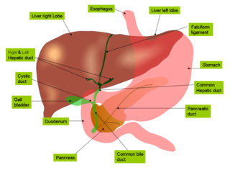](https://en.wikipedia.org/wiki/File:Anatomy_of_liver_and_gall_bladder.png)Liver and gall bladder

The [liver](https://en.wikipedia.org/wiki/Human_liver) is the second largest organ (after the [skin](https://en.wikipedia.org/wiki/Skin)) and is an accessory digestive gland which plays a role in the body's [metabolism](https://en.wikipedia.org/wiki/Metabolism). The liver has many functions some of which are important to digestion. The liver can detoxify various [metabolites](https://en.wikipedia.org/wiki/Metabolite); synthesise [proteins](https://en.wikipedia.org/wiki/Protein) and produce [biochemicals](https://en.wikipedia.org/wiki/Biochemical) needed for digestion. It regulates the storage of [glycogen](https://en.wikipedia.org/wiki/Glycogen) which it can form from [glucose](https://en.wikipedia.org/wiki/Glucose) ([glycogenesis](https://en.wikipedia.org/wiki/Glycogenesis)). The liver can also synthesise glucose from certain [amino acids](https://en.wikipedia.org/wiki/Amino_acid). Its digestive functions are largely involved with the breaking down of [carbohydrates](https://en.wikipedia.org/wiki/Carbohydrate). It also maintains protein metabolism in its synthesis and degradation. In [lipid](https://en.wikipedia.org/wiki/Lipid) metabolism it synthesises [cholesterol](https://en.wikipedia.org/wiki/Cholesterol). [Fats](https://en.wikipedia.org/wiki/Fat) are also produced in the process of [lipogenesis](https://en.wikipedia.org/wiki/Lipogenesis). The liver synthesises the bulk of lipoproteins. The liver is located in the upper right quadrant of the abdomen and below the diaphragm to which it is attached at one part, the [bare area of the liver](https://en.wikipedia.org/wiki/Bare_area_of_the_liver). This is to the right of the stomach and it overlies the [gall bladder](https://en.wikipedia.org/wiki/Gall_bladder). The liver synthesises [bile acids](https://en.wikipedia.org/wiki/Bile_acid) and [lecithin](https://en.wikipedia.org/wiki/Lecithin) to promote the digestion of fat.[[24]](https://en.wikipedia.org/wiki/Human_digestive_system#cite_note-Saladin4-24)

**Bile**

[Bile](https://en.wikipedia.org/wiki/Bile) produced by the liver is made up of water (97%), [bile salts](https://en.wikipedia.org/wiki/Bile_salt), mucus and [pigments](https://en.wikipedia.org/wiki/Pigment_(biology)), 1% fats and inorganic salts.[[25]](https://en.wikipedia.org/wiki/Human_digestive_system#cite_note-25) [Bilirubin](https://en.wikipedia.org/wiki/Bilirubin) is its major pigment. Bile acts partly as a [surfactant](https://en.wikipedia.org/wiki/Surfactant) which lowers the surface tension between either two liquids or a solid and a liquid and helps to [emulsify](https://en.wikipedia.org/wiki/Emulsify) the fats in the [chyme](https://en.wikipedia.org/wiki/Chyme). Food fat is dispersed by the action of bile into smaller units called [micelles](https://en.wikipedia.org/wiki/Micelle). The breaking down into micelles creates a much larger surface area for the pancreatic enzyme, [lipase](https://en.wikipedia.org/wiki/Lipase) to work on. Lipase digests the [triglycerides](https://en.wikipedia.org/wiki/Triglyceride) which are broken down into two [fatty acids](https://en.wikipedia.org/wiki/Fatty_acid) and a [monoglyceride](https://en.wikipedia.org/wiki/Monoglyceride). These are then absorbed by [villi](https://en.wikipedia.org/wiki/Intestinal_villi) on the intestinal wall. If fats are not absorbed in this way in the small intestine problems can arise later in the large intestine which is not equipped to absorb fats. Bile also helps in the absorption of [vitamin K](https://en.wikipedia.org/wiki/Vitamin_K) from the diet. Bile is collected and delivered through the [common hepatic duct](https://en.wikipedia.org/wiki/Common_hepatic_duct). This duct joins with the [cystic duct](https://en.wikipedia.org/wiki/Cystic_duct) to connect in a [common bile duct](https://en.wikipedia.org/wiki/Common_bile_duct) with the gallbladder. Bile is stored in the gallbladder for release when food is discharged into the duodenum and also after a few hours.[[5]](https://en.wikipedia.org/wiki/Human_digestive_system#cite_note-Macpherson1999-5)

**Gallbladder**

[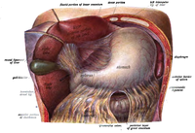](https://en.wikipedia.org/wiki/File:Sobo_1906_405.png)Gallbladder shown in green below the liver

The [gallbladder](https://en.wikipedia.org/wiki/Gallbladder) is a hollow part of the [biliary tract](https://en.wikipedia.org/wiki/Biliary_tract) that sits just beneath the liver, with the gallbladder body resting in a small depression.[[26]](https://en.wikipedia.org/wiki/Human_digestive_system#cite_note-26) It is a small organ where the [bile](https://en.wikipedia.org/wiki/Bile) produced by the liver is stored, before being released into the small intestine. Bile flows from the liver through the [bile ducts](https://en.wikipedia.org/wiki/Bile_duct) and into the gall bladder for storage. The bile is released in response to [cholecystokinin](https://en.wikipedia.org/wiki/Cholecystokinin) (CCK) a [peptide hormone](https://en.wikipedia.org/wiki/Peptide_hormone) released from the duodenum. The production of CCK (by endocrine cells of the duodenum) is stimulated by the presence of fat in the duodenum.[[27]](https://en.wikipedia.org/wiki/Human_digestive_system#cite_note-27)

It is divided into three sections, a fundus, body and neck. The neck tapers and connects to the biliary tract via the [cystic duct](https://en.wikipedia.org/wiki/Cystic_duct), which then joins the [common hepatic duct](https://en.wikipedia.org/wiki/Common_hepatic_duct) to form the [common bile duct](https://en.wikipedia.org/wiki/Common_bile_duct). At this junction is a mucosal fold called *Hartmann's pouch*, where [gallstones](https://en.wikipedia.org/wiki/Gallstone) commonly get stuck. The [muscular layer](https://en.wikipedia.org/wiki/Muscular_layer) of the body is of smooth muscle tissue that helps the gallbladder contract, so that it can discharge its bile into the bile duct. The gallbladder needs to store bile in a natural, semi-liquid form at all times. [Hydrogen ions](https://en.wikipedia.org/wiki/Hydrogen_ions) secreted from the inner lining of the gallbladder keep the bile acidic enough to prevent hardening. To dilute the bile, water and [electrolytes](https://en.wikipedia.org/wiki/Electrolyte) from the digestion system are added. Also, salts attach themselves to cholesterol molecules in the bile to keep them from [crystallising](https://en.wikipedia.org/wiki/Crystallization). If there is too much cholesterol or bilirubin in the bile, or if the gallbladder does not empty properly the systems can fail. This is how gallstones form when a small piece of calcium gets coated with either cholesterol or bilirubin and the bile crystallises and forms a gallstone. The main purpose of the gallbladder is to store and release bile, or *gall*. Bile is released into the small intestine in order to help in the digestion of fats by breaking down larger molecules into smaller ones. After the fat is absorbed, the bile is also absorbed and transported back to the liver for reuse.

**Pancreas**

*Main article:*[*Pancreas*](https://en.wikipedia.org/wiki/Pancreas)

[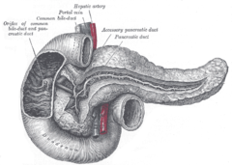](https://en.wikipedia.org/wiki/File:Gray1100.png)Pancreas, duodenum and bile duct[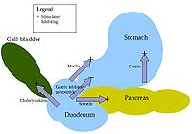](https://en.wikipedia.org/wiki/File:Digestive_hormones.jpg)Action of digestive hormones

The [pancreas](https://en.wikipedia.org/wiki/Pancreas) is a major organ functioning as an accessory digestive gland in the digestive system. It is both an [endocrine gland](https://en.wikipedia.org/wiki/Endocrine_gland) and an [exocrine gland](https://en.wikipedia.org/wiki/Exocrine_gland).[[28]](https://en.wikipedia.org/wiki/Human_digestive_system#cite_note-isbn0-8385-1474-X-28) The endocrine part secretes [insulin](https://en.wikipedia.org/wiki/Insulin) when the [blood sugar](https://en.wikipedia.org/wiki/Blood_sugar) becomes high; insulin moves glucose from the blood into the muscles and other tissues for use as energy. The endocrine part releases [glucagon](https://en.wikipedia.org/wiki/Glucagon) when the blood sugar is low; glucagon allows stored sugar to be broken down into [glucose](https://en.wikipedia.org/wiki/Glucose) by the liver in order to re-balance the sugar levels. The pancreas produces and releases important digestive enzymes in the [pancreatic juice](https://en.wikipedia.org/wiki/Pancreatic_juice) that it delivers to the duodenum.[[24]](https://en.wikipedia.org/wiki/Human_digestive_system#cite_note-Saladin4-24) The pancreas lies below and at the back of the stomach. It connects to the duodenum via the [pancreatic duct](https://en.wikipedia.org/wiki/Pancreatic_duct) which it joins near to the bile duct's connection where both the bile and pancreatic juice can act on the [chyme](https://en.wikipedia.org/wiki/Chyme) that is released from the stomach into the duodenum. Aqueous pancreatic secretions from [pancreatic duct cells](https://en.wikipedia.org/wiki/Pancreatic_duct_cell) contain [bicarbonate](https://en.wikipedia.org/wiki/Bicarbonate) ions which are alkaline and help with the bile to neutralise the acidic chyme that is churned out by the stomach.

The pancreas is also the main source of enzymes for the digestion of [fats](https://en.wikipedia.org/wiki/Fat) and proteins. Some of these are released in response to the production of [CKK](https://en.wikipedia.org/wiki/Cholecystokinin) in the duodenum. (The enzymes that digest polysaccharides, by contrast, are primarily produced by the walls of the intestines.) The cells are filled with secretory granules containing the precursor digestive enzymes. The major [proteases](https://en.wikipedia.org/wiki/Protease), the pancreatic enzymes which work on proteins, are [trypsinogen](https://en.wikipedia.org/wiki/Trypsinogen) and [chymotrypsinogen](https://en.wikipedia.org/wiki/Chymotrypsinogen). [Elastase](https://en.wikipedia.org/wiki/Elastase) is also produced. Smaller amounts of lipase and amylase are secreted. The pancreas also secretes [phospholipase A2](https://en.wikipedia.org/wiki/Phospholipase_A2), [lysophospholipase](https://en.wikipedia.org/wiki/Lysophospholipase), and [cholesterol](https://en.wikipedia.org/wiki/Cholesterol) [esterase](https://en.wikipedia.org/wiki/Esterase). The precursor [zymogens](https://en.wikipedia.org/wiki/Zymogens), are inactive variants of the enzymes; which avoids the onset of [pancreatitis](https://en.wikipedia.org/wiki/Pancreatitis) caused by autodegradation. Once released in the intestine, the enzyme [enteropeptidase](https://en.wikipedia.org/wiki/Enteropeptidase) present in the intestinal mucosa activates trypsinogen by cleaving it to form trypsin; further cleavage results in chymotripsin.

**Lower gastrointestinal tract**

*Main article:*[*Gastrointestinal tract*](https://en.wikipedia.org/wiki/Gastrointestinal_tract)

*Further information:*[*Gastrointestinal physiology*](https://en.wikipedia.org/wiki/Gastrointestinal_physiology)

The lower gastrointestinal tract (GI), includes the [small intestine](https://en.wikipedia.org/wiki/Small_intestine) and all of the [large intestine](https://en.wikipedia.org/wiki/Large_intestine).[[29]](https://en.wikipedia.org/wiki/Human_digestive_system#cite_note-29) The intestine is also called the bowel or the gut. The lower GI starts at the pyloric sphincter of the stomach and finishes at the anus. The small intestine is subdivided into the [duodenum](https://en.wikipedia.org/wiki/Duodenum), the [jejunum](https://en.wikipedia.org/wiki/Jejunum) and the [ileum](https://en.wikipedia.org/wiki/Ileum). The cecum marks the division between the small and large intestine. The large intestine includes the rectum and [anal canal](https://en.wikipedia.org/wiki/Anal_canal).[[2]](https://en.wikipedia.org/wiki/Human_digestive_system#cite_note-eb-2)

**Small intestine**

[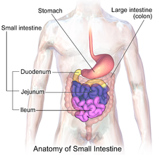](https://en.wikipedia.org/wiki/File:Blausen_0817_SmallIntestine_Anatomy.png)Illustration of small intestine

Partially digested food starts to arrive in the [small intestine](https://en.wikipedia.org/wiki/Small_intestine) as semi-liquid [chyme](https://en.wikipedia.org/wiki/Chyme), one hour after it is eaten.[[*citation needed*](https://en.wikipedia.org/wiki/Wikipedia:Citation_needed)] The stomach is half empty after an average of 1.2 hours.[[30]](https://en.wikipedia.org/wiki/Human_digestive_system#cite_note-Read-30) After four or five hours the stomach has emptied.[[31]](https://en.wikipedia.org/wiki/Human_digestive_system#cite_note-Colorado-31)

In the small intestine, the [pH](https://en.wikipedia.org/wiki/PH) becomes crucial; it needs to be finely balanced in order to activate digestive enzymes. The chyme is very acidic, with a low pH, having been released from the stomach and needs to be made much more alkaline. This is achieved in the [**duodenum**](https://en.wikipedia.org/wiki/Duodenum) by the addition of bile from the gall bladder combined with the [bicarbonate](https://en.wikipedia.org/wiki/Bicarbonate) secretions from the pancreatic duct and also from secretions of bicarbonate-rich mucus from duodenal glands known as [Brunner's glands](https://en.wikipedia.org/wiki/Brunner%27s_glands). The chyme arrives in the intestines having been released from the stomach through the opening of the [pyloric sphincter](https://en.wikipedia.org/wiki/Pyloric_sphincter). The resulting alkaline fluid mix neutralises the gastric acid which would damage the lining of the intestine. The mucus component lubricates the walls of the intestine.

[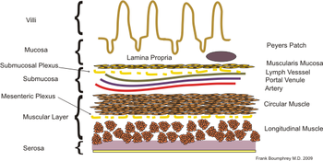](https://en.wikipedia.org/wiki/File:Intestinal_layers.png)Layers of the small intestine

When the digested food particles are reduced enough in size and composition, they can be absorbed by the intestinal wall and carried to the bloodstream. The first receptacle for this chyme is the [duodenal bulb](https://en.wikipedia.org/wiki/Duodenal_bulb). From here it passes into the first of the three sections of the small intestine, the duodenum (the next section is the [**jejunum**](https://en.wikipedia.org/wiki/Jejunum) and the third is the [**ileum**](https://en.wikipedia.org/wiki/Ileum)). The duodenum is the first and shortest section of the small intestine. It is a hollow, jointed C-shaped tube connecting the stomach to the jejunum. It starts at the duodenal bulb and ends at the [suspensory muscle of duodenum](https://en.wikipedia.org/wiki/Suspensory_muscle_of_duodenum). The attachment of the suspensory muscle to the diaphragm is thought to help the passage of food by making a wider angle at its attachment.

Most food digestion takes place in the small intestine. [Segmentation contractions](https://en.wikipedia.org/wiki/Segmentation_contractions) act to mix and move the chyme more slowly in the small intestine allowing more time for absorption (and these continue in the large intestine). In the duodenum, pancreatic lipase is secreted together with a [co-enzyme](https://en.wikipedia.org/wiki/Co-enzyme), [colipase](https://en.wikipedia.org/wiki/Colipase) to further digest the fat content of the chyme. From this breakdown, smaller particles of emulsified fats called [chylomicrons](https://en.wikipedia.org/wiki/Chylomicron) are produced. There are also digestive cells called [enterocytes](https://en.wikipedia.org/wiki/Enterocyte) lining the intestines (the majority being in the small intestine). They are unusual cells in that they have [villi](https://en.wikipedia.org/wiki/Intestinal_villus) on their surface which in turn have innumerable [microvilli](https://en.wikipedia.org/wiki/Microvilli) on their surface. All these villi make for a greater surface area, not only for the absorption of chyme but also for its further digestion by large numbers of digestive enzymes present on the microvilli.

The chylomicrons are small enough to pass through the enterocyte villi and into their [lymph](https://en.wikipedia.org/wiki/Lymph) capillaries called [lacteals](https://en.wikipedia.org/wiki/Lacteal). A milky fluid called [chyle](https://en.wikipedia.org/wiki/Chyle), consisting mainly of the emulsified fats of the chylomicrons, results from the absorbed mix with the lymph in the lacteals.[[*clarification needed*](https://en.wikipedia.org/wiki/Wikipedia:Please_clarify)] Chyle is then transported through the [lymphatic system](https://en.wikipedia.org/wiki/Lymphatic_system) to the rest of the body.

The suspensory muscle marks the end of the duodenum and the division between the upper gastrointestinal tract and the lower GI tract. The digestive tract continues as the jejunum which continues as the ileum. The jejunum, the midsection of the small intestine contains [circular folds](https://en.wikipedia.org/wiki/Circular_folds), flaps of doubled mucosal membrane which partially encircle and sometimes completely encircle the [lumen](https://en.wikipedia.org/wiki/Lumen_(anatomy)) of the intestine. These folds together with villi serve to increase the surface area of the jejunum enabling an increased absorption of digested sugars, amino acids and fatty acids into the bloodstream. The circular folds also slow the passage of food giving more time for nutrients to be absorbed.

The last part of the small intestine is the ileum. This also contains villi and [vitamin B12](https://en.wikipedia.org/wiki/Vitamin_B12); bile acids and any residue nutrients are absorbed here. When the chyme is exhausted of its nutrients the remaining waste material changes into the semi-solids called [feces](https://en.wikipedia.org/wiki/Human_feces), which pass to the large intestine, where bacteria in the [gut flora](https://en.wikipedia.org/wiki/Gut_flora) further break down residual proteins and starches.[[32]](https://en.wikipedia.org/wiki/Human_digestive_system#cite_note-32)

Transit time through the small intestine is an average of 4 hours. Half of the food residues of a meal have emptied from the small intestine by an average of 5.4 hours after ingestion. Emptying of the small intestine is complete after an average of 8.6 hours.[[30]](https://en.wikipedia.org/wiki/Human_digestive_system#cite_note-Read-30)

**Cecum**

[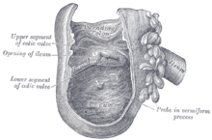](https://en.wikipedia.org/wiki/File:Gray1075.png)Cecum and beginning of ascending colon

The [cecum](https://en.wikipedia.org/wiki/Cecum) is a pouch marking the division between the small intestine and the large intestine. It lies below the [ileocecal valve](https://en.wikipedia.org/wiki/Ileocecal_valve) in the [lower right quadrant](https://en.wikipedia.org/wiki/Quadrants_and_regions_of_abdomen) of the abdomen.[[33]](https://en.wikipedia.org/wiki/Human_digestive_system#cite_note-Saladin-33) The cecum receives chyme from the last part of the small intestine, the [ileum](https://en.wikipedia.org/wiki/Ileum), and connects to the [ascending colon](https://en.wikipedia.org/wiki/Ascending_colon) of the large intestine. At this junction there is a sphincter or valve, the ileocecal valve which slows the passage of chyme from the ileum, allowing further digestion. It is also the site of the [appendix](https://en.wikipedia.org/wiki/Vermiform_appendix) attachment.[[33]](https://en.wikipedia.org/wiki/Human_digestive_system#cite_note-Saladin-33)

**Large intestine**

[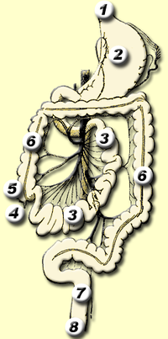](https://en.wikipedia.org/wiki/File:Gastro-intestinal_tract.png)Lower GI tract - 3) Small intestine; 5) Cecum; 6) Large intestine

*Further information:*[*Excretory system*](https://en.wikipedia.org/wiki/Excretory_system)

In the [large intestine](https://en.wikipedia.org/wiki/Large_intestine),[[2]](https://en.wikipedia.org/wiki/Human_digestive_system#cite_note-eb-2) the passage of the digesting food in the [colon](https://en.wikipedia.org/wiki/Large_intestine#Structure) is a lot slower, taking from 30 to 40 hours until it is removed by [defecation](https://en.wikipedia.org/wiki/Defecation).[[31]](https://en.wikipedia.org/wiki/Human_digestive_system#cite_note-Colorado-31) The colon mainly serves as a site for the fermentation of digestible matter by the [gut flora](https://en.wikipedia.org/wiki/Gut_flora). The time taken varies considerably between individuals. The remaining semi-solid waste is termed [feces](https://en.wikipedia.org/wiki/Feces) and is removed by the coordinated contractions of the intestinal walls, termed [peristalsis](https://en.wikipedia.org/wiki/Peristalsis), which propels the [excreta](https://en.wikipedia.org/wiki/Excreta) forward to reach the [rectum](https://en.wikipedia.org/wiki/Rectum) and exit through the [anus](https://en.wikipedia.org/wiki/Human_anus) via defecation. The wall has an outer layer of longitudinal muscles, the [taeniae coli](https://en.wikipedia.org/wiki/Taeniae_coli), and an inner layer of circular muscles. The circular muscle keeps the material moving forward and also prevents any back flow of waste. Also of help in the action of peristalsis is the [basal electrical rhythm](https://en.wikipedia.org/wiki/Basal_electrical_rhythm) that determines the frequency of contractions.[[34]](https://en.wikipedia.org/wiki/Human_digestive_system#cite_note-Wood-34) The taeniae coli can be seen and are responsible for the bulges ([haustra](https://en.wikipedia.org/wiki/Haustrum_(anatomy))) present in the colon. Most parts of the GI tract are covered with [serous membranes](https://en.wikipedia.org/wiki/Serous_membrane) and have a [mesentery](https://en.wikipedia.org/wiki/Mesentery). Other more muscular parts are lined with [adventitia](https://en.wikipedia.org/wiki/Adventitia).

Blood supply

[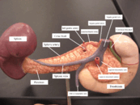](https://en.wikipedia.org/wiki/File:TIEU_0442.gif)Arteries and veins around the pancreas and spleen

The digestive system is supplied by the [celiac artery](https://en.wikipedia.org/wiki/Celiac_artery). The celiac artery is the first major branch from the [abdominal aorta](https://en.wikipedia.org/wiki/Abdominal_aorta), and is the only major artery that nourishes the digestive organs.

There are three main divisions – the [left gastric artery](https://en.wikipedia.org/wiki/Left_gastric_artery), the [common hepatic artery](https://en.wikipedia.org/wiki/Common_hepatic_artery) and the [splenic artery](https://en.wikipedia.org/wiki/Splenic_artery).

The celiac artery supplies the liver, stomach, spleen and the upper 1/3 of the duodenum (to the [sphincter of Oddi](https://en.wikipedia.org/wiki/Sphincter_of_Oddi)) and the pancreas with oxygenated blood. Most of the blood is returned to the liver via the [portal venous system](https://en.wikipedia.org/wiki/Portal_venous_system) for further processing and detoxification before returning to the [systemic circulation](https://en.wikipedia.org/wiki/Circulatory_system) via the [hepatic veins](https://en.wikipedia.org/wiki/Hepatic_veins).

The next branch from the abdominal aorta is the [superior mesenteric artery](https://en.wikipedia.org/wiki/Superior_mesenteric_artery), which supplies the regions of the digestive tract derived from the midgut, which includes the distal 2/3 of the duodenum, jejunum, ileum, cecum, appendix, ascending colon, and the proximal 2/3 of the transverse colon.

The final branch which is important for the digestive system is the [inferior mesenteric artery](https://en.wikipedia.org/wiki/Inferior_mesenteric_artery), which supplies the regions of the digestive tract derived from the hindgut, which includes the distal 1/3 of the transverse colon, descending colon, sigmoid colon, rectum, and the anus above the [pectinate line](https://en.wikipedia.org/wiki/Pectinate_line).

Blood flow to the digestive tract reaches its maximum 20–40 minutes after a meal and lasts for 1.5–2 hours.[[35]](https://en.wikipedia.org/wiki/Human_digestive_system#cite_note-35)

Nerve supply

*Further information:*[*Neurogastroenterology*](https://en.wikipedia.org/wiki/Neurogastroenterology)*and*[*Gut-brain axis*](https://en.wikipedia.org/wiki/Gut-brain_axis)

The [enteric nervous system](https://en.wikipedia.org/wiki/Enteric_nervous_system) consists of some one hundred million [neurons](https://en.wikipedia.org/wiki/Neuron)[[36]](https://en.wikipedia.org/wiki/Human_digestive_system#cite_note-36) that are embedded in the [peritoneum](https://en.wikipedia.org/wiki/Peritoneum), the lining of the [gastrointestinal tract](https://en.wikipedia.org/wiki/Human_gastrointestinal_tract) extending from the esophagus to the anus.[[37]](https://en.wikipedia.org/wiki/Human_digestive_system#cite_note-37) These neurons are collected into two [plexuses](https://en.wikipedia.org/wiki/Plexus) - the [myenteric (or Auerbach's) plexus](https://en.wikipedia.org/wiki/Myenteric_plexus) that lies between the longitudinal and the smooth muscle layers, and the [submucosal (or Meissner's) plexus](https://en.wikipedia.org/wiki/Submucosal_plexus) that lies between the circular smooth muscle layer and the mucosa.[[38]](https://en.wikipedia.org/wiki/Human_digestive_system#cite_note-urlThe_Enteric_Nervous_System-38)[[39]](https://en.wikipedia.org/wiki/Human_digestive_system#cite_note-39)[[40]](https://en.wikipedia.org/wiki/Human_digestive_system#cite_note-40)

[Parasympathetic innervation](https://en.wikipedia.org/wiki/Parasympathetic_nervous_system) to the [ascending colon](https://en.wikipedia.org/wiki/Ascending_colon) is supplied by the [vagus nerve](https://en.wikipedia.org/wiki/Vagus_nerve). [Sympathetic innervation](https://en.wikipedia.org/wiki/Sympathetic_nervous_system) is supplied by the [splanchnic nerves](https://en.wikipedia.org/wiki/Splanchnic_nerves) that join the [celiac ganglia](https://en.wikipedia.org/wiki/Celiac_ganglia). Most of the digestive tract is innervated by the two large celiac ganglia, with the upper part of each ganglion joined by the [greater splanchnic nerve](https://en.wikipedia.org/wiki/Thoracic_splanchnic_nerves) and the lower parts joined by the [lesser splanchnic nerve](https://en.wikipedia.org/wiki/Thoracic_splanchnic_nerves). It is from these ganglia that many of the [gastric plexuses](https://en.wikipedia.org/wiki/Gastric_plexuses) arise.

RESPIRATORY SYSTEM

The respiratory system includes the nose, mouth, throat, voice box, windpipe, and lungs. Air enters the respiratory system through the nose or the mouth. If it goes in the nostrils (also called nares), the air is warmed and humidified.

* + The human respiratory system consisted of a pair of nostrils openings out above the upper lips.
  + The nasal passage starts from the nostrils and ends in the nasal chamber.
  + This passage opens into the pharynx. It is the common passage for food and air and it is connected with the mouth and nose.
  + This pharynx is connected with the trachea via Larynx.
  + The larynx or soundbox, consisting of two vocal cords, is a cartilaginous box that is responsible for sound production.
  + During the time of swallowing glottis is covered by the epiglottis, a thin elastic cartilaginous flap and it prevents the entry of food particles into the larynx.
  + Trachea, a straight tube-like structure extending up to the middle of the thoracic cavity.
  + This trachea then divides at the level of the 5th thoracic vertebra into a right and left primary bronchi.
  + Each bronchus is then further divided into repeated divisions to form the secondary and tertiary.
  + Those tertiary bronchi then finally end up in very thin terminal bronchioles.
  + Many incomplete cartilaginous rings are present in the passage between the trachea and the initial bronchioles to support the structure.
  + Alveoli, very thin, irregular-walled and vascularized saclike structures are present at the end of each terminal bronchiole.
  + The branching network of bronchi, bronchioles and alveoli comprise the lungs.
  + Humans have two lungs, the left and the right lung. Both are covered by a double-layered membrane, called Pleura. Between the double layer membrane, a jelly-like fluid is also present to lower the friction on the lung surface.
  + The lungs are situated in the air-tight chamber known as the thoracic chamber.
  + The vertebral column is present in the back or dorsal position of the thoracic chamber and the sternum is present on the front side, the ribs forming the lateral walls and on the lower side, it is guarded by the dome-shaped diaphragm, a muscular membrane.

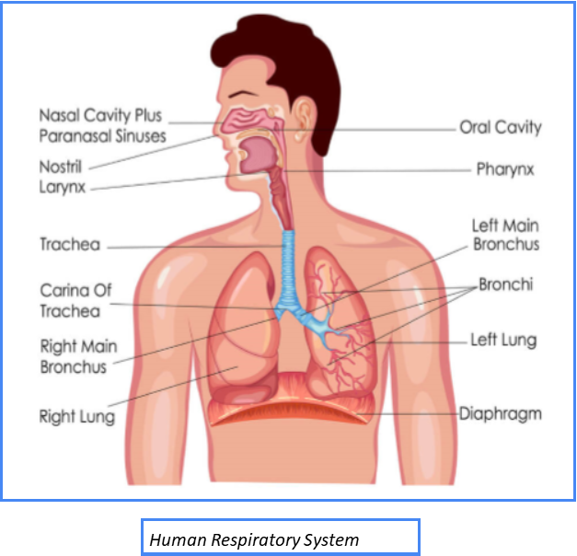

## RRRRRThere are two main parts of the human respiratory system:-

* + The conducting part: From the external nostrils up to the terminal bronchioles. It transports the atmospheric air to the alveoli, removes the foreign particles, humidifies the air and brings the air to body temperature.
  + The exchange part: The alveoli and their ducts. In this part the actual diffusion of O2 and CO2 between blood and atmospheric air takes place.

**Steps in Respiration**

* + Pulmonary ventilation or Breathing by which atmospheric air is drawn in and CO2 rich alveolar air is released out. Diffusion of gases (O2 and CO2) across the alveolar membrane.
  + Transport of gases by the blood.
  + Diffusion of O2 and CO2 between blood and tissues.
  + Utilization of O2 by the cells for catabolic reactions like cellular respiration and release of CO2 as a waste product

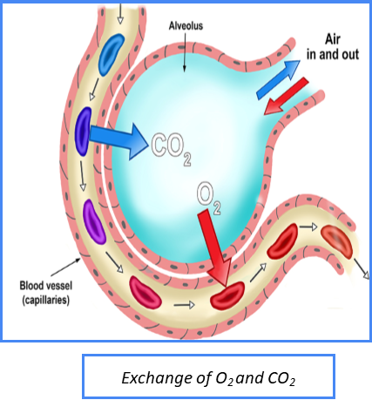

**Mechanism of Respiration**

* + Breathing involves inspiration and expiration. During inspiration atmospheric air is drawn in and during expiration, alveolar air is released out.
  + The movement of air in and out takes place due to differences in pressure gradients.
  + Inspiration occurs when the pressure inside the lung is less than atomic pressure and expiration occurs when the pressure inside the lung is more than atomic pressure.
  + The diaphragm and external and internal intercostal muscles between the ribs help in developing pressure gradients due to change in volume.
  + The contraction of intercostal muscles lifts the ribs and sternum causing an increase in the volume of the thoracic cavity that results in a decrease in pressure than the atmospheric pressure. This causes inspiration.
  + Relaxation of the diaphragm and intercostal muscles reduce the thoracic volume and increase the pressure causing expiration.
  + The volume of air involved in breathing movements is estimated by using a spirometer for the clinical assessment of pulmonary functions and volume.

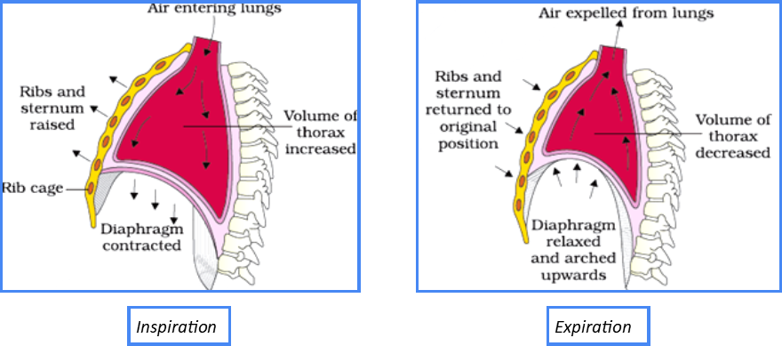

**Exchange of Gases**

* + The exchange of gases takes place at two sites
  + Alveoli to blood
  + Between blood and tissues.
  + Exchanges of gases occur by simple diffusion due to pressure/ concentration gradient, the solubility of the gases and thickness of the membrane.
  + Pressure contributed by an individual gas in a mixture of gas is known as partial pressure represented by pCO2 and pO2.
  + The partial pressure of Oxygen and carbon dioxide at different parts involved in diffusion varies from one part to another and moves from higher partial pressure to lower partial pressure.
  + The solubility of CO2 is 20-25 times more than the solubility of O2, so CO2 diffuses much faster through the membrane.
  + The diffusion membrane is three-layered thick, that is the alveolar squamous epithelium, endothelium of alveolar capillaries, and basement substance between them.

Learn about [Cell Division: Meiosis, Mitosis](https://testbook.com/biology/cell-division-meiosis-mitosis) here.

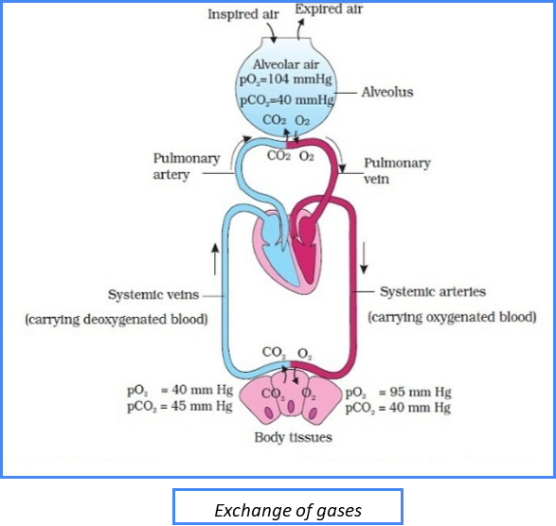

**Chloride Shift**

* + The chloride shift is defined as the movement of chloride ions from the plasma into RBCs as the blood undergoes the transition from arterial to venous gas.
  + The chloride shift is also known as the Hamburger shift. It is the process that takes place in a cardiovascular system where the exchange of bicarbonate HCO−3 and chloride Cl– across the membrane of RBCs.
  + Following are the times when does the chloride shift occur:
    - * When the chloride moves into erythrocytes and bicarbonate moves out into the venous blood.
      * When chloride moves out and bicarbonate moves into the pulmonary capillaries.

[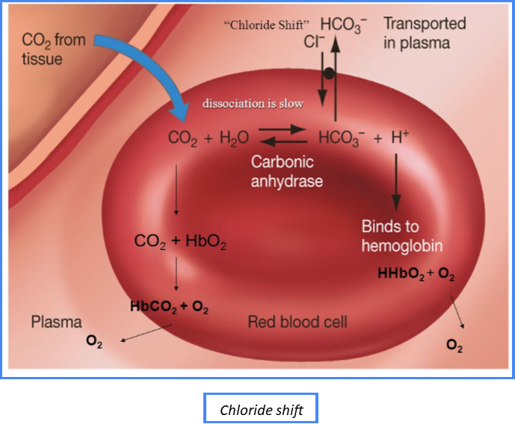](https://blogmedia.testbook.com/blog/wp-content/uploads/2021/06/hrs5-371d09a8.png)

Learn about [ANS, PNS and CNS](https://testbook.com/biology/human-nervous-system-ans-pns-cns) here.

**Regulation of Respiration**

* The central nervous system controls Breathing.
* Respiratory centres are situated in the medulla oblongata and pons Varolii and they regulate the rate and depth of breathing. This is done by controlling the contraction of the diaphragm and other respiratory muscles.
* The dorsal portion of the medulla oblongata contains the inspiration centre and the ventral portion contains the expiration centre connected with the vagus nerve that innervates the lungs.
* Pons varollii contains pneumotaxic centre that can moderate the functions of the respiratory rhythm centre and apneustic centre that operates in association with the depth of the inspiration
* The neural signal from the pneumotaxic centre can reduce the duration of inspiration and thus the respiratory rate.
* A chemosensitive area is highly sensitive to CO2 and hydrogen ions. It is situated near the rhythm centre. An increase in CO2 and hydrogen ions activates this centre. It signals the rhythm centre to make necessary adjustments in the respiration process.

SKELETAL SYSTEMS

The human body is amazing because it works similarly to a city that functions properly with the help of different systems within the city. There is a grocery store that provides food, a post office that delivers mail, a power source that provides electricity to the city, and even a garbage system that keeps the city clean. Just like a city, the body is made up of different systems that work together to form a functioning human being. This includes the skeletal system.

The **skeletal system** is a part of the human body that contains bones and [connective tissue](https://study.com/academy/lesson/connective-tissue-types-functions-disorders.html), including ligaments and tendons. Each bone is made up of a hard outer shell and a porous interior, which allows the bone to have structure while remaining light. An adult human skeleton contains 206 bones that each have a particular shape so that they can perform their function well. Let's take a look at the different functions the skeletal system provides for the body.

**Skeletal System Functions**

Because the human body is made up of multiple [organ systems](https://study.com/academy/lesson/what-is-an-organ-system-definition-pictures-quiz.html), each system has its unique function to provide support for the body and help it thrive. Although it would seem obvious that the main function of the skeletal system is to provide structure and support, the skeletal system also has many other roles within the human body. Here is a list of all the functions that the skeletal system provides for the body:

**Structure and Support**

The skeletal system provides structure and support for the human body. In other words, it protects the soft tissues and organs within the body by becoming a hard barrier between the organs and the outside of the body. Also, it allows the human body to stand, sit upright, or lay down without the body caving in on itself.

**Movement**

The skeletal system provides movement for the human body. This might seem odd because bones don't move. However, [the muscular system relies on the skeletal system](https://study.com/academy/lesson/skeletal-system-and-muscular-system.html) for movement. Each bone is connected together by a soft tissue called a [**ligament**](https://study.com/academy/lesson/what-are-ligaments-definition-types-quiz.html). Ligaments are important because they keep each bone part together while providing flexibility. This flexibility is especially important for movement. Bones are also connected to the muscular system by a soft tissue called a [**tendon**](https://study.com/academy/lesson/what-is-a-tendon-anatomy-definition-quiz.html). Tendons help the skeletal system move as certain muscles contract or relax.

**Blood Cell Production**

The skeletal system provides blood cell production for the human body. Although this function is often overlooked for the skeletal system, it is one of the most important aspects of the human body. **Blood cells** are tiny units within the circulatory system that provide the body with oxygen as well as immunity and abrasion protection. Because blood cells are so important, the human body found a way to produce these cells and replace them when needed.

Found inside some of the bones of the body is **red bone marrow**, which is a red, porous bone tissue that contains **hematopoietic stem cells**, or [bone cells](https://study.com/academy/lesson/types-of-bone-cells.html) that produce blood cells. As the body requests blood cells, the hematopoietic stem cells produce the blood cells and push them into the circulatory system to do their work.

**Fat and Mineral Storage**

The skeletal system provides fat and mineral storage for the human body. Fat is stored in another type of marrow known as **yellow marrow**, which looks yellow in color and contains important cells that help with fat storage in the body. One cell is known as a **mesenchymal stem cell**, which is a cell that helps produce cells for cartilage, fat storage, and cells that repair bones. When energy is needed by the body, the yellow marrow will release its stored fat energy into the human body to be used up.

The skeletal system is also responsible for mineral and vitamin storage in the body. Certain muscles and organs need minerals and vitamins to function properly. When there is a lack of these minerals and vitamins within the body, it will turn to its skeletal system to release stored minerals and vitamins within the bones into the bloodstream to be used by the body. Calcium, phosphorus, and vitamin D are [examples of the minerals](https://study.com/academy/lesson/what-are-minerals-types-properties-examples.html) and vitamins stored by the skeletal system.

**Skeletal System Organs**

|  |
| --- |
| Diagram of the skeletal system |
| ***Skeletal system*** |

An adult human skeletal system contains 206 bones, 360 joints, and many tendons, ligaments, and cartilage that help the skeletal system perform its functions. Each of these items listed is known as an **organ**, or self-contained, functioning part of the body. Let's take a look at each individual organ part and its role within the skeletal system.

**Bones**

The main organs of the skeletal system are made up of hard, whitish, mineral-filled parts called **bones**. Bones are mostly made of **collagen**, a protein that provides the shape for the bone, and **calcium phosphate**, a mineral that helps strengthen the collagen.

|  |
| --- |
| Compact and spongy bone is part of the skeletal system. |
| ***Compact and spongy bone is part of the skeletal system.*** |

Although these organs are hard, many of the bones are not completely solid. Most of the bones contain a hard outside called **compact bone** and a porous inside called [**spongy bone**](https://study.com/academy/lesson/cancellous-bone-definition-structure-function.html). The compact bone provides support and protection to the bone, while the spongy bone provides space for the bone marrow as well as helps each bone of the skeleton be light in weight. Every bone is covered with a thin membrane called a [**periosteum**](https://study.com/academy/lesson/periosteum-of-bone-definition-function.html) that helps protect the bone from microorganisms and damage.

Because our skeletal system has many different functions, it is important that each bone has a particular shape to perform its function properly. Biologists classify each of these bone shapes into five categories:

* Long Bone: These bones are classified by their long lengths and short widths. Many of these bones contain both compact and spongy bones since they are quite large within the skeletal system. Some [examples of long bones](https://study.com/learn/lesson/long-bones-types-examples.html) are your [arm bones](https://study.com/academy/lesson/bones-of-the-arm-and-hand-anatomy-and-functions.html), such as your ulna, radius, and humerus. There are also long bones in your legs, such as the femur, tibia, and fibula.
* [Short Bone](https://study.com/learn/lesson/short-bone-characteristics-function.html): These bones are classified by their short lengths and short widths. Many of these bones also contain spongy bone and compact bone. These bones can be found together in groups performing certain motions, such as the wrist bones, or tarsals, and ankle bones, or [carpals](https://study.com/academy/lesson/carpal-bones-anatomy-function.html).
* Flat Bone: These bones are classified by their flat, smooth shape. These bones are important for protecting important organs within the body, so they are composed of mostly compact bone. Some examples of these bones are the bones of the skull, or cranial bones, and ribs.
* Irregular Bone: These bones are classified by their odd shapes and sizes. Since they do not fall under the previous three categories, they are classified together. Depending on their shape, these bones have a variety of jobs from helping you hear to providing the nervous system protection and stability in the back. Examples of these bones include ear bones, bones in your back (vertebrae), and tailbone or sacrum.
* Sesamoid Bone: These are unique in the fact that they are within tendons. One example of a sesamoid bone is your knee cap or patella.

**Joints and Cartilage**

|  |
| --- |
| This elbow joint with ligaments is part of the skeletal system. |
| ***This elbow joint with ligaments is part of the skeletal system.*** |

[Joints](https://study.com/academy/lesson/types-of-joints-joint-structures-in-the-body.html) and cartilage are important parts of the skeletal system. Together, joints and cartilage help the skeletal system move smoothly, without wearing down the hard, protective layers of the bone.

**Joints** are sections in the skeletal system where bone meets the bone. Joints are also sites where ligaments, tendons, and cartilage are present. Because joints join bones together, it's important that these areas are highly lubricated with fluid so that there is smooth movement between the bones. There are three main types of joints:

* Movable Joints: This is where bones that connect at the joint move constantly with a wide range. Some examples of movable joints are your elbows and knees.
* Partly Movable Joints: This is where bones that connect at the joint move just slightly to compensate for other movements around the body. An example of this type of joint is found in the [rib cage](https://study.com/academy/lesson/rib-cage-anatomy-facts-function-humans.html), where the bones expand and collapse as you breathe in and out.
* Immovable Joints: This is where bones that contact at the joints don't move at all, such as your skull bones.

**Cartilage** is a type of tissue that is rigid but flexible. It is important for the skeletal system because it helps protect the bones from wear and tear by covering bone surfaces, especially near joints. This is helpful for preventing friction and roughness on the bones that are in motion side-by-side. Some places where cartilage can be found are in your hand bones, backbones, and [leg bones](https://study.com/academy/lesson/bones-of-the-leg-and-foot-names-anatomy-functions.html).

**Ligaments**

Ligaments are tissues that hold one bone to another bone and provide flexibility. These tissues are very important for the skeletal system because they keep the bones of the skeletal system connected to one another. This allows the skeleton to have full structure. A well-known ligament within your body is your ACL, or anterior cruciate ligament, which attaches your femur to your tibia.

**Tendons**

Tendon is a soft tissue that connects bone to muscle, allowing for movement in the skeletal system. Tendons are important for the skeleton because they allow movement to occur. Muscles that contract pull on the tendon that is connected to the bone. This allows the bone to move. An example is your Achilles tendon, which connects the muscles of the back of your leg to your leg bones.

**Skeletal System Diseases**

|  |
| --- |
| This hip bone with osteoporosis is an example of a skeletal system disease. |
| ***This hip bone with osteoporosis is an example of a skeletal system disease.*** |

Although the skeletal system seems pretty well designed, there are a few diseases that can break down this body system. Some of the most common [skeletal system diseases](https://study.com/academy/lesson/common-disorders-of-the-skeletal-system.html) are:

* Osteoporosis is a [disease of the bone](https://study.com/academy/lesson/types-of-bone-diseases.html) where bones become fragile and brittle because of a lack of nutrients to the bone. This disease is quite common among women.
* Leukemia is a disease of the bone marrow where abnormal blood cells are being formed, especially white blood cells. When this occurs, the body's immunity decreases because these white cells don't know how to fight off diseases.
* Arthritis is a disease where joints swell up due to injury or infection that causes pain with every movement in that joint. Many athletes or elderly individuals develop arthritis over time.
* Osteocarcenoma is a disease where cancer cells form tumors in the bone. This in turn causes bone tissues to break down. This type of cancer is aggressive and can manifest at any age.
* Tendonitis is a disease of the tendons where injury to the tendon causes it to swell and become painful. This disease occurs with most athletes.

MUSCULAR SYSTEM

In the muscular system, skeletal muscles are connected to the skeleton, either to bone or to connective tissues such as ligaments. Muscles are always attached at two or more places. When the muscle contracts, the attachment points are pulled closer together; when it relaxes, the attachment points move

The **muscular system** is an [organ system](https://en.wikipedia.org/wiki/Organ_(anatomy)) consisting of [skeletal](https://en.wikipedia.org/wiki/Skeletal_muscle), [smooth](https://en.wikipedia.org/wiki/Smooth_muscle), and [cardiac](https://en.wikipedia.org/wiki/Cardiac_muscle) muscle. It permits movement of the body, maintains posture, and circulates blood throughout the body.[[1]](https://en.wikipedia.org/wiki/Muscular_system#cite_note-:0-1) The muscular systems in [vertebrates](https://en.wikipedia.org/wiki/Vertebrate) are controlled through the [nervous system](https://en.wikipedia.org/wiki/Nervous_system) although some muscles (such as the [cardiac muscle](https://en.wikipedia.org/wiki/Cardiac_muscle)) can be completely autonomous. Together with the [skeletal system](https://en.wikipedia.org/wiki/Human_skeleton) in the human, it forms the [musculoskeletal system](https://en.wikipedia.org/wiki/Musculoskeletal_system), which is responsible for the movement of the [body](https://en.wikipedia.org/wiki/Human_body).[[2]](https://en.wikipedia.org/wiki/Muscular_system#cite_note-2)

Types[[edit](https://en.wikipedia.org/w/index.php?title=Muscular_system&action=edit&section=1" \o "Edit section: Types)]

*Main article:*[*Muscle tissue*](https://en.wikipedia.org/wiki/Muscle_tissue)

[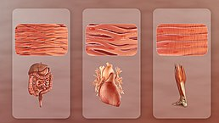](https://en.wikipedia.org/wiki/File:Types_Of_Muscle.jpg)Three distinct types of muscle (L to R): Smooth (non-striated) muscle in internal organs, cardiac or heart muscle, and skeletal muscle.

There are three distinct types of muscle: [skeletal muscle](https://en.wikipedia.org/wiki/Skeletal_muscle), [cardiac or heart muscle](https://en.wikipedia.org/wiki/Cardiac_muscle), and [smooth (non-striated) muscle](https://en.wikipedia.org/wiki/Smooth_muscle). [Muscles](https://en.wikipedia.org/wiki/Muscle) provide strength, balance, posture, movement, and heat for the body to keep warm.[[3]](https://en.wikipedia.org/wiki/Muscular_system#cite_note-:1-3)

There are approximately 640 muscles in an adult male human body.[[4]](https://en.wikipedia.org/wiki/Muscular_system#cite_note-4) A kind of elastic tissue makes up each muscle, which consists of thousands, or tens of thousands, of small muscle fibers. Each fiber comprises many tiny strands called fibrils, impulses from nerve cells control the contraction of each muscle fiber.

**Skeletal**[[edit](https://en.wikipedia.org/w/index.php?title=Muscular_system&action=edit&section=2" \o "Edit section: Skeletal)]

*Main article:*[*Skeletal muscle*](https://en.wikipedia.org/wiki/Skeletal_muscle)

*See also:*[*List of muscles of the human body*](https://en.wikipedia.org/wiki/List_of_muscles_of_the_human_body)

Skeletal muscle, is a type of [striated muscle](https://en.wikipedia.org/wiki/Striated_muscle), composed of [muscle cells](https://en.wikipedia.org/wiki/Muscle_cell), called [muscle fibers](https://en.wikipedia.org/wiki/Skeletal_muscle#Skeletal_muscle_cells), which are in turn composed of [myofibrils](https://en.wikipedia.org/wiki/Myofibrils). Myofibrils are composed of [sarcomeres](https://en.wikipedia.org/wiki/Sarcomere), the basic building blocks of striated muscle tissue. Upon stimulation by an [action potential](https://en.wikipedia.org/wiki/Action_potential), skeletal muscles perform a coordinated contraction by shortening each sarcomere. The best proposed model for understanding contraction is the [sliding filament model](https://en.wikipedia.org/wiki/Sliding_filament_model) of muscle contraction. Within the sarcomere, [actin](https://en.wikipedia.org/wiki/Actin) and [myosin](https://en.wikipedia.org/wiki/Myosin) fibers overlap in a contractile motion towards each other. Myosin filaments have club-shaped [myosin heads](https://en.wikipedia.org/wiki/Myosin_head) that project toward the actin filaments,[[1]](https://en.wikipedia.org/wiki/Muscular_system" \l "cite_note-:0-1)[[3]](https://en.wikipedia.org/wiki/Muscular_system#cite_note-:1-3)[[5]](https://en.wikipedia.org/wiki/Muscular_system#cite_note-:2-5) and provide attachment points on binding sites for the actin filaments. The myosin heads move in a coordinated style; they swivel toward the center of the sarcomere, detach and then reattach to the nearest active site of the actin filament. This is called a ratchet type drive system.[[5]](https://en.wikipedia.org/wiki/Muscular_system#cite_note-:2-5)

This process consumes large amounts of [adenosine triphosphate](https://en.wikipedia.org/wiki/Adenosine_triphosphate) (ATP), the energy source of the cell. ATP binds to the cross-bridges between myosin heads and actin filaments. The release of energy powers the swiveling of the myosin head. When ATP is used, it becomes [adenosine diphosphate](https://en.wikipedia.org/wiki/Adenosine_diphosphate) (ADP), and since muscles store little ATP, they must continuously replace the discharged ADP with ATP. Muscle tissue also contains a stored supply of a fast-acting recharge chemical, [creatine phosphate](https://en.wikipedia.org/wiki/Creatine_phosphate), which when necessary can assist with the rapid regeneration of ADP into ATP.[[6]](https://en.wikipedia.org/wiki/Muscular_system#cite_note-:3-6)

[Calcium ions](https://en.wikipedia.org/wiki/Calcium_ions) are required for each cycle of the sarcomere. Calcium is released from the [sarcoplasmic reticulum](https://en.wikipedia.org/wiki/Sarcoplasmic_reticulum) into the [sarcomere](https://en.wikipedia.org/wiki/Sarcomere) when a muscle is stimulated to contract. This calcium uncovers the actin-binding sites. When the muscle no longer needs to contract, the calcium ions are pumped from the sarcomere and back into storage in the [sarcoplasmic reticulum](https://en.wikipedia.org/wiki/Sarcoplasmic_reticulum).[[5]](https://en.wikipedia.org/wiki/Muscular_system#cite_note-:2-5)

There are approximately 639 skeletal muscles in the human body.

* [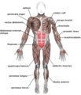](https://en.wikipedia.org/wiki/File:Muscles_anterior_labeled.png)

Skeletal muscles, viewed from the front

* [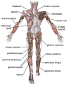](https://en.wikipedia.org/wiki/File:Muscle_posterior_labeled.png)

Skeletal muscles, viewed from the back

**Cardiac**[[edit](https://en.wikipedia.org/w/index.php?title=Muscular_system&action=edit&section=3" \o "Edit section: Cardiac)]

*Main article:*[*Cardiac muscle*](https://en.wikipedia.org/wiki/Cardiac_muscle)

Heart muscle is striated muscle but is distinct from skeletal muscle because the [muscle fibers](https://en.wikipedia.org/wiki/Muscle_fibers) are laterally connected. Furthermore, just as with smooth muscles, their movement is involuntary. Heart muscle is controlled by the [sinus node](https://en.wikipedia.org/wiki/Sinus_node) influenced by the [autonomic nervous system](https://en.wikipedia.org/wiki/Autonomic_nervous_system).[[1]](https://en.wikipedia.org/wiki/Muscular_system#cite_note-:0-1)[[3]](https://en.wikipedia.org/wiki/Muscular_system#cite_note-:1-3)

**Smooth**[[edit](https://en.wikipedia.org/w/index.php?title=Muscular_system&action=edit&section=4" \o "Edit section: Smooth)]

*Main article:*[*Smooth muscle*](https://en.wikipedia.org/wiki/Smooth_muscle)

Smooth muscle contraction is regulated by the autonomic [nervous system](https://en.wikipedia.org/wiki/Nervous_system), [hormones](https://en.wikipedia.org/wiki/Hormone), and local chemical signals, allowing for gradual and sustained contractions. This type of [muscle tissue](https://en.wikipedia.org/wiki/Muscle_tissue) is also capable of adapting to different levels of stretch and tension, which is important for maintaining proper blood flow and the movement of materials through the [digestive system](https://en.wikipedia.org/wiki/Human_digestive_system).

Physiology[[edit](https://en.wikipedia.org/w/index.php?title=Muscular_system&action=edit&section=5" \o "Edit section: Physiology)]

**Contraction**[[edit](https://en.wikipedia.org/w/index.php?title=Muscular_system&action=edit&section=6" \o "Edit section: Contraction)]

|  |  |
| --- | --- |
| [https://upload.wikimedia.org/wikipedia/en/thumb/9/99/Question_book-new.svg/50px-Question_book-new.svg.png](https://en.wikipedia.org/wiki/File:Question_book-new.svg) | This section **does not**[**cite**](https://en.wikipedia.org/wiki/Wikipedia:Citing_sources)**any**[**sources**](https://en.wikipedia.org/wiki/Wikipedia:Verifiability). Please help [improve this section](https://en.wikipedia.org/w/index.php?title=Muscular_system&action=edit) by [adding citations to reliable sources](https://en.wikipedia.org/wiki/Help:Referencing_for_beginners). Unsourced material may be challenged and [removed](https://en.wikipedia.org/wiki/Wikipedia:Verifiability#Burden_of_evidence). *(October 2016) (*[*Learn how and when to remove this template message*](https://en.wikipedia.org/wiki/Help:Maintenance_template_removal)*)* |

[Neuromuscular junctions](https://en.wikipedia.org/wiki/Neuromuscular_junctions) are the focal point where a [motor neuron](https://en.wikipedia.org/wiki/Motor_neuron) attaches to a muscle. Acetylcholine, (a [neurotransmitter](https://en.wikipedia.org/wiki/Neurotransmitter) used in skeletal muscle contraction) is released from the axon terminal of the nerve cell when an action potential reaches the microscopic junction called a [synapse](https://en.wikipedia.org/wiki/Synapse). A group of chemical messengers across the synapse and stimulate the formation of electrical changes, which are produced in the muscle cell when the acetylcholine binds to receptors on its surface. Calcium is released from its storage area in the cell's sarcoplasmic reticulum. An impulse from a nerve cell causes calcium release and brings about a single, short [muscle contraction](https://en.wikipedia.org/wiki/Muscle_contraction) called a [muscle twitch](https://en.wikipedia.org/wiki/Muscle_twitch). If there is a problem at the neuromuscular junction, a very prolonged contraction may occur, such as the muscle contractions that result from [tetanus](https://en.wikipedia.org/wiki/Tetanus). Also, a loss of function at the junction can produce [paralysis](https://en.wikipedia.org/wiki/Paralysis).[[5]](https://en.wikipedia.org/wiki/Muscular_system#cite_note-:2-5)

Skeletal muscles are organized into hundreds of [motor units](https://en.wikipedia.org/wiki/Motor_unit), each of which involves a motor neuron, attached by a series of thin finger-like structures called [axon terminals](https://en.wikipedia.org/wiki/Chemical_synapse#Anatomy_and_physiology). These attach to and control discrete bundles of muscle fibers. A coordinated and fine-tuned response to a specific circumstance will involve controlling the precise number of motor units used. While individual muscle units contract as a unit, the entire muscle can contract on a predetermined basis due to the structure of the motor unit. Motor unit coordination, balance, and control frequently come under the direction of the [cerebellum](https://en.wikipedia.org/wiki/Cerebellum) of the brain. This allows for complex muscular coordination with little conscious effort, such as when one drives a car without thinking about the process.[[5]](https://en.wikipedia.org/wiki/Muscular_system#cite_note-:2-5)[[7]](https://en.wikipedia.org/wiki/Muscular_system#cite_note-7)

**Tendon**[[edit](https://en.wikipedia.org/w/index.php?title=Muscular_system&action=edit&section=7" \o "Edit section: Tendon)]

*Main article:*[*Tendon*](https://en.wikipedia.org/wiki/Tendon)

A tendon is a piece of connective tissue that connects a muscle to a bone.[[8]](https://en.wikipedia.org/wiki/Muscular_system#cite_note-8) When a muscle contracts, it pulls against the skeleton to create movement. A tendon connects this muscle to a bone, making this function possible.

**Aerobic and anaerobic muscle activity**[[edit](https://en.wikipedia.org/w/index.php?title=Muscular_system&action=edit&section=8" \o "Edit section: Aerobic and anaerobic muscle activity)]

At rest, the body produces the majority of its [ATP](https://en.wikipedia.org/wiki/Adenosine_triphosphate) aerobically in the [mitochondria](https://en.wikipedia.org/wiki/Mitochondria)[[9]](https://en.wikipedia.org/wiki/Muscular_system#cite_note-9) without producing [lactic acid](https://en.wikipedia.org/wiki/Lactic_acid) or other fatiguing byproducts. During exercise, the method of ATP production varies depending on the fitness of the individual as well as the duration and intensity of exercise. At lower activity levels, when exercise continues for a long duration (several minutes or longer), energy is produced aerobically by combining oxygen with [carbohydrates](https://en.wikipedia.org/wiki/Carbohydrate) and [fats](https://en.wikipedia.org/wiki/Fat) stored in the body.[[6]](https://en.wikipedia.org/wiki/Muscular_system#cite_note-:3-6)[[10]](https://en.wikipedia.org/wiki/Muscular_system#cite_note-10)

During activity that is higher in intensity, with possible duration decreasing as intensity increases, ATP production can switch to anaerobic pathways, such as the use of the [creatine phosphate](https://en.wikipedia.org/wiki/Phosphocreatine) and the phosphagen system or anaerobic [glycolysis](https://en.wikipedia.org/wiki/Glycolysis). Aerobic ATP production is biochemically much slower and can only be used for long-duration, low-intensity exercise, but produces no fatiguing waste products that can not be removed immediately from the [sarcomere](https://en.wikipedia.org/wiki/Sarcomere) and the body, and it results in a much greater number of ATP molecules per fat or carbohydrate molecule. Aerobic training allows the oxygen delivery system to be more efficient, allowing aerobic metabolism to begin quicker. Anaerobic ATP production produces ATP much faster and allows near-maximal intensity exercise, but also produces significant amounts of [lactic acid](https://en.wikipedia.org/wiki/Lactic_acid) which render high-intensity exercise unsustainable for more than several minutes. The phosphagen system is also anaerobic. It allows for the highest levels of exercise intensity, but intramuscular stores of [phosphocreatine](https://en.wikipedia.org/wiki/Phosphocreatine) are very limited and can only provide energy for exercises lasting up to ten seconds. Recovery is very quick, with full creatine stores regenerated within five minutes.[[](https://en.wikipedia.org/wiki/Muscular_system#cite_note-:3-6)

EXCRETORY SYSTEM

Human excretory system includes organs that facilitate the removal of nitrogenous wastes from the body. The main excretory organs include kidney, ureter, urinary bladder and urethra. Kidneys filter the blood and urine is the filtrate obtained.

The generation of energy from food leads to the generation of waste too in the human body. The bi-products of the various chemical and physiological processes which are no longer needed for the human body need to be eliminated from the body. For simple organisms such as [unicellular organisms](https://www.vedantu.com/biology/unicellular-organisms), excretion is also simple and takes place by the elimination of gases and water or by diffusion. Inside the complex bodies of human beings, excretion is also a complex process that takes place through an organ system composed of various organs.

We all get our nutrients from various sources, which are then digested and processed in our bodies. The process of digestion and metabolism helps us absorb nutrients and generate energy in our bodies. These chemical reactions and processes lead to the production of toxic substances. Following metabolic responses, the body begins to separate helpful and hazardous molecules in an individual. Toxin buildup, as we all know, may be dangerous, and the body eliminates all metabolic wastes through a process known as excretion.

These toxic substances, if kept inside the body for a long time, will start affecting it. Hence, they need to be thrown out from the body regularly. The process of excretion makes sure that the body gets rid of the toxic substances from the body time to time.

There are various modes of excretion. Depending upon the morphology of the organism, the habitat where it lives, or the kind of waste products generated, excretion takes place in various ways by various means.

Excretion can be carried out by lungs, skin, kidneys, etc.

Aquatic creatures, for example, fishes, have abundant availability of water, hence the waste generated in fishes is ammonia, which is highly soluble in water. Humans generate urea as a waste product that is fairly soluble in water. That is also why we are suggested to drink plenty of water, so that elimination of waste from our body takes place smoothly. In the case of birds, they hardly have the availability of water, and the waste generated in their bodies is uric acid, which requires less water to keep the process of excretion going.

Let us take a closer look at the excretory system notes to learn more about the excretory system in humans, distinct organs of the excretory system, and the excretory mechanism in humans.

**Human Excretory System**

A dedicated system of organs that removes waste products from the human body is called the human excretory system. The major waste product generated in the human body is urea. Along with which some other toxins are also generated. Urea is eliminated by kidneys in the form of liquid by the process of urination and solid wastes are removed from the body by the intestines.

**Organs of the Excretory System**

Organs of the human excretory system include:

* A set of kidneys
* A [ureter](https://www.vedantu.com/biology/ureter) and a uretero-uretero-uretero
* A bladder that stores urine
* The urethra

**Excretory System Organs**

The main organs of the human excretory system are-

* Kidneys
* Ureters
* bladder
* [urethra](https://www.vedantu.com/biology/urethra)

These organs work together to remove nitrogenous waste- urea from our bodies.

**The kidney's structure is described below:**

**Kidneys**

The kidneys are bean-shaped organs that are positioned on either side of the backbone and are protected by the ribs and back muscles. They are primarily responsible for the production of [urine](https://www.vedantu.com/biology/urine). Kidneys collect waste from our bloodstream and turn that waste into a simpler form (urine) which is then eliminated from the body. Kidneys are present in the [abdomen](https://www.vedantu.com/biology/abdomen), just below the diaphragm. Each adult human [kidney](https://www.vedantu.com/biology/structure-of-kidney) measures 10-12 cm in length, 5-7 cm in breadth, and weighs 120-170g.

The kidneys have a concave inner structure. The blood vessels, ureter and nerves enter the kidneys through the hilum, which is a notch at the inner concave surface of the kidney. The renal pelvis, a large funnel-shaped space that is present inner to the hilum, has many projections known as calyces.

Kidneys are made up of a number of subunits called nephrons. The kidney is divided into two major structures-

**Capsule**

The capsule refers to the outer layer. The kidney is divided into two zones: the cortex on the outside and the medulla on the inside. As renal columns are known as columns of Bertin, the cortex spreads between the medullary pyramids.

1. **Outer renal cortex**

The outer part of the kidneys consists of the glomerulus and convoluted tubules from the outer cortex. The outer cortex is surrounded by the renal capsule. The renal cortex provides the space for the renal artery and veins and glomerular capillaries. Apart from providing a protective layer it also manufactures the hormone Erythropoietin, which is necessary for the synthesis of new [blood cells](https://www.vedantu.com/biology/blood-cells).

1. **Inner renal medulla**

The inner smooth part of the kidney which consists of the Loop of Henle and [renal pyramids](https://www.vedantu.com/biology/renal-pyramids) forms the Renal Medulla.

**Nephrons**

The functioning units of the kidney are known as nephrons. Each of our kidneys has as many as 1 million nephrons in each human kidney. The basic functions of nephrons are to carry out secretion as well as the process of excretion. Each nephron is made up of two parts: the glomerulus and the renal tubule.

* **Glomerulus** - Glomerulus is a mass of capillaries Glomerulus is a collection of capillaries created by afferent arterioles which absorb protein from the blood that travels through the Malpighian Body. Different arterioles transport blood out from the glomerulus.
* **Renal Tubule** - Bowman's capsule, which encloses the glomerulus, forms the beginning of the renal tubule. The malpighian body is made up of the glomerulus and the Bowman's capsule. The proximal convoluted tubule is the heavily coiled structure in the tubule adjacent to Bowman's capsule. Renal Tubule is composed of a Proximal convoluted tubule that lies in the cortex and absorbs water, sodium, and glucose back into the blood, a distal convoluted tubule that reabsorbs sodium into the blood and absorbs potassium and acid from blood and Loop of Henle.

**Henle's loop**

Henle's loop is the long ‘U tubule’ which has an ascending and descending limb and is the next section of the tubule. As a distal convoluted tubule, the ascending loop continues. Many nephrons have distal convoluted tubules that open into the collecting duct. It is primarily involved in the recovery of water and sodium chloride from urine is Loop of Henle. The Loop of Henle produces very concentrated urine. Therefore, desert animals have a highly efficient Loop of Henle to carry out excretion with a very less amount water. The Loop of Henle lies in the medulla region.

**Nephrons are of two types, namely**

1. **Cortical Nephrons** - The nephrons which are at a higher position in the cortex with a Short Loop of Henle which does not penetrate into the medulla are called Cortical Nephrons.
2. **Juxtamedullary Nephrons** - Juxtamedullary nephrons have a longer Loop of Henle which runs deeper into the Renal Medulla.

**Ureter**

Each kidney is connected to the renal pelvis by a thin and muscular tube. This tube is called the Ureter. The function of the ureter is to propel urine from the kidneys to the [urinary bladder](https://www.vedantu.com/biology/urinary-bladder) from time to time.

**Urinary Bladder**

Urinary bladder is the organ that controls the passage of urine. It is a muscular sac-like structure present above the pubic bone that stores urine. The average capacity of a human bladder is 400-600 ml. It holds urine until its capacity and expels it by the process of micturition when it is full. The bladder is lined by muscular tissue, which squeezes during micturition allowing the urine to flow out.

**Urethra**

The urethra is a tube made up of fibro-muscular tissue and emerges from the lower opening of the urinary bladder and extends through urogenital and pelvic diaphragms and opens out of the body through an external urethral orifice. It aids in the removal of urine from the body. In males, it carries the sperms as well. The Urethra is guarded by the sphincter which relaxes during urination.

**The function of the Human Excretory System**

The main function of the human excretory system is to eliminate wastes from the body which are generated as the bi-products of metabolism. The excretory system works in order to maintain homeostasis. Homeostasis is maintaining an equilibrium in the body by keeping the temperature and fluid balance stable. Apart from the metabolic wastes, there are other chemical and hormonal wastes too which are generated in the body and are excreted by various processes. The urinary system, however, filters the blood of nitrogenous waste- urea, salts, and excess water and excretes them out of the body in the form of urination. Kidneys also help in the reabsorption of useful substances.

The filtration of blood occurs in the nephrons in kidneys. Millions of nephrons work together to absorb minerals like glucose, amino acid, salts and let the pure blood flow to other parts of the body. Urea and excess water are converted into urine which is passed to the bladder through the ureters and expelled from the body through the urethra. The Urinary bladder holds the urine for some time, till it's full and receives signals from the brain. Upon receiving the signal, the sphincters at the opening of the bladder relax and urine is expelled.

**Excretion Mechanism in Humans : Process of Urine formation**

In humans, Urine is generated in the nephrons and the elimination process is divided into the following steps:

* Glomerular Filtration
* Tubular Reabsorption
* Secretion

**Glomerular Filtration**

The first step of urine formation occurs in the glomerulus of the kidneys. The blood enters the glomerular capillaries by afferent arteriole and leaves by an efferent arteriole. In this process excess water, ions, glucose, and waste products are eliminated from the blood into the urine collection which is then eliminated from the body.

The glomerular filtrate consists of water, glucose, ions along urea. Therefore, these necessary substances need to be reabsorbed into the body. It happens by tubular reabsorption.

The rate at which the glomerulus filters blood and produces a filtrate is called the glomerular filtration rate.

**Tubular Reabsorption**

It is the second step of urine formation and is a very important step, as it makes sure that essential substances and ions are excreted from our bodies. In this process, ions and substances such as sodium ions, glucose, amino acids, water, etc are absorbed. It also ensures less water loss. There are two types of transport taking place during tubular reabsorption.

1. **Active transport**- Glucose and Ions are absorbed by active transport.
2. **Passive transport**- Water is absorbed by passive transport.

Various tubules that carry out the process of reabsorption are as follows.

1. **Proximal Convoluted Tubule (PCT) -** The PCT reabsorbs ion, water, and nutrients from the filtrate. By secreting potassium, hydrogen, and ammonia to filtrate and reabsorbing bicarbonate ions from the filtrate. It also eliminates toxins from the filtrate aid in regulating the ionic balance and pH of bodily fluids. thus maintaining the pH of the filtrate.
2. **Ascending loop of Henle** - Allows the reabsorption of sodium and chloride ions from the filtrate.
3. Descending Loop of Henle is impervious to water but permeable to electrolytes. The passage of electrolytes from the filtrate to the medullary fluid dilutes the filtrate. It allows the reabsorption of water.
4. **Distal Tubule** - Reabsorbs selective ions from the filtrate including sodium chloride ions. The Distal Convoluted Tubule (DCT) is responsible for the reabsorption of water and sodium ions. It also aids in the maintenance of pH and ionic equilibrium by the secretion and reabsorption of ions such as PCT.
5. **Collecting duct** - Connect the nephrons to the minor calyx or renal pelvis and reabsorbs a substantial amount of solutes and water from the filtrate.

**Secretion**

Along with the formation of urine, the waste ions like hydrogen and potassium, and ammonia are secreted out which are then mixed with the urine and expelled from the body. This is called secretion.

After a series of these processes, the bladder gets filled with urine. Upon signaling from the brain, the bladder relaxes and releases urine from the body by the process of micturition or urination.

**Micturition**

The bladder is stretched and filled with urine produced by the nephrons. The receptors on the urinary bladder walls convey signals to the Central Nervous System, allowing the sphincter muscles to relax and discharge urine. This is referred to as micturition.

**Human Urine Excretion:**

**Excretion**

Excretion is the process through which all metabolic wastes are eliminated from the organism. Excretion in humans occurs via a succession of procedures that include various bodily components and internal organs.

**Diffusion:** Diffusion is the most prevalent excretory mechanism in lower species. A human body is a remarkable mechanism in which several living activities (respiration, circulation, digestion, and so on) occur at the same time. As a result, many waste products created in our bodies take numerous forms, such as carbon dioxide, water, and nitrogenous compounds such as urea, ammonia, and uric acid. In addition, toxins and other hazardous components derived from pharmaceuticals and hormonal products are created. Simple diffusion will not suffice to remove these wastes from our bodies. Kidneys, which separate beneficial substances via reabsorption from poisonous substances via urine production.

The nephron is a structural filtration unit of the kidney where blood is filtered. A million nephrons are found in each kidney. Capillaries in the kidneys filter the blood, reabsorbing vital chemicals such as glucose, amino acids, salts, and the appropriate quantity of water before returning the blood to circulation.

In humans, urine is formed from excess water and nitrogenous waste. The ureters transport the generated urine to the urinary bladder. The urine bladder is controlled by the Central Nervous System. The brain causes the urinary bladder to contract, and urine is excreted through the urinary opening known as the urethra.

**Dialysis**

The kidneys fail to fulfil their tasks under specific conditions, such as insufficient blood supply to the kidneys, infections, trauma, and so on. In such cases, artificial kidneys are employed for blood filtering, a process known as dialysis.

Aside from the urinary system, the skin, lungs, and even the eyes aid in the excretion of waste items in various forms. Sweating is a method of excretion in which water, urea, and other salts are expelled via the skin. Lungs assist us in exhaling gaseous wastes such as carbon dioxide, nitrogen, and others.

**Important Information About the Human Excretory System**

* The human excretory system consists of organs that aid in the elimination of nitrogenous wastes from the body.
* The kidney, ureter, urinary bladder, and urethra are the primary excretory organs.
* The blood is filtered by the kidneys, and the filtrate is urine.
* Urine travels from the ureter to the urinary bladder before being evacuated from the body. This is referred to as micturition.
* Through excessive purification and filtration, kidneys also manage the osmotic pressure of a mammal's blood. This is referred to as osmoregulation.
* This was a thorough examination of the human excretory system.

 NERVOUS SYSTEM

The nervous system has two main parts: The central nervous system is made up of the brain and spinal cord. The peripheral nervous system is made up of nerves that branch off from the spinal cord and extend to all parts of the body.

Living organisms adapt to their moves and positions in response to the environmental changes for their protection or to their advantage. When an entity reacts to the changes in its surroundings, it is referred to as stimulus while the reaction to the stimulus is referred to as a response. Common stimuli are sound, light, air, heat, smell, taste, water and gravity.

Think of burning your finger of fracturing your bone without any pain sensation. It may certainly sound like a superpower or an ideal situation, however, when it comes to the standpoint of survival, it can be disastrous.

The characteristic behaviour of living entities is to respond to stimuli with the intervention of the nervous system. It is an organ system ascribed to send signals from the spinal cord and the brain throughout the body and then back from all the body parts to the brain. The neuron acts as the mediator and is the basic signalling unit of the nervous system.

Pain is the body’s way of letting us know that something is not right. It can prevent further injuries or push us to seek medical attention. Moreover, all of this is possible because humans can respond and react to stimuli due to control and coordination among the various organs and organ systems.

Control and Coordination in simple multicellular organisms take place through only the Nervous system which coordinates activities of our body. It is the control system for all our actions, thinking, and behaviour.

Refer more: [Control and Coordination](https://byjus.com/biology/control-and-coordination/)

Let us have a detailed look at the nervous system notes to explore what is the nervous system, and the different functions of the nervous system with the help of diagrams.  
**Table of Contents**

* [What is the Nervous System?](https://byjus.com/#what-is-the-nervous-system?)
* [Human Nervous System Diagram](https://byjus.com/#human-nervous-system-diagram)
* [Central Nervous System](https://byjus.com/#central-nervous-system)
* [Peripheral Nervous System](https://byjus.com/#peripheral-nervous-system)
* [Neuron](https://byjus.com/#neuron)
* [Nerves](https://byjus.com/#nerves)

**Recommended Video:**

3,53,617

**What is the Nervous System?**

The nervous system or the neural system is a complex network of neurons specialized to carry messages**.**The complexity of the nervous system increases as we move towards higher animals.

For instance, cnidarians such as jellyfish have relatively simple nerve nets spread throughout their body. Crabs have a more complicated nervous system in the form of 2 nerve centers called dorsal ganglion and ventral ganglion.

As we move further up the ladder, higher organisms such as vertebrates have a developed brain. Moreover, it is one of the most complicated structures in the animal kingdom, containing billions of neurons, all intricately connected.

In the human body, the neural system integrates the activities of organs based on the stimuli, which the neurons detect and transmit. They transmit messages in the form of electrical impulses and convey messages to and from the sense organs. Thus, the nervous coordination involves the participation of the sense organs, nerves, spinal cord, and brain.

**Also Read:**[Creutzfeldt-Jakob Disease](https://byjus.com/biology/creutzfeldt-jakob-disease-cjd/)

**Human Nervous System Diagram**

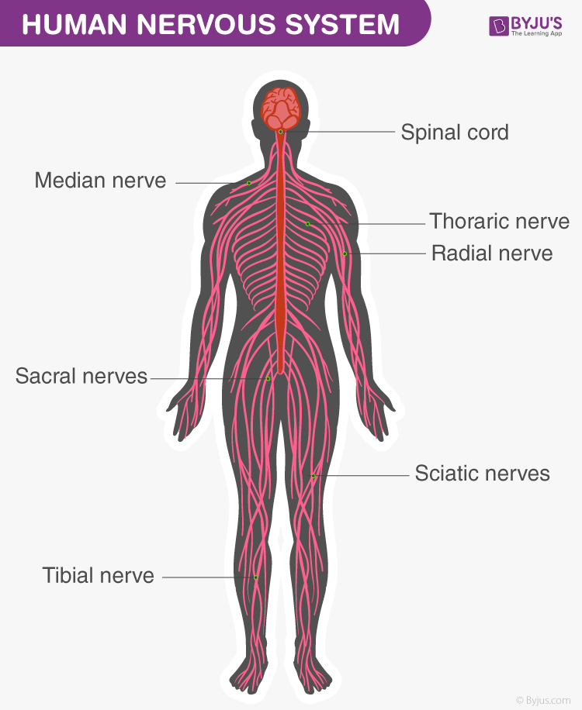

***Diagram of the Human Nervous System***

One of the most complex organ system to ever evolve, the human nervous system consists of two parts, namely:

1. Central Nervous System (consists of the brain and spinal cord)
2. Peripheral Nervous System (includes all the nerves of the body)

**Central Nervous System**

[**Central Nervous System**](https://byjus.com/biology/central-nervous-system/)(CNS) is often called the central processing unit of the body. It consists of the brain and the spinal cord.

**Brain**

The brain is one of the important, largest and central organ of the human nervous system. It is the control unit of the nervous system, which helps us in discovering new things, remembering and understanding, making decisions, and a lot more. It is enclosed within the skull, which provides frontal, lateral and dorsal protection. The human brain is composed of three major parts:

1. **Forebrain**: The anterior part of the brain, consists of Cerebrum, Hypothalamus and Thalamus.
2. **Midbrain**: The smaller and central part of the brainstem, consists of Tectum and Tegmentum.
3. **Hindbrain**: The central region of the brain, composed of Cerebellum, Medulla and Pons.

Also read: [Human Brain](https://byjus.com/biology/human-brain/)

**Spinal Cord**

The spinal cord is a cylindrical bundle of nerve fibers and associated tissues enclosed within the spine and connect all parts of the body to the brain. It begins in continuation with the medulla and extends downwards. It is enclosed in a bony cage called vertebral column and surrounded by membranes called meninges. The spinal cord is concerned with spinal reflex actions and the conduction of nerve impulses to and from the brain.

**Peripheral Nervous System**

Peripheral Nervous System (PNS) is the lateral part of the nervous system that develops from the central nervous system which connects different parts of the body with the CNS. We carry out both voluntary and involuntary actions with the help of peripheral nerves.

Also refer: [Peripheral Nervous System](https://byjus.com/biology/peripheral-nervous-system/)

PNS includes two types of nerve fibers:

1. **Afferent nerve fibers** – These are responsible for transmitting messages from tissues and organs to the CNS.
2. **Efferent nerve-fibers** – These are responsible for conveying messages from CNS to the corresponding peripheral organ.

Classification of the peripheral nervous system:

**Somatic neural system (SNS):** It is the neural system that controls the voluntary actions in the body by transmitting impulses from CNS to skeletal muscle cells. It consists of the somatic nerves.

**Autonomic neural system (ANS):**The autonomic neural system is involved in involuntary actions like regulation of physiological functions (digestion, respiration, salivation, etc.). It is a self-regulating system which conveys the impulses from the CNS to the smooth muscles and involuntary organs (heart, bladder and pupil). The autonomic neural system can be further divided into:

1. Sympathetic nervous system
2. Parasympathetic nervous system

**Neuron**

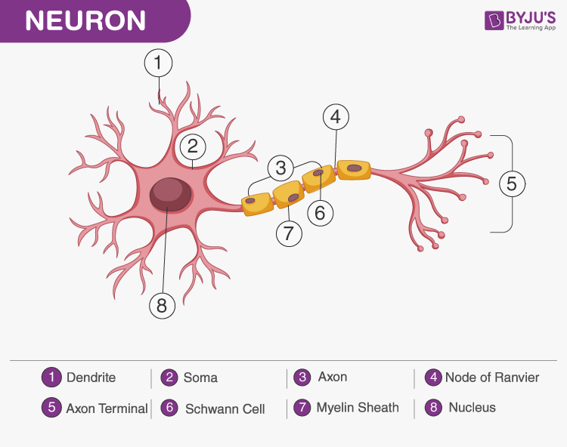

A Neuron is a structured and functional unit of the nervous system and unlike other cells, neurons are irregular in shape and able to conduct electrochemical signals. The different parts of a neuron are discussed below.

* Dendrite stretches out from the cell body of a neuron, and it is the shortest fibre in the cell body.
* Axon is the longest thread on the cell body of a neuron and has an insulating and protective sheath of myelin around it.
* Cell body consists of cytoplasm and nucleus.
* Synapse is the microscopic gap between a pair of adjacent neurons over which nerve impulses pass, when moving from one neuron to the other.

Explore more: [Placebo Effect](https://byjus.com/biology/placebo-effect/)

**Nerves**

Nerves are thread-like structures that emerge from the brain and spinal cord. It is responsible for carrying messages to all the parts of the body. There are three types of nerves. Some of these neurons can fire signals at speeds of over 119 m/s or above 428 km/h.

1. Sensory nerves send messages from all the senses to the brain.
2. Motor nerves carry messages from the brain to all the muscles.
3. Mixed nerves carry both sensory and motor nerves.

Also read: [Nerves](https://byjus.com/biology/nerves/)

[**Cranial nerves**](https://byjus.com/biology/cranial-nerves/)begin from the brain as these nerves carry impulses to start from the central nervous system. Certain cranial nerves belong to the group of mixed nerves while certain ones fall under sensory nerves. Spinal nerves originate from the spinal cord. All the spinal nerves carry impulses to and from the central nervous system and these are part of mixed nerves. The above nervous system diagram depicts the various nerves arising from various parts of the body.

GLANDULAR SYSTEM

The endocrine system is made up of glands that make hormones. Hormones are the body's chemical messengers. They carry information and instructions from one set of cells to another. The endocrine (pronounced: EN-duh-krin) system influences almost every cell, organ, and function of our bodies.

The [endocrine system](https://www.webmd.com/diabetes/endocrine-system-facts) is a network of glands in your body that make the hormones that help cells talk to each other. They’re responsible for almost every cell, organ, and function in your body.

If your endocrine system isn't healthy, you might have problems developing during [puberty](https://teens.webmd.com/default.htm), [getting pregnant](https://www.webmd.com/baby/getting-started-on-getting-pregnant), or [managing stress](https://www.webmd.com/heart-disease/heart-edu-20/stop-stress-now). You also might [gain weight](https://www.webmd.com/diet/ss/slideshow-weight-gain-shockers) easily, have weak bones, or lack energy because too much [sugar](https://www.webmd.com/diet/ss/slideshow-sugar-addiction) stays in your [blood](https://www.webmd.com/heart/anatomy-picture-of-blood) instead of moving into your cells where it's needed for energy.

**What Is a Gland?**

A gland is an organ that makes and puts out hormones that do a specific job in your body. Endocrine and exocrine glands release the substances they make into your bloodstream.

**Endocrine System Functions**

What does your endocrine system do? Its glands create and release hormones that control almost all processes in your body. They coordinate your metabolism, growth, and development, and control your emotions, mood, sexual function, and even sleep. Your endocrine system:

* Makes hormones that control your [moods](https://www.webmd.com/balance/cm/rm-quiz-moods), growth and development, [metabolism](https://www.webmd.com/fitness-exercise/guide/how-to-boost-your-metabolism), organs, and reproduction
* Controls how your hormones are released
* Sends those hormones into your bloodstream so they can travel to other body parts

**Parts of the Endocrine System**

Many glands make up the endocrine system. The hypothalamus, pituitary gland, and pineal gland are in [your brain](https://www.webmd.com/brain/picture-of-the-brain-vue3). The thyroid and parathyroid glands are in your neck. The thymus is between your [lungs](https://www.webmd.com/lung/healthy-lungs-smokers-lungs), the adrenals are on top of your [kidneys](https://www.webmd.com/a-to-z-guides/understanding-kidney-disease-basic-information), and the pancreas is behind your [stomach](https://www.webmd.com/pain-management/guide/abdominal-pain-causes-treatments). Your ovaries (if you're a woman) or testes (if you're a man) are in your pelvic region.

**Endocrine glands**

* [**Hypothalamus**](https://www.webmd.com/brain/hypopituitary)**.** This organ connects your endocrine system with your [nervous system](https://www.webmd.com/brain/what-is-nervous-system). Its main job is to tell your pituitary gland to start or stop making hormones.
* **Pituitary gland.** This is your endocrine system’s master gland. It uses information it gets from your brain to tell other glands in your body what to do. It makes many important hormones, including growth [hormone](https://www.webmd.com/women/features/escape-hormone-horrors-what-you-can-do); prolactin, which helps [breastfeeding](https://www.webmd.com/parenting/baby/nursing-basics) moms make milk; antidiuretic hormone (ADH or vasopressin), which controls blood pressure and helps control body water balance through its effect on the kidneys; adrenocorticotropic hormone (ACTH), which stimulates the adrenal gland to make certain hormones; thyroid-stimulating hormone (TSH), which stimulates the production and secretion of thyroid hormones; oxytocin, which helps in milk ejection during breastfeeding; and luteinizing hormone, which manages [estrogen](https://www.webmd.com/women/normal-testosterone-and-estrogen-levels-in-women) in women and testosterone in men.
* **Pineal gland.** It makes a chemical called [melatonin](https://www.webmd.com/drugs/drug-29-melatonin+oral.aspx) that helps your body get ready to go to [sleep](https://www.webmd.com/sleep-disorders/default.htm).
* [**Thyroid gland**](https://www.webmd.com/women/guide/understanding-thyroid-problems-basics)**.** This gland makes thyroid hormone, which controls your growth and [metabolism](https://www.webmd.com/diet/ss/slideshow-boost-your-metabolism). If this gland doesn't make enough (a condition called hypothyroidism), everything happens more slowly. Your [heart rate](https://www.webmd.com/heart-disease/heart-failure/watching-rate-monitor) might slow down. You could get [constipated](https://www.webmd.com/digestive-disorders/digestive-diseases-constipation). And you might gain weight. If it makes too much (hyperthyroidism), everything speeds up. Your [heart](https://www.webmd.com/heart-disease/high-cholesterol-healthy-heart) might race. You could have [diarrhea](https://www.webmd.com/digestive-disorders/digestive-diseases-diarrhea). And you might [lose weight](https://www.webmd.com/diet/default.htm) without trying. The thyroid gland also produces the hormone calcitonin, which may contribute to bone strength by helping calcium get incorporated into bone.
* **Parathyroid.** This is a set of four small glands behind your thyroid. They play a role in [bone](https://www.webmd.com/osteoporosis/features/building-stronger-bones) health. The glands control your levels of [calcium](https://www.webmd.com/drugs/2/drug-1575/calcium+oral/details) and phosphorus.
* **Thymus.** This gland makes white blood cells called T lymphocytes that fight infection and are crucial as a child's [immune system](https://www.webmd.com/cold-and-flu/immune-system-function) develops. The thymus starts to shrink after puberty.
* **Adrenals.** Best known for making the "fight or flight" hormone adrenaline (also called [epinephrine](https://www.webmd.com/drugs/drug-93171-epinephrine+im.aspx)), these two glands also make hormones called corticosteroids. They affect your [metabolism](https://www.webmd.com/fitness-exercise/cm/rm-quiz-truth-about-metabolism) heart rate, oxygen intake, blood flow, and sexual function, among other things.

**Endocrine organs**

* [**Pancreas**](https://www.webmd.com/digestive-disorders/digestive-diseases-pancreatitis)**.** This organ is part of your digestive and endocrine systems. It makes digestive enzymes that break down food. It also makes the hormones [insulin](https://www.webmd.com/diabetes/diabetes-types-insulin) and [glucagon](https://www.webmd.com/diabetes/glucagon-blood-sugar). These ensure you have the right amount of [sugar](https://www.webmd.com/diet/cm/rm-quiz-sugars-sweeteners) in your bloodstream and your cells.
* If you don't make insulin, which is the case for people with [type 1 diabetes](https://www.webmd.com/diabetes/type-1-diabetes), your [blood sugar levels](https://www.webmd.com/diabetes/how-sugar-affects-diabetes) can get dangerously high. In [type 2 diabetes](https://www.webmd.com/diabetes/type-2-diabetes), the [pancreas](https://www.webmd.com/diabetes/cm/rm-quiz-pancreas) usually makes some insulin but not enough.
* [**Ovaries**](https://www.webmd.com/women/ovarian-pain-causes-diagnosis-treatments)**.** In women, these organs make estrogen and progesterone. These hormones help develop [breasts](https://www.webmd.com/women/picture-of-the-breasts) at puberty, regulate the [menstrual cycle](https://teens.webmd.com/all-about-menstruation), and support a [pregnancy](https://www.webmd.com/baby/default.htm).
* **Testes.** In men, the testes make testosterone. It helps them grow facial and body [hair](https://www.webmd.com/skin-problems-and-treatments/hair-loss/understanding-hair-loss-basics) at puberty. It also tells the [penis](https://www.webmd.com/erectile-dysfunction/how-an-erection-occurs) to grow larger and plays a role in making [sperm](https://www.webmd.com/infertility-and-reproduction/sperm-and-semen-faq).

**NATURE CENTERED FOOD HABITS AND YOGIC DIET**

The research indicates that diets rich in plant-based are better for the environment and can improve health outcomes, too. “Certain foods like beef and lamb take a lot of carbon to create,” White says. But she says you don't have to become vegetarian or vegan.

Including healthy eating habits in your life is a must if you want to support your overall well-being. While trendy diets and lifestyle overhauls are all the rage, the truth is that simple changes and swaps can lead to big results in the health department.

As a registered dietitian, I have some go-to healthy-eating tips that I lean on when people want to eat more healthfully. All of my tips are simple to do and they won't require juice cleanses or expensive supplements to accomplish. To make implementing healthy eating habit changes more sustainable, I generally recommend that people choose two or three tips to kick-start their healthy eating journey. Once you master a few tips, you can add more.

For people who truly want to make positive changes in their eating routine, here are 20 top healthy eating habits that are dietitian-approved and incredibly impactful.

[Healthy Eating 101](https://www.eatingwell.com/category/4306/healthy-eating-101/)

**1. Skip Drinks with Added Sugars**

Added sugars are lurking in many seemingly healthy drinks, like fruit punch and sports drinks. Unfortunately, taking in too many added sugars has been linked to adverse outcomes including obesity, cardiovascular disease, type 2 diabetes, nonalcoholic fatty liver disease and metabolic syndrome, according to a 2019 [*European Journal of Paediatric Dentistry*](https://pubmed.ncbi.nlm.nih.gov/31246081/) article.

The [Dietary Guidelines for Americans recommend](https://www.dietaryguidelines.gov/sites/default/files/2020-12/DGA_2020-2025_ExecutiveSummary_English.pdf) that people limit their added sugar intake to less than 10% of their total calories. For a 2,000-calorie diet, that means around 12 teaspoons of the sweet stuff. Yet, according to the [Centers for Disease Control and Prevention](https://www.cdc.gov/nutrition/data-statistics/added-sugars.html), the average intake of added sugars among U.S. adults is about 17 teaspoons, far exceeding the suggested quota.

Swapping out beverages with added sugars—think regular soda, sweet tea, sports drinks, fruit punch, lemonade and fruit "drinks"—for no-sugar-added choices like water, [seltzer water](https://www.eatingwell.com/article/290289/does-seltzer-water-have-any-health-benefits/), unsweetened coffee or tea and even 100% fruit juice in moderation can give your body the hydration it needs without any added sugars.

**2. Include Fermented Food in Your Diet**

Kimchi, sauerkraut and other [fermented foods](https://www.eatingwell.com/article/281916/7-must-eat-fermented-foods-for-a-healthy-gut/) not only taste delish, but they also fuel the body with live probiotics that support our overall health in various ways. To give your body a [boost of probiotics](https://www.eatingwell.com/article/16530/can-probiotics-really-help-your-health/), start your day with plain yogurt, enjoy a miso soup at dinnertime or sip on a kombucha midday for some fermented goodness.

**3. Eat 2 to 3 Servings of Low-Mercury Non-Fried Fish Every Week**

Although the Dietary Guidelines for Americans suggest that most Americans eat at least 8 ounces of fish every week, the majority of people are sorely missing the mark. Fish, especially oily fish like salmon, is a rich source of DHA omega-3 fatty acids, selenium, vitamin B12 and a slew of other important nutrients that support our health.

Eating fish is linked to a plethora of potential health benefits too, including a reduced risk for cardiovascular disease, according to a 2018 advisory published in [*Circulation*](https://pubmed.ncbi.nlm.nih.gov/29773586/).

**4. Swap Out Highly Processed Meat for Fresher Options**

Highly processed meats like lunch meats, bacon and sausage are certainly convenient and incredibly appetizing. But these meat choices can also be loaded with nitrates, additives that, when heated, can produce potentially cancer-causing compounds, according to a 2020 report in [*Antioxidants (Basel)*](https://www.ncbi.nlm.nih.gov/pmc/articles/PMC7139399/). Many of these meat choices are loaded with sodium as well.

Fresh cuts of meat like turkey, chicken and beef are lower-sodium and nitrate-free meat options that can be just as satisfying to eat.

**5. Have a Glass of Milk Every Day**

Milk isn't just for kids. As a staple food that is a perfect accompaniment to chocolate chip cookies, a glass of milk is loaded with 13 essential nutrients, including bone-building calcium, protein and magnesium. Yet, as nutrient-dense as milk is, most adults don't drink even one glass of this beverage a day.

**6. Add Fruit to Your Midday Snack**

In the U.S., only about 12% of us eat the recommended amount of fruit and 10% get the suggested servings of vegetables every day. And since a lower intake of fruit is linked to outcomes like increased risk of certain cancers, heart disease and stroke, sneaking in some fruit every day is a smart move.

When the 3 p.m. slump strikes, instead of reaching for sugary candy or caffeine-laden drinks, enjoying fruit as a part of your balanced snack can give you sustained energy along with some energy-supporting nutrients. Combining a serving of fruit with protein can help give your snack some staying power, so you will feel satisfied and avoid a potential sugar crash shortly after eating.

If you don't have fresh fruit at your fingertips, know that dried, freeze-dried and frozen fruit are all healthy options as well, as long as they don't contain added salt or sugar. So, from freeze-dried blueberries to dried mango slices, the fruit choices are endless.

GETTY IMAGES / 10'000 HOURS

**7. Add More Vegetables to Your Dishes**

Vegetables are one of the best sources of fiber, a nutrient that can help keep your body healthy by supporting gut health and possibly reducing the risk of developing certain cancers. Plus, many veggies are low in calories and can help make dishes a bit more satisfying and flavorful.

Adding vegetables to your dishes doesn't mean living off of salad every day of the week. Adding extra broccoli to your stir-fry or tossing a handful of spinach in your homemade soup can give your dishes a healthy boost in a simple way.

**8. Don't Eat in Front of the TV**

Your meals are meant to be enjoyed. And when you eat while watching TV, you can end up being distracted and ultimately eat more calories while feeling less satisfied.

Instead, enjoy your meals with friends and family. Or, at the very least, simply make sure you are not distracted by the TV while you are eating.

**9. Choose BPA-Free Canned Foods**

Canned foods like tuna, tomatoes and beans are convenient foods that can be easily included in a healthy diet. But if the cans that your food is stored in contain BPA, a chemical that helps prevent metal corrosion, you may not be eating as well as you think.

According to a 2020 review in [*Frontiers in Nutrition*](https://www.frontiersin.org/articles/10.3389/fnut.2022.1047827/full), some research has linked BPA exposure to cancers, endocrine disruption, and reduced immune function. However, there are many unanswered questions about BPA's metabolism and its toxic effects.

Most U.S. can manufacturers have voluntarily phased out BPA, but there's concern that similar substitute materials may carry risks as well. At this point, there's not enough known research to make a conclusion about the safety of these substitutes. Ultimately, if you're concerned about these materials, choose foods stored in glass or aseptic paper-based boxes.

**10. Plan Your Meals**

Meal planning can help people eat a healthier diet and even may help them experience less obesity. Taking the time to [plan out your meals](https://www.eatingwell.com/category/4286/meal-plans/) for the week can help you navigate your healthy eating with ease. To meal-plan, figure out what you are going to eat for your meals throughout the week. Make yourself a shopping list and prep your ingredients for quick meals for the entire week.

**11. Don't Eat the Same Foods on Repeat**

To eat a healthy diet, variety is key. Eating a wide variety of foods will give your body different nutrients and may help prevent nutritional gaps. Plus, a 2022 [*Nutrients*](https://pubmed.ncbi.nlm.nih.gov/36558457/) study suggests that focusing on a variety of healthy foods may reduce the risk of developing metabolic syndrome.

One strategy that many dietitians recommend is to "eat the rainbow", meaning that people should aim to eat foods that naturally contain a wide variety of colors throughout the week. Purple cabbage, orange carrots, red radishes and green spinach are all good-for-you foods, but each variety contains a different nutritional composition. Rotating your food can add some excitement to your plate as well as giving your body different important nutrients every day.

**12. Prep Your Veggies**

Before you put your groceries away after your shopping haul, prep your veggies before you store them in the fridge. Having chopped onions and sliced cucumbers on hand makes it incredibly easy to add good-for-you vegetables to your dishes.

**13. Skip the Diet Soda**

Intuitively, it makes sense to believe that drinking diet soda is a healthy choice, thanks to the calorie-free sweetness that it provides. It turns out that drinking diet soda isn't as healthy a choice as we once thought, with a 2019 [*Circulation*](https://www.ahajournals.org/doi/10.1161/CIRCULATIONAHA.118.037401)study suggesting that sipping on the bubbly sweet stuff is associated with an increased risk of developing cardiovascular disease. And for people with type 2 diabetes, results from a small, short-term 2021 study in[*Diabetes, Metabolic Syndrome and Obesity*](https://www.ncbi.nlm.nih.gov/pmc/articles/PMC8163615/) found an association between drinking diet soda on a regular basis and developing vision challenges.

**14. Limit Fried Foods**

There is nothing like biting into a crispy french fry or piece of fried chicken. But eating too many fried foods is linked to a slew of unsavory health outcomes.

To get that satisfying crunch without the added calories and fat, opt for air-frying or baking your dishes instead.

**15. Swap Cocktails for Mocktails**

Consuming alcohol can increase risk of[certain types of cancers.](https://www.cdc.gov/cancer/alcohol/index.htm) But for some people, doing without an evening cocktail can be a huge life change. [Enjoying a mocktail](https://www.eatingwell.com/recipe/7870391/sparkling-cranberry-cider-mocktail/) instead of a cocktail is one way to limit or eliminate alcohol intake while still partaking in the ritual of sipping on a delicious beverage.

YOGIC DIET

The yogic diet stresses the consumption of natural, unprocessed foods that promote spiritual, mental, and physical health and aligns with [yogic philosophy](https://www.yogabasics.com/learn/philosophy-of-yoga/). It’s based primarily on the yogic principles of ahimsa, sattva, and saucha.

* **Ahimsa** is commonly translated to non-violence. Ahimsa is the idea that all living things are connected and that the world would be a better place if you do not harm living things. The most obvious way to not cause harm is to reduce or eliminate the consumption of meat and dairy products.
* **Sattva** is a state of equanimity that yogic practices aim to cultivate. A diet that is abundant in [sattvic foods](https://www.yogabasics.com/explore/yogic-lifestyle/yogic-diet/sattvic-foods/) will promote a calm heart and a clear mind. Sattvic foods are generally fresh vegetables, whole grains and beans, mild healing spices, and other mildly sweet fruits and vegetables.
* **Saucha** is the practice of purity and cleanliness. One of the simplest ways to promote saucha is to remove or reduce impurities in your body by only eating organic foods, which are free of chemicals.

How to follow a yogic diet

Beginning and adhering to a yogic diet can certainly be challenging. It is best to take it slow and ease your way into it. Start with just one or two changes and see how you feel. Slowly explore and add more changes as you can. Most importantly, make sure these changes do not create stress or imbalance in your life.

* **Eat fresh seasonal foods**A yoga diet consists of whole, fresh, seasonal foods and organic, locally grown foods, and as close to their natural state as possible. Try to grow your own vegetables in a garden or container, shop at farmers’ markets, or buy directly from local farmers. Buy fresh produce that’s in season, and avoid processed and packaged items, even if they are organic. Stale food and canned products should also be avoided.
* **Be vegetarian**A plant-based, whole-food diet is essential for yogis. Fortunately, [vegetarianism](https://www.yogabasics.com/explore/yogic-lifestyle/yogic-diet/to-be-or-not-to-be-vegetarian/) and veganism have become quite popular, making going meat-free much easier when grocery shopping, cooking, and dining out. Nuts, dairy products, leafy greens, and legumes are all great sources of high-quality protein in a vegetarian diet.
* **Avoid chemicals and stimulants**We are exposed to chemical substances just about everywhere–in the air, in the water, and especially in the junk food that we consume. One of the goals of [hatha yoga](https://www.yogabasics.com/learn/hatha-yoga-the-physical-path/) is to purify the physical and energetic bodies. Thus, reducing or eliminating chemicals and stimulants is encouraged. Wherever possible, avoid processed foods, artificial sweeteners, caffeine, alcohol, and tobacco to move towards a healthier lifestyle and to create purity in the body and mind.
* **Eat at regular intervals and allow space between meals**Except for the first meal of the day, it’s important to allow at least five hours between your meals. This allows your system to fully digest from your last meal. When you eat at regular intervals, your meals will taste better, and you will be less likely to overeat. It would be best if you ate only when you are truly hungry and not because of stress or boredom.
* **Eat two hours before asana practice or sleep**To avoid the discomfort of a full stomach during asana practice, it’s important to keep your meals small and light. It’s also important to eat at least two hours before your yoga sessions.
* **Make lunch the biggest meal of the day**Ayurvedic theory states that the digestive fire is strongest at midday and encourages the largest meal to be consumed at lunchtime. Raw vegetables and difficult to digest proteins are best suited for a [yogi](https://www.yogabasics.com/connect/what-is-a-yogi/)‘s lunchtime meal. Small amounts of fats should come from wholesome sources such as nuts and seeds and cold-pressed [olive oil](https://www.oliveoil.com/) or [high-oleic safflower oil](https://www.medicalnewstoday.com/articles/322245#six-health-benefits).
* **Eat mostly cooked foods at dinner**Yogic diet recommendations encourage eating a cooked dinner because it’s easier to digest than a raw meal. The body digests cooked food much more easily, which allows for quicker absorption and allows you to rest more after a meal. Try to eat as many cooked vegetables at your evening meal. Incorporate soothing soups and root veggies like carrots, sweet potatoes, yams, winter squash, and beets.
* **Emphasize healing herbs and spices**A yoga diet emphasizes healing herbs and spices, like [turmeric](https://www.yogabasics.com/connect/yoga-blog/improve-yoga-with-turmeric/), cardamom, cinnamon, ginger, fennel, mint, basil, cumin, parsley, cilantro, and black pepper. These spices offer many benefits to your body, including aiding digestion, alkalizing the blood, increasing mood, reducing anxiety, and promoting cleansing and healing.To make your diet more healing, work on adding more of these healing herbs to your meals. You can also use some of these in herbal teas as well. While you can purchase tea bags with pre-mixed herbal blends, making your own [herbal teas](https://www.herbcottage.com.au/collections/herbal-tea-blends) by steeping fresh or dried herbs in hot water can provide you with a more potent and customized infusion.Avoid hot peppers, such as jalapenos or cayenne pepper, as they can be too stimulating for the body and can disrupt the calm and balanced state that yoga aims to achieve. Opt for milder spices instead, like paprika or mild chili powder, to add flavor without overpowering your system.
* **Eat with mindfulness and a positive attitude**Your attitude towards your food is more important than the food itself. In our fast-paced world, it’s hard to think of food in terms of a spiritual practice. That’s why yoga teaches that eating should be an act of love and gratitude; you are taking sustenance from Mother Earth, and you should honor that.

[Mindful eating](https://www.yogabasics.com/connect/yoga-blog/new-year-nutrition-start-the-year-off-with-health/) can help you avoid mindless munching or bingeing, helping you focus on what you’re grateful for, as well as what you’re not. When you develop peace of mind about food, you can start to learn how to eat mindfully, control how much you eat, and understand what your body needs to maintain balance and health. Being mindful of what you eat can lead to weight loss, a healthier heart, a calm mind, and a longer life.

* **Consider fasting**The concept of fasting should be considered in the context of a yogic diet. Fasting is the practice of abstaining from food and/or drink for a period of time. The purpose of fasting is to cleanse the body, seek a spiritual goal, or express devotion to a chosen deity.The different fasting methods also vary in their requirements–from abstinence from all food and liquids to abstinence from only certain foods, for example. Fasting is not recommended for those who have poor digestion or a tendency towards weight gain. Fasting for more than a few days is not recommended as it puts excessive stress on your body’s systems.

DINCHARYA AND RITUCHARYA WITH RESPECT TO YOGIC LIFE STYLE

According to Ayurveda, the principles of Ritucharya advocate living one's life according to the flow of the seasons. 'Ritu' means 'season' and 'charya' means 'regime'.

“Dincharya” and “Ritucharya” are traditional Ayurvedic concepts that emphasize daily and seasonal routines for maintaining optimal health and well-being. While they are rooted in Ayurveda, integrating these principles into a yogic lifestyle can enhance overall health and complement yogic practices. Let’s explore each concept in detail:

1. **Dincharya (Daily Routine)**:

* **Definition**: Dincharya refers to a daily routine that aligns with the natural rhythms of the day, promoting balance and good health.
* **Principles**:
  + **Waking Early**: Rising before sunrise (Brahma muhurta) aligns with the body’s natural rhythms and promotes a fresh start to the day.
  + **Oral Hygiene**: Practices like tongue cleaning, oil pulling, and brushing teeth are essential for oral health and overall hygiene.
  + **Elimination**: Establishing a regular bowel and bladder routine promotes detoxification and good digestive health.
  + **Physical Exercise**: Engaging in yoga, stretching, or other forms of physical activity in the morning enhances circulation and prepares the body for the day.
  + **Pranayama and Meditation**: Including breath control (pranayama) and meditation practices in the morning fosters mental clarity, focus, and a calm mind.
  + **Balanced Diet**: Eating balanced, nutritious meals at regular intervals throughout the day supports energy levels and overall well-being.
  + **Adequate Rest**: Ensuring sufficient sleep and rest at night allows the body to rejuvenate and recover.

2. **Ritucharya (Seasonal Routine)**:

* **Definition**: Ritucharya involves adapting one’s lifestyle, diet, and activities according to the changing seasons to maintain balance and harmony with nature.
* **Principles**:
  + **Understanding Seasons**: Recognizing the distinct qualities of each season (Vata, Pitta, Kapha) helps in making appropriate lifestyle adjustments.
  + **Diet Modifications**: Adapting the diet to seasonal produce and qualities (cooling in summer, warming in winter) helps balance the body’s internal environment.
  + **Exercise and Yoga**: Modifying the intensity and type of physical activity to suit the season prevents imbalances and supports optimal health.
  + **Sleep Patterns**: Adjusting sleep timings and patterns based on daylight duration and the body’s needs during different seasons.
  + **Practices for Immunity**: Incorporating practices that enhance immunity during seasonal changes, like Ayurvedic herbs, is important.
  + **Hydration**: Adapting water intake to the weather and body’s requirements in various seasons is vital.

Integrating these principles into a yogic lifestyle:

* **Synchronizes with Circadian Rhythms**: Aligning daily routines with natural rhythms supports the body’s innate clock and enhances overall health.
* **Promotes Mind-Body Balance**: Following a disciplined daily routine ensures regularity in yoga practice, meditation, and self-care, promoting mental and physical harmony.
* **Enhances Yogic Practice**: Optimal rest, balanced nutrition, and appropriate adjustments to seasons complement the effects of yoga and pranayama, optimizing the benefits.

By understanding and applying Dincharya and Ritucharya, individuals can harmonize with nature’s rhythms, enhance their overall well-being, and optimize the benefits derived from their yogic practices. These practices can promote a holistic approach to health, incorporating both yogic principles and Ayurvedic wisdom.

YOGIC MANAGEMENT OF STRESS AND ITS CONSEQUENCES

Yoga can help reduce stress because it promotes relaxation, which is the natural opposite of stress. Yoga can benefit three aspects of ourselves that are often affected by stress: our body, mind, and breathing. You don't have to wait to feel stressed out to do yoga, and you shouldn't!

These words are very common to people now a days. When your job demands an overtime hectic works or scheduled high pressured targets or deadlines: all these causes unwanted stress in a man’s life. When we are busy making money, we forgets or want fully rejects the impacts that these pressure makes on our mental and physical health.

It is high time that we pause and look inwards to see ourselves and our inner sense for a betterment so that all our hard works for a better future are not in vein.

**Yogic Management of Stress**

Stress is not something which we can totally wipe out, but through proper techniques, we can progressively manage and peacefully live with it. So let’s see how we can manage stress through various techniques. [Yoga](https://wellnessloka.com/retreat/yoga-meditation) and meditation is one of the best technique for managing stress. Bringing yoga and meditation to our daily life eases our mind and soul and make us free from all our trauma and anxiety. Everyday practice of yoga therapy helps to release endorphins – happy hormones from the body thereby which gives a symptomatic relief. Let’s see how we can manage stress through yogic management.

Below are some of the benefits of yogic Management:

* Relaxation to mind and body
* Relaxation to muscles and joints
* Increase blood circulation
* Improves metabolism
* Improves sleep
* Promotes self-esteem and self confidence

**Stress-Relief Techniques Involved in Yoga**

Yoga has its own ways and techniques for managing physical well-being. It include

1. Relaxation techniques
2. Asanas (postures).
3. Pranayama

**Yoga Nidra**

[Yoga](https://wellnessloka.com/retreat/online-yoga) nidra defines as yogic sleep. It is a state of consciousness from waking and sleeping which is induced by a guided meditation. It is powerful meditation technique which can be well maintained and practiced under a expert guidance. It is practiced to get higher level of consciousness. It can be done from children to seniour citizen.Yoga nidra offers a space to explore what you need in the moment, as well as an opportunity to work on releasing long-held emotions.

Yoga Nidra place a very important role for stress management. They can reduce the impact of exaggerated stress responses and thereby reduce anxiety and stress.It includes 8 steps. Should do under expert guidance.

Benefits of yoga nidra

* Improves self esteem and self confidence
* Relaxation to mind and body
* Lifestyle modification
* Improves sleep

**1. Relaxation techniques**

            Relaxation techniques are procedure or techniques which helps one to relax mentally and physically.

**Benefits of relaxation techniques**

* Lowers blood pressure
* Promotes good sleep
* Reduces stress, anger and frustration
* Facilitates a soothing effect

Relaxation techniques include:

* Deep relaxation techniques
* Quick relaxation technique
* Instant relaxation technique

**Deep relaxation techniques**

   It’s a 45 mins to 1 hr practice by relaxating the entire muscles and joints. It is practiced by lying down at savasana. Should do under exepert guidance

**Quick relaxation technique**

  It’s a 15 mins to 30 mins relaxation technique.

Relaxation of the whole body in 15 mins .

Should do under expert guidance

**Instant relaxation technique.**

It’s a 5 mins practice . Relaxation done in 5 mins which is said to be instant relaxation technique .

Should do under expert guidance

**2. Asanas/ postures**.

 Asana is defined as steady and comfortable postures.

**Benefits of asanas in stress management**

* Promotes good sleep
* Improves blood circulation
* Reduces stress and anxiety
* Helps in lowering blood pressure

Asnas include :

* **Savasana**

    Savasana otherwise called as corpse pose which is a relaxative asana helps in relaxation at the end of sessions.

**Benefits of savasana for stress management**

* + Calms central nervous system, aiding the digestive and immune systems.
  + Calms the mind and reduces stress.
  + Reduces headache, fatigue and anxiety.
  + Helps lower blood pressure**.**

* **Sukhasana**

Sukhasana or simple yogic pose helps in relaxation and meditative pose.

**Benefits of sukhasana for stress management**

* Being a meditative pose sukhasana helps in relaxation of body and mind
* Builds physical and mental balance
* Helps in reducing stress and anxiety
* Improves blood circulation

* **Balasana**

Balasana otherwise called as child relaxative pose.

**Benefits of Balasana for stress management**

* Calms the brain and helps relieve stress and fatigue.
* Relieves back and neck pain
* Promotes soothing effect to the body.

* **Makrasana**

Makrasana is otherwise called as crocodile pose which is the relaxative pose at the end of each session.

**Benefits of makarasna for stress management**

* Reduces anger and tension
* Calms the body and mind
* Rejuvenate the whole body and mind
* Improves sleep

1. **Pranayama**

Pranayama is defined as prana means breath ayama means to control . Controlling of breath is pranayama.

* Nadishuddhi paranayam
* Seetkari
* Brahmari
* Hand in and out streching exercise
* Hand up and down streching exercise

**HOLISTIC APPROACH OF YOGA TOWARDS HEALTH AND DISEASES**

Some of the ways yoga contributes to holistic health:This also benefits the connections between nerve cells in the brain, helping prevent the onset of disease. Yoga promotes healthy aging as it improves balance, body awareness and concentration, thus reducing the risk of falls and fractures that can come with old age.

Yoga offers a holistic approach to health and well-being, encompassing the physical, mental, emotional, and spiritual dimensions of an individual. It emphasizes the interconnection between these aspects and strives for balance and harmony within the body and mind. The holistic approach of yoga towards health and diseases involves a variety of practices and principles that promote overall wellness. Here’s a detailed elaboration:

Table of Contents



* [1. Physical Well-being:](https://www.askyogaexpert.org/blog/holistic-approach-of-yoga-towards-health-and-diseases/#1_Physical_Well-being)
* [2. Mental and Emotional Well-being:](https://www.askyogaexpert.org/blog/holistic-approach-of-yoga-towards-health-and-diseases/#2_Mental_and_Emotional_Well-being)
* [3. Diet and Nutrition:](https://www.askyogaexpert.org/blog/holistic-approach-of-yoga-towards-health-and-diseases/#3_Diet_and_Nutrition)
* [4. Lifestyle Choices:](https://www.askyogaexpert.org/blog/holistic-approach-of-yoga-towards-health-and-diseases/#4_Lifestyle_Choices)
* [5. Prevention and Management of Diseases:](https://www.askyogaexpert.org/blog/holistic-approach-of-yoga-towards-health-and-diseases/#5_Prevention_and_Management_of_Diseases)
* [6. Spiritual Well-being:](https://www.askyogaexpert.org/blog/holistic-approach-of-yoga-towards-health-and-diseases/#6_Spiritual_Well-being)
* [7. Philosophical Foundation:](https://www.askyogaexpert.org/blog/holistic-approach-of-yoga-towards-health-and-diseases/#7_Philosophical_Foundation)
* [Overall Relevance:](https://www.askyogaexpert.org/blog/holistic-approach-of-yoga-towards-health-and-diseases/#Overall_Relevance)

1. **Physical Well-being**:

* **Asanas (Physical Postures)**: Yoga postures help maintain physical health by enhancing flexibility, strength, balance, and alignment. They stimulate the circulatory, respiratory, and digestive systems, promoting overall vitality.
* **Pranayama (Breath Control)**: Pranayama techniques enhance lung capacity, improve oxygen intake, and aid in respiratory health. Proper breathing practices reduce stress, calm the nervous system, and boost energy levels.

2. **Mental and Emotional Well-being**:

* **Meditation and Mindfulness**: Yoga encourages meditation and mindfulness practices to cultivate mental clarity, focus, and emotional stability. It helps manage stress, anxiety, and depression, promoting a sense of peace and well-being.
* **Yogic Relaxation (Yoga Nidra)**: Deep relaxation techniques like Yoga Nidra induce a state of profound rest, relieving mental and emotional tension, and enhancing mental clarity and emotional resilience.

3. **Diet and Nutrition**:

* **Sattvic Diet**: Yoga recommends a sattvic diet comprising fresh fruits, vegetables, whole grains, nuts, and dairy. Sattvic foods promote clarity, balance, and overall well-being, supporting the body’s natural healing processes.
* **Fasting and Cleansing**: Intermittent fasting and occasional cleansing practices help detoxify the body, remove impurities, and rejuvenate the digestive system.

4. **Lifestyle Choices**:

* **Daily Routine (Dincharya)**: Structuring the day in alignment with natural rhythms promotes balance and discipline. Rising early, practicing yoga and meditation, and maintaining a consistent daily routine contribute to overall well-being.
* **Simplicity and Non-Excess (Aparigraha)**: Embracing a simple and moderate lifestyle, focusing on essentials, and minimizing excess promote contentment and mental peace.

5. **Prevention and Management of Diseases**:

* **Yoga Therapy**: Tailored yoga practices (asanas, pranayama, relaxation techniques) are used for preventing and managing various health conditions, such as diabetes, hypertension, back pain, and more.
* **Stress Reduction**: Yoga’s emphasis on relaxation and stress reduction plays a crucial role in preventing stress-related diseases, a significant health concern in modern times.

6. **Spiritual Well-being**:

* **Connecting with the Self**: Yoga encourages self-reflection, self-awareness, and inner exploration. Connecting with one’s true self (Atman) leads to a deeper understanding of life’s purpose and enhances spiritual growth.
* **Service and Compassion (Seva)**: Encourages selfless service and compassion towards others, promoting a sense of unity, empathy, and inner fulfillment.

7. **Philosophical Foundation**:

* **Yamas and Niyamas**: Yoga philosophy advocates ethical guidelines (yamas) and personal observances (niyamas) that foster a balanced and harmonious life, reflecting on values like truthfulness, non-violence, contentment, and discipline.

Overall Relevance:

* The holistic approach of yoga integrates physical health, mental peace, emotional balance, and spiritual growth, leading to a complete sense of well-being.
* By addressing the root causes of diseases and imbalances, yoga offers sustainable solutions for long-term health and vitality.
* Regular yoga practice supports individuals in leading a balanced and fulfilling life, aligning with their innate nature and potential.

By embracing the holistic approach of yoga, individuals can nurture a deeper understanding of themselves, enhance their overall health and well-being, and achieve a harmonious integration of mind, body, and spirit.